Online data supplementary material
Early-life liquefied petroleum gas cooking intervention and lung function in Guatemalan children: a randomized clinical trial
Laura M. Grajeda, Keyla Castellanos, Anaité Díaz-Artiga, Maria Reneé López, Alexander Ramirez, Tatiana Petrovick, Albino Barraza-Villarreal, Lisa M. Thompson, Shirin Jabbarzadeh, Jiantong Wang, Lance Waller, Maggie L. Clark, Amy E. Lovvorn, Christina M. Eckhardt, Nadia E. Hoekstra, Michael A. Johnson, Ajay Pillarisetti, Diddier Prada, Andrea Baccarelli, Ye Shen, Jessica Knight, Luke Naeher, Thomas Clasen, Jennifer Peel, Eric D. McCollum, John P. McCracken

Contents
Text 2
Ethical review approvals 2
Assessment of acute lower respiratory infections 2
Interpretation and measurement of respiratory oscillometry 2
Power calculations 4
Statistical analysis for the fully adjusted models 7
Sensitivity analyses 7
Tables 9
Table E1: Comparison of mixed regression models to model the resistance across all the prime frequencies. 9
Table E2: Alternative measurement quality control methods 13
Table E3: Characteristics of study participants by missing outcome data 14
Table E4: Summary statistics of covariates before and after imputation of missing values among children alive at age 1 year 17
Table E5: Effect of LPG intervention on lung oscillometry at age 3 years in cmH₂O*S/L, including children with a lower respiratory infection in the seven days before testing 18
Table E6: Summary statistics of oscillometry test collected at age 3 or 4 years 18
Figures 19
Figure E1: Identification of the causal effect of an early life intervention with LPG on lung oscillometry at age 3 using directed acyclic graphs 19
Figure E2: Effect of LPG intervention on lung oscillometry at age 3 years in cmH₂O*S/L by oscillometry quality control method and alternative covariate adjustment 23
Figure E3: Effect of LPG intervention on lung oscillometry at age 3 or 4 years in cmH₂O*S/L by oscillometry quality control method and alternative covariate adjustment 24
References 25

Text

Ethical review approvals
The protocol for the trial was approved by the institutional review boards at Emory University (Atlanta, Georgia, USA; #00089799), Johns Hopkins University (Baltimore, Maryland, USA; #00007403), Universidad del Valle de Guatemala (Guatemala, Guatemala; #146-08-2016), and the Guatemalan Ministry of Health (Guatemala, Guatemala; #11-2016). The follow-up at age 3 was approved by the institutional review boards at Emory University (Atlanta, Georgia, USA; #00089799), and Universidad del Valle de Guatemala (Guatemala, Guatemala; #146-08-2016).

Assessment of acute lower respiratory infections
Acute lower respiratory infection was defined as difficulty breathing or fast breathing. Difficulty breathing was assessed by asking the caregiver or by observing the child when the caregiver reported no difficulty breathing. Fast breathing was assessed by asking the caregiver about short, rapid breaths due to a “chest problem” and by measuring respiratory rate when the caregiver reported cough or difficulty breathing. Tachypnea was defined as an elevated respiratory rate of ≥40 breaths per minute.

Interpretation and measurement of respiratory oscillometry
Respiratory oscillometry (oscillometry) is a non-invasive pulmonary function technique used with preschool-aged children because it requires minimal cooperation compared to spirometry (1). Oscillometry assesses the mechanical properties of the lungs by applying external multifrequency (e.g. 7-41 Hertz (Hz)) pressure and flow waves through the mouth that are superimposed onto normal breathing and then measuring the returning flow and pressure waves (2). These outputs estimate lung resistance (R) and reactance (X).
Resistance is the pressure required to produce airflow in the respiratory system and is influenced by the length and radius of the airways and the volume of the lungs. Higher resistance has been observed in airway diseases including COPD and asthma (3-5). The frequency of the waves is associated with the depth of penetration into the respiratory system. Low-frequency waves (e.g. resistance at 7 Hertz or R7) travel deeper into the lungs and may produce higher R with abnormalities in the overall respiratory system. High-frequency waves, on the other hand, travel shorter distances and may generate a higher R when the central or upper airways are abnormal.
X measures the elastance and inertance of the respiratory system. Elastance, the inverse of compliance, represents the lung’s capacity to recoil. Inertance is the inertia of air within the large airways. Elastance dominates at lower frequencies (e.g. reactance at 7 Hertz or X7) while inertance at higher frequencies. Measures over multiple frequencies, like the area above X (AX), are believed to be more sensitive than single frequencies alone (3). There are no globally accepted standardized reference equations to establish normal oscillometry values (6).
Oscillometry was measured at house visits using the Tremoflo C-100 Airwave Oscillometry System (THORASYS Thoracic Medical Systems, Montreal, Quebec, Canada) at a 7 to 41 Hertz frequency range. The Tremoflo was calibrated upon arrival at the participant’s home following the manufacturer's instructions using a 15 cmH2O.s/L reference load. Before the first measurement, we familiarized the children with the procedure and the mouthpiece. We placed the mouthpiece in the child's mouth and instructed the child to seal it with teeth and lips to avoid air leakage, to place the tongue under the mouthpiece, and to avoid swallowing to prevent blocking of the airflow. We asked the child to breathe steadily and quietly through the mouthpiece while we blocked his nose with a clip or with the child's or caretaker's fingers. We started each measurement only after the child took two consecutive normal breaths. During the measurements, children sat upright in a chair or their caretaker's lap with their chin up at a 15-degree angle toward the operator while the operator supported the child's cheeks with the hands. The same team of two operators, including a nurse, conducted all measurements. Bronchodilator reversibility or single-frequency measurements were not assessed.
Measurement quality control was performed using Thorasys software. The software automatically removed time intervals with upper airway artifacts, defined as ±3 standard deviations from the average of R7, or implausible negative R values. Measurements with ≥70% of data points remaining after artifact filtering were considered valid. Among the valid measurements, we selected the first three with a coefficient of variation (CoV) ≤15% for R7 and averaged them to obtain test summaries. When no three measures satisfied the CoV criterion or the number of valid measures was less than three, we averaged all valid measures.

Power calculations
We calculated the power to estimate the effect of early life intervention with LPG cooking on oscillometry endpoints in Guatemalan preschoolers of the HAPIN study. The power was calculated with a z-test to compare the means of two independent groups using the formulas below:
$$Effect size= \frac{abs({OSM}_{Intervention}-{OSM}_{control})}{std dev}$$

$Z_{1-B}=\sqrt{\frac{sample size/2}{2}}*Effect size-Z_{1-α}$, where $Z_{1-α/2}$ is 1.96 for two-sided tests.

We evaluated the power for a range of effect sizes that were considered plausible based on the results of the Ghana Randomized Air Pollution and Health Study (GRAPHS) and the study by Zeng et al. 2018 (Table). GRAPHS had similar aims and design to the HAPIN study. It was a cluster-randomized trial of early-life intervention with LPG stoves (n = 221) compared to traditional open-fire stoves (n = 240) conducted in Ghana, and its effects on OSM endpoints at age four years (7). The study by Zeng et al. 2018 was a comparison of preschool-age children with uncontrolled asthma diagnosed by a pediatric respiratory specialist in the Third Military Medical University (n=27) and healthy children presenting to the hospital for a health check-up (n=25) in China (8). The study by Zeng offers a contrast in OSM outcomes between healthy and sick children.
Table: Contrasts reported in studies of lung oscillometry in preschool-aged children (in cmH₂O*S/L)
OSM endpoint | GRAPHS study  OSM_{LPG} – OSM_{open fire} | Zeng 2018  OSM_{healthy} – OSM_{asthma}
R5 | 14.2 – 14.0 = 0.2 | 10.0 – 11.4 = -1.4
X5 | -3.2 – -3.4 = 0.2 | -3.9 – -5.1 = 1.5
AX | 55.9 – 58.2 = -2.3 | 26.2 – 38.3 = -12.1

Additionally, we also evaluated the power to detect an effect from LPG cooking by varying the size of the analytical sample from 200 to 750. The number of children alive at age 3 years in the Guatemalan HAPIN cohort is 750.

a) | 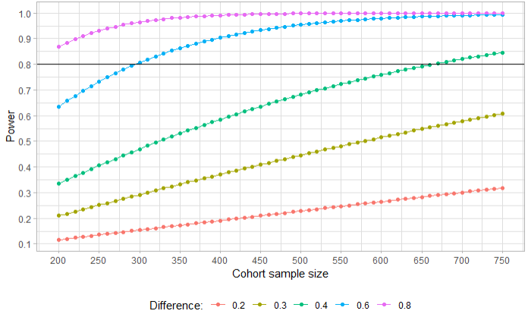
b) | 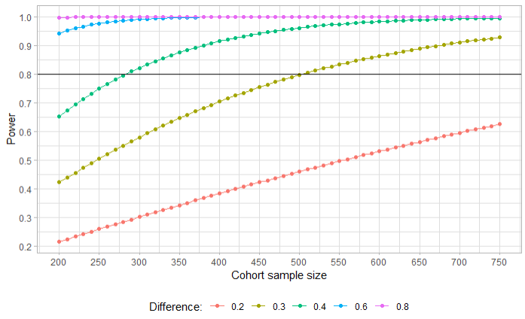
c) | 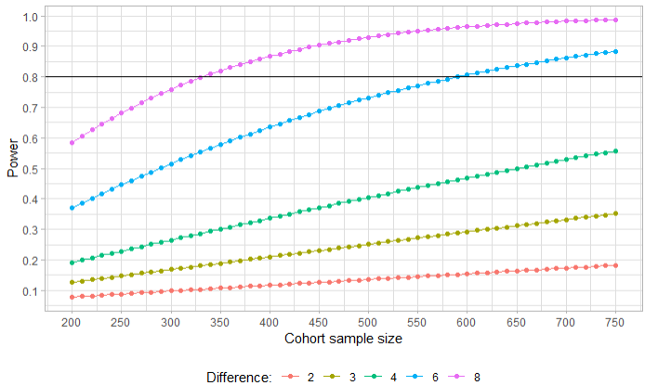

Figure: Power calculations for different effect sizes by OSM outcome.

Statistical analysis for the fully adjusted models
We used marginal structural models for the pseudopopulation of children alive at 1 year (n=750). Stabilized weights for the intervention assignment and the censoring status were calculated from the child’s sex, age, weight, and height; the presence of cough, common cold, fever, or diarrhea in the last week; gestational age at randomization; and pre-randomization socioeconomic score, food insecurity score, exposure to secondhand smoke, maternal education, maternal age, and number of siblings. The 95% confidence intervals were calculated from 1000 bootstrap resamples. Missing covariate data were imputed using 5 iterations of multivariate imputations by chained equations to create one imputed dataset. The completeness of the covariates with missing data and summary statistics before and after the imputation are shown in Table E4.

Sensitivity analyses
Concerns about measurement error, a recognized limitation of the oscillometry technique, were addressed by repeating the analyses with measurements that underwent an alternative quality control method developed by our research team. A comparison of both methods is presented in Table E3.
In a second sensitivity analysis, we added oscillometry tests collected at age 4 years to increase precision and the representativeness of the analytical sample relative to the cohort. Oscillometry at age 4 was only collected when oscillometry at age 3 was missed.

Tables

Table E1: Comparison of mixed regression models to model the resistance across all the prime frequencies.
Model¹ | Frequency specification | Random terms | Regression equation | N Parameters | AIC² | Log likelihood ratio test  p-value
1 | Categorical | Intercept | $R_{i}=\left(β_{o}+b_{oi}\right)+β_{1}Freq11+β_{2}Freq13+β_{3}Freq17+β_{4}Freq19+β_{5}Freq23+β_{6}Freq29+β_{7}Freq31+β_{8}Freq37+{β_{9}Freq41+e}_{ij}$ | 12  (10 fix + 1 ran + 1 err) | 12,694
2 | Quadratic | Intercept | $R_{i}=\left(β_{o}+b_{oi}\right)+β_{1}Freq+β_{2}{Freq}^{2}{+e}_{ij}$ | 5  (3 fix + 1 ran + 1 error) | 13,003 | <0.0001
3 | Quadratic | Intercept and slope | $R_{i}=\left(β_{o}+b_{oi}\right)+\left(β_{1}+b_{1i}\right)Freq+\left(β_{2}+b_{2i}\right){Freq}^{2}{+e}_{ij}$ | 10  (3 fix + 3 ran + 3 cov + 1 err) | 11,224 | <0.0001
4 | Quadratic B-spline with knot in 21 Hz | Intercept | $R_{i}=\left(β_{o}+b_{oi}\right)+β_{1}Freq+β_{2}{Freq}^{2}{+{β_{3}\left(Freq-21\right)}_{+}^{2}+e}_{ij}$  Where  ${\left(Freq-21\right)}_{+}^{2}=\left\{\begin{aligned}0, &Freq<21 \\ 1, &Freq≥21\end{aligned}\right.$ | 6  (4 fix + 1 ran + 1 err) | 12,930 | <0.0001
5 | Quadratic B-spline with knot in 21 Hz | Intercept and slope |  | 15  (4 fix + 4 ran + 6 cov + 1 err) | 8,481 | <0.0001
6 | Quadratic B-spline with knots in 17 and 29 Hz | Intercept | $R_{i}=\left(β_{o}+b_{oi}\right)+β_{1}Freq+β_{2}{Freq}^{2}{+{β_{3}\left(Freq-17\right)}_{+}^{2}+{β_{4}\left(Freq-29\right)}_{+}^{2}+e}_{ij}$  Where  ${\left(Freq-17\right)}_{+}^{2}=\left\{\begin{aligned}0, &Freq<17 \\ 1, &Freq≥17\end{aligned}\right.$  ${\left(Freq-29\right)}_{+}^{2}=\left\{\begin{aligned}0, &Freq<29 \\ 1, &Freq≥29\end{aligned}\right.$ | 7  (5 fix + 1 ran +1 err) | 12,783 | <0.0001
7 | Quadratic B-spline with knots in 17 and 29 Hz | Intercept and slope |  | 21  (5 fix + 5 ran + 10 cov + 1 err) | 7,469 | <0.0001
8 | Quadratic B-spline with knots in 13, 21 and 31 Hz | Intercept | $R_{i}=\left(β_{o}+b_{oi}\right)+β_{1}Freq+β_{2}{Freq}^{2}{+{β_{3}\left(Freq-13\right)}_{+}^{2}+{β_{4}\left(Freq-21\right)}_{+}^{2}+{β_{5}\left(Freq-31\right)}_{+}^{2}+e}_{ij}$  Where  ${\left(Freq-13\right)}_{+}^{2}=\left\{\begin{aligned}0, &Freq<13 \\ 1, &Freq≥13\end{aligned}\right.$  ${\left(Freq-21\right)}_{+}^{2}=\left\{\begin{aligned}0, &Freq<21 \\ 1, &Freq≥21\end{aligned}\right.$  ${\left(Freq-31\right)}_{+}^{2}=\left\{\begin{aligned}0, &Freq<31 \\ 1, &Freq≥31\end{aligned}\right.$ | 8  (6 fix + 1 ran +1 err) | 12,776 | <0.0001
9 | Quadratic B-spline with knots in 13, 21 and 31 Hz | Intercept and slope |  | 28  (6 fix + 6 ran + 15 cov + 1 err) | 7,230 | <0.0001
10 | Cubic B-spline with a knot in 21 Hz | Intercept | $R_{i}=\left(β_{o}+b_{oi}\right)+β_{1}Freq+β_{2}{Freq}^{2}{+β_{3}{Freq}^{3}+{β_{4}\left(Freq-21\right)}_{+}^{3}+e}_{ij}$  Where  ${\left(Freq-21\right)}_{+}^{3}=\left\{\begin{aligned}0, &Freq<21 \\ 1, &Freq≥21\end{aligned}\right.$ | 7  (5 fix + 1 ran + 1 err) | 12,788 | <0.0001
11 | Cubic B-spline with a knot in 21 Hz | Intercept and slope |  | 21  (5 fix + 5 ran + 10 cov + 1 err) | 7,477 | <0.0001
12 | Cubic B-spline with knots in 17 and 29 Hz | Intercept | $R_{i}=\left(β_{o}+b_{oi}\right)+β_{1}Freq+β_{2}{Freq}^{2}{+β_{3}{Freq}^{3}+{β_{4}\left(Freq-17\right)}_{+}^{3}+{β_{5}\left(Freq-29\right)}_{+}^{3}+e}_{ij}$  Where  ${\left(Freq-17\right)}_{+}^{3}=\left\{\begin{aligned}0, &Freq<17 \\ 1, &Freq≥17\end{aligned}\right.$  ${\left(Freq-29\right)}_{+}^{3}=\left\{\begin{aligned}0, &Freq<29 \\ 1, &Freq≥29\end{aligned}\right.$ | 8  (6 fix + 1 ran + 1 err) | 12,789 | <0.0001
13 | Cubic B-spline with knots in 17 and 29 Hz | Intercept and slope |  | 28  (6 fix + 6 ran + 15 cov + 1 err) | 7,287 | <0.0001
14 | Cubic B-spline with knots in 13, 21, and 31 Hz | Intercept | $R_{i}=\left(β_{o}+b_{oi}\right)+β_{1}Freq+β_{2}{Freq}^{2}{+β_{3}{Freq}^{3}+{β_{4}\left(Freq-13\right)}_{+}^{3}+{β_{5}\left(Freq-21\right)}_{+}^{3}+{β_{6}\left(Freq-31\right)}_{+}^{3}+e}_{ij}$  Where  ${\left(Freq-13\right)}_{+}^{3}=\left\{\begin{aligned}0, &Freq<13 \\ 1, &Freq≥13\end{aligned}\right.$  ${\left(Freq-21\right)}_{+}^{3}=\left\{\begin{aligned}0, &Freq<21 \\ 1, &Freq≥21\end{aligned}\right.$  ${\left(Freq-31\right)}_{+}^{3}=\left\{\begin{aligned}0, &Freq<31 \\ 1, &Freq≥31\end{aligned}\right.$ | 9  (7 fix + 1 ran + 1 err) | 12,789 | <0.0001
15 | Cubic B-spline with knots in 13, 21, and 31 Hz | Intercept and slope |  | 36  (7 fix + 7 ran + 21 cov + 1 err) | 7,276 | <0.0001
¹Models fitted with lme4 in r statistical software. ²In orange is the model with the lowest AIC.

Table E2: Alternative measurement quality control methods
Characteristic | Main method | Alternative method
Type of algorithm | Proprietary commercial algorithm | Investigators' algorithm coded in r
Time level at the identification of artifacts | 0.1-second time-resolved intervals | 0.1-second time-resolved intervals
Criteria for identification of leaks | None | R7 or X7 values between -1 and 1 cmH2O.s/L within >15% of a breath
Criteria for identification of obstructions | R outside 3 standard deviations from the measurement mean | R7, X7, or Z7 outside 3 standard deviations from the measurement mean, iterated three times
Exclusion intervals | 0.1 seconds | Breath
Criteria for a valid measure | ≥70% valid data points from a 20-second measure | ≥4 valid breaths
Criteria for measurement selection | The first three with an R7 coefficient of variation <15%. If none, use all the artifact-free measurements. | The four measurements with the closest values for each endpoint. If <4 measurements, use all the artifact-free measurements.
R7: Resistance at 7 Hertz. X7: Reactance at 7 Hertz. Z7: Impedance at 7 Hertz.

Table E3: Characteristics of study participants by missing outcome data
Characteristic | Included in the analysis  N=525 | Not included in the analysis  N=275 | p-value¹
Baseline
Maternal PM_{2.5} exposure in μg/m³ (n=733)², mean (SD) | 141.9 (129.3) | 155.1 (120.7) | 0.173
Maternal age in years, n (%)  [18-20)  [20-25)  [25-30)  [30-35) | 78 (14.9)  209 (39.8)  157 (29.9)  81 (15.4) | 44 (16.0)  115 (41.8)  74 (26.9)  42 (15.3) | 0.826
Maternal education, n (%)  None or some primary  Primary or some secondary  Secondary or more | 246 (46.9)  208 (39.6)  71 (13.5) | 135 (49.1)  104 (37.8)  36 (13.1) | 0.833
Socioeconomic tertiles³, n (%)  Low  Mid  High | 171 (32.6)  180 (34.3)  174 (33.1) | 97 (35.3)  85 (30.9)  93 (33.8) | 0.595
Second-hand smoke in the household, n (%) | 32 (6.1) | 12 (4.4) | 0.391
Household food insecurity (n=790)⁴, n (%)  Food secure  Mild food insecurity | 278 (53.7)  240 (46.3) | 162 (59.6)  110 (40.4) | 0.131
Number of siblings in the house, n (%)  0  1  2  3 or more | 149 (28.4)  148 (28.2)  111 (21.1)  117 (22.3) | 78 (31.8)  62 (25.3)  45 (18.4)  60 (24.5) | 0.537
Male (n=770), n (%) | 286 (54.5) | 108 (44.1) | 0.008
Intervention
Randomization assignment  Intervention arm  Control arm | 262 (49.9)  263 (50.1) | 138 (50.2)  137 (49.8) | 1.000
Gestation at baseline in weeks, med [IQR] | 13.7 [11.7, 16.4] | 14.1 [12.1, 16.9] | 0.117
Gestation at randomization in weeks, med [IQR] | 15.6 [13.6; 18.3] | 16.1 [14.0; 18.7] | 0.086
Gestation at stove installation in weeks (n=400), med [IQR] | 17.4 [15.4, 20.6] | 18.0 [15.4, 20.4] | 0.462
Pregnancy
Maternal PM_{2.5} exposure in μg/m³ (n=766)⁵, mean (SD) | 80.4 (87.3) | 82.1 (85.6) | 0.798
Gestation at birth in weeks (n=770), med [IQR] | 39.3 [38.4, 40.1] | 39.3 [38.3, 40.0] | 0.329
Preterm birth (n=770)⁶, n (%) | 25 (4.8) | 25 (10.2) | 0.007
Birth weight in grams (n=751)⁷, med [IQR] | 2,910 [2,684, 3168] | 2,736 [2,507, 3,017] | <0.001
Low birth weight (n=751)⁸, n (%) | 67 (13.0) | 58 (24.6) | <0.001
Infancy
Infant PM_{2.5} exposure in μg/m³ (n=658)⁹, mean (SD) | 93.5 (129.5) | 101.3 (121.4) | 0.457
Diagnosis of infant severe pneumonia (n=770)¹⁰, n (%) | 38 (7.2) | 26 (10.6) | 0.150
Up-to-date pentavalent vaccination at trial exit (n=746)¹¹, n (%) | 491 (95.0) | 216 (94.3) | 0.851
Up-to-date pneumococcal conjugate vaccination at trial exit (n=738)¹², n (%) | 495 (97.2) | 226 (98.7) | 0.346
Child characteristics at age 2 years
Primary stove, n (%)  Open fire  Chimney stove  LPG stove  Electric stove | 319 (65.8)  118 (24.3)  47 (9.7)  1 (0.2) | 125 (66.8)  46 (24.6)  16 (8.6)  0 (0.0) | 0.947
Child characteristics and health at oscillometry
Primary stove, n (%)  Open fire  Chimney stove  LPG stove | 354 (67.4)  92 (17.5)  79 (15.0) | 113 (68.1)  37 (22.3)  16 (9.6) | 0.121
Age in years (n=687), med [IQR] | 3.1 [3.1, 3.2] | 3.1 [3.1, 3.2] | 0.952
Height in cm (n=690), med [IQR] | 88.3 [86.0, 90.7] | 87.0 [84.4, 89.8] | <0.001
Weight in kg (n=690), med [IQR] | 12.7 [11.9, 13.8] | 12.3 [11.5, 13.3] | 0.001
Cough in the last 7 days (n=686)¹³, n (%) | 96 (18.3) | 37 (23.0) | 0.228
Common cold in the last 7 days (n=683)¹⁴, n (%) | 89 (17.0) | 40 (25.0) | 0.032
Fever in the last 7 days (n=684)¹⁴, n (%) | 24 (4.6) | 16 (10.0) | 0.018
Diarrhea in the last 7 days (n=684)¹⁴, n (%) | 48 (9.2) | 8 (5.0) | 0.124
¹ For categorical or binary variables, the p-values were calculated using a chi-squared or Fisher test; for continuous variables, the p-values were calculated using t-tests or the Mann-Whitney U test. ² Preintervention 24-hour personal exposure to particulate matter with aerodynamic size <2.5μm. ³ Socioeconomic status was calculated as the first component in a principal component analysis of water source, sanitation, electricity, housing materials, and ownership of 24 household assets. ⁴ Household food insecurity was measured using the Food Insecurity Experience Scale (FIES) applied with a 30-day reference period. ⁵ Average of two 24-hour personal exposure measurements of PM_{2.5} collected at 24-28 and 32-36 weeks of gestation. ⁶ Birth <37 weeks of gestation. ⁷ Weight measured by study personnel within 24 hours of birth. If missing, the weight was obtained from health services records. ⁸ Birthweight <2,500 grams. ⁹ Average of three 24-hour indirect exposure measurements of PM_{2.5} collected at 3, 6, and 12 months old. ¹⁰ Case definition adapted from the World Health Organization’s Integrated Management of Childhood Illness to improve specificity and objectivity. ¹¹ Three doses by age 1 year. ¹² Two doses by age 1 year. ¹³ Caregiver report, but when the caregiver reported the absence of the cough, the cough was assessed by observation from the study nurse. ¹⁴ Caregiver report.

Table E4: Summary statistics of covariates before and after imputation of missing values among children alive at age 1 year
Variable | Completeness before imputation  N=750 | Summary before imputation  N=750 | Summary after imputation  N=750
Baseline characteristics | n (%) | n (%) | n (%)
Household food insecurity  Food secure  Mild food insecurity  Moderate or severe food insecurity | 741 (99) | 412 (56)  240 (32)  89 (12) | 418 (56)  242 (32)  90 (12)
Child characteristics at oscillometry | n (%) | mean (sd) | mean (sd)
Age in years | 687 (92) | 3 (0) | 3 (0)
Height in cm | 690 (92) | 88 (4) | 88 (4)
Weight in kg | 690 (92) | 13 (1) | 13 (1)
Child health at oscillometry | n (%) | n (%) | n (%)
Cough in the last 7 days | 686 (91) | 133 (19) | 154 (21)
Common cold in the last 7 days | 683 (91) | 129 (19) | 145 (19)
Fever in the last 7 days | 684 (91) | 40 (4) | 44 (6)
Diarrhea in the last 7 days | 684 (91) | 56 (8) | 64 (9)

Table E5: Effect of LPG intervention on lung oscillometry at age 3 years in cmH₂O*S/L, including children with a lower respiratory infection in the seven days before testing
Outcome | Intervention  Mean (sd) | Control  Mean (sd) | Unadjusted difference  (95% CI) | Adjusted difference*  (95% CI) | Fully adjusted difference†  (95% CI)
R7 | 13.50 (2.46) | 13.57 (2.68) | -0.07 (-0.51, 0.36) | -0.13 (-0.53, 0.28) | -0.12 (-0.60, 0.36)
X7 | -5.58 (1.49) | -5.56 (1.62) | -0.02 (-0.28, 0.24) | 0.02 (-0.23, 0.27) | -0.07 (-0.38, 0.24)
AX | 93.41 (36.41) | 92.52 (41.86) | 0.89 (-5.76, 7.54) | -0.22 (-6.49, 6.06) | 2.92 (-5.43, 11.26)
R19 | 11.35 (2.11) | 11.59 (2.37) | -0.24 (-0.62, 0.15) | -0.28 (-0.63, 0.08) | -0.27 (-0.67, 0.14)
R7-R19 | 2.14 (1.13) | 1.98 (1.19) | 0.16 (-0.03, 0.36) | 0.15 (-0.05, 0.35) | 0.15 (-0.06, 0.36)
R | 11.29 (2.40) | 11.51 (2.57) | -0.29 (-0.58, 0.00) | -0.30 (-0.57, -0.02) | -0.28 (-0.52, -0.05)
* Adjusted for child’s age, sex, height, and weight. † Adjusted by inverse probability weighting for child’s age, sex, height, weight; presence of cough, common cold, fever, or diarrhea in the last week; gestational age at randomization; and pre-randomization socioeconomic score, food insecurity score, exposure to secondhand smoke, maternal education, maternal age, and number of siblings. N=537.

Table E6: Summary statistics of oscillometry test collected at age 3 or 4 years
Outcome | Age 3 years |  | Age 4 years
Outcome | Intervention  N=262  Mean (sd)* | Control  N=263  Mean (sd)* | Intervention  N=40  Mean (sd)* | Control  N=43  Mean (sd)*
R7 | 13.4 (2.44) | 13.6 (2.70) | 11.8 (2.37) | 11.1 (2.19)
X7 | -5.54 (1.44) | -5.58 (1.63) | -5.19 (1.31) | -5.05 (1.59)
AX | 92.6 (36.0) | 92.9 (42.0) | 79.6 (31.0) | 72.4 (30.1)
R19 | 11.32 (2.12) | 11.58 (2.38) | 9.28 (2.07) | 8.87 (1.88)
R7-R19 | 2.11 (1.10) | 2.00 (1.19) | 2.47 (1.20) | 2.26 (1.00)
R | 11.25 (2.40) | 11.50 (2.58) | 9.41 (2.29) | 8.96 (2.13)
*In cmH₂O*S/L

Figures

Figure E1: Identification of the causal effect of an early life intervention with LPG on lung oscillometry at age 3 using directed acyclic graphs
Green arrows represent causal paths. A description of the nodes and their operationalization in alphabetical order follows. Age: Exact age in years at the time of oscillometry assessment. ALRI: Episode of an acute lower respiratory infection concurrent with oscillometry testing. The analysis was restricted to children with no ALRI. ALRI history: history of acute lower respiratory infection. Anthropometry: Height in cm and weight in kg within 14 days of oscillometry assessment. Arm assignment: Randomized assignment to an intervention with a liquefied petroleum gas stove, fuel, and behavioral change messaging or cooking with biomass. COVID-19: Coronavirus pandemic of 2019. Crowding: Number of siblings in the house as a proxy of household crowding. FIES: Baseline household food insecurity measured with the Food Insecurity Experience Scale with a 30-day reference period. GA at ANC: Gestational age at first antenatal care visit. GA at intervention: Gestational age at the start of the intervention. GA at randomization: Gestational age at randomization. Illness: Fever, diarrhea, cough, or common cold 7 days before oscillometry testing. Mat age: Baseline maternal age. Mat education: Baseline maternal education. Missing OSM: Unavailable oscillometry values mainly due to uncooperative children, lack of parental consent, or family migration outside the study area. Preg outcomes: Gestational age at birth and birth weight. OSM 3 yrs: Lung oscillometry at age 3 years. OSM* 3 yrs: Lung oscillometry at age 3 years measured with error. SES: Baseline socioeconomic index from principal component analysis including the number of persons in the household, maternal education level, water and sanitation, electricity, housing materials, ownership of 24 household assets, and food insecurity score. Sex: Child’s sex. SHS: Exposure to secondhand smoke. Tx version: Intervention version defined as the random assignment of the intervention and the gestational age at the beginning of the intervention. Unknown: Unknown behavioral factors influence care-seeking behavior and lung oscillometry.
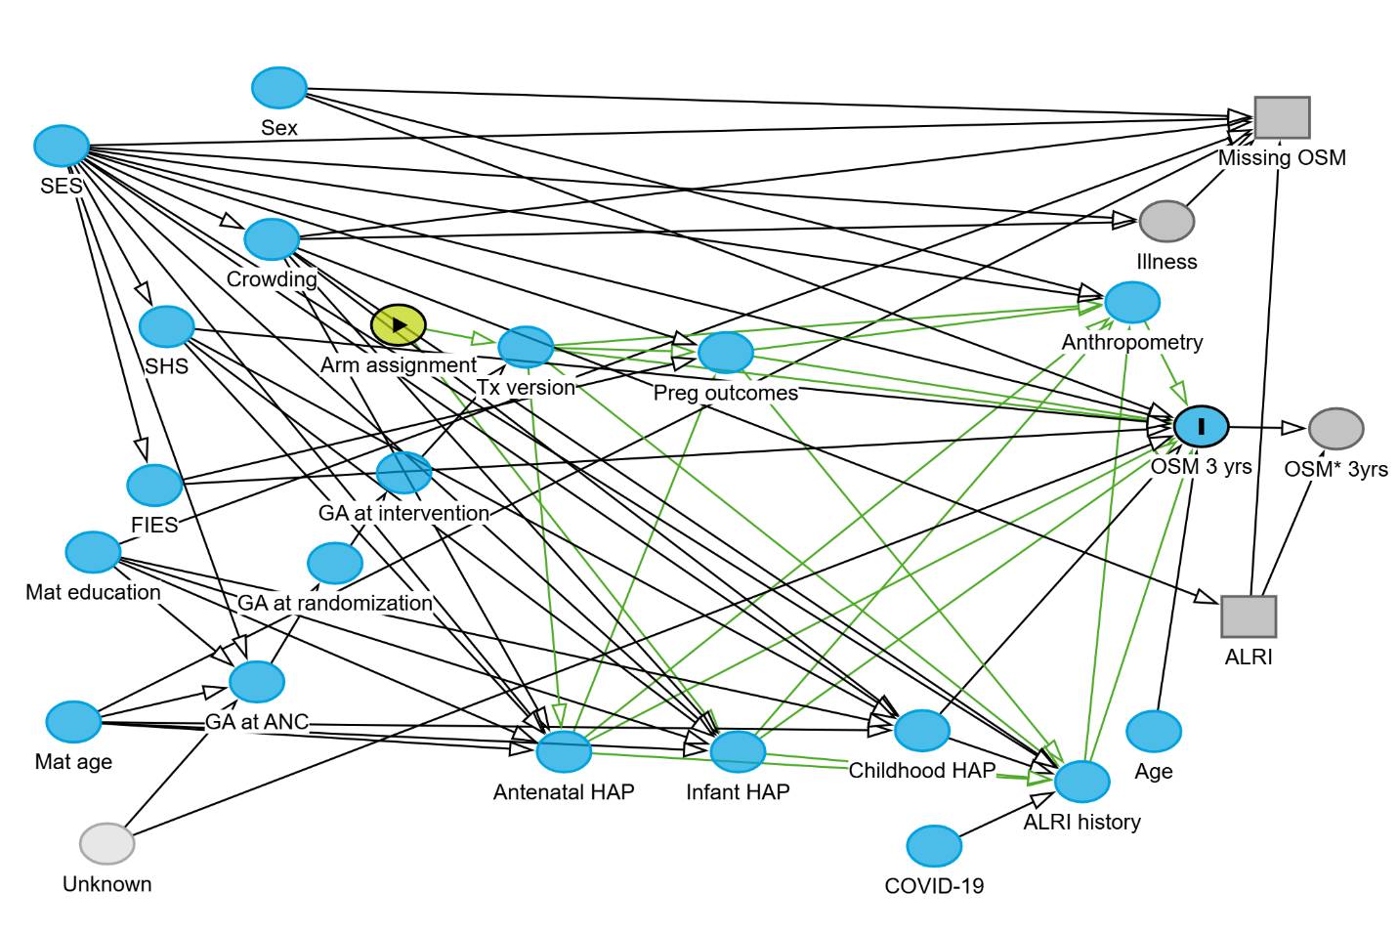

dag {
"ALRI history" [pos="-0.583,0.921"]
"Antenatal HAP" [pos="-1.140,0.883"]
"Arm assignment" [exposure,pos="-1.318,0.340"]
"COVID-19" [pos="-0.742,1.003"]
"Childhood HAP" [pos="-0.755,0.856"]
"GA at ANC" [pos="-1.470,0.794"]
"GA at intervention" [pos="-1.312,0.528"]
"GA at randomization" [pos="-1.386,0.643"]
"Infant HAP" [pos="-0.953,0.883"]
"Mat age" [pos="-1.667,0.845"]
"Mat education" [pos="-1.646,0.629"]
"Missing OSM" [selected,pos="-0.368,0.076"]
"OSM 3 yrs" [outcome,pos="-0.455,0.469"]
"OSM* 3yrs" [pos="-0.310,0.472"]
"Preg outcomes" [pos="-0.966,0.375"]
"Tx version" [pos="-1.181,0.368"]
ALRI [selected,pos="-0.404,0.711"]
Age [pos="-0.506,0.857"]
Anthropometry [pos="-0.529,0.311"]
Crowding [pos="-1.454,0.231"]
FIES [pos="-1.580,0.544"]
Illness [pos="-0.492,0.208"]
SES [pos="-1.680,0.112"]
SHS [pos="-1.567,0.342"]
Sex [pos="-1.446,0.038"]
Unknown [latent,pos="-1.631,1.000"]
"ALRI history" -> "OSM 3 yrs"
"ALRI history" -> Anthropometry
"Antenatal HAP" -> "ALRI history"
"Antenatal HAP" -> "OSM 3 yrs"
"Antenatal HAP" -> "Preg outcomes"
"Antenatal HAP" -> Anthropometry
"Arm assignment" -> "Infant HAP"
"Arm assignment" -> "Tx version"
"COVID-19" -> "ALRI history"
"Childhood HAP" -> "ALRI history"
"Childhood HAP" -> "OSM 3 yrs"
"GA at ANC" -> "GA at randomization"
"GA at intervention" -> "Tx version"
"GA at randomization" -> "GA at intervention"
"Infant HAP" -> "ALRI history"
"Infant HAP" -> "OSM 3 yrs"
"Infant HAP" -> Anthropometry
"Mat age" -> "Antenatal HAP"
"Mat age" -> "Childhood HAP"
"Mat age" -> "GA at ANC"
"Mat age" -> "Infant HAP"
"Mat age" -> "Missing OSM"
"Mat education" -> "Antenatal HAP"
"Mat education" -> "Childhood HAP"
"Mat education" -> "GA at ANC"
"Mat education" -> "Infant HAP"
"Mat education" -> "Missing OSM"
"OSM 3 yrs" -> "OSM* 3yrs"
"Preg outcomes" -> "ALRI history"
"Preg outcomes" -> "OSM 3 yrs"
"Preg outcomes" -> Anthropometry
"Tx version" -> "ALRI history"
"Tx version" -> "Antenatal HAP"
"Tx version" -> "OSM 3 yrs"
"Tx version" -> "Preg outcomes"
"Tx version" -> Anthropometry
ALRI -> "Missing OSM"
ALRI -> "OSM* 3yrs"
Age -> "OSM 3 yrs"
Anthropometry -> "OSM 3 yrs"
Crowding -> "ALRI history"
Crowding -> "Antenatal HAP"
Crowding -> "Childhood HAP"
Crowding -> "Infant HAP"
Crowding -> "Missing OSM"
Crowding -> ALRI
Crowding -> Illness
FIES -> "OSM 3 yrs"
FIES -> "Preg outcomes"
Illness -> "Missing OSM"
SES -> "ALRI history"
SES -> "Antenatal HAP"
SES -> "Childhood HAP"
SES -> "GA at ANC"
SES -> "Infant HAP"
SES -> "Missing OSM"
SES -> "OSM 3 yrs"
SES -> "Preg outcomes"
SES -> Anthropometry
SES -> Crowding
SES -> FIES
SES -> Illness
SES -> SHS
SHS -> "Antenatal HAP"
SHS -> "Childhood HAP"
SHS -> "Infant HAP"
SHS -> "OSM 3 yrs"
Sex -> "Missing OSM"
Sex -> "OSM 3 yrs"
Sex -> Anthropometry
Unknown -> "GA at ANC"
Unknown -> "OSM 3 yrs"
}

Figure E2: Effect of LPG intervention on lung oscillometry at age 3 years in cmH₂O*S/L by oscillometry quality control method and alternative covariate adjustment
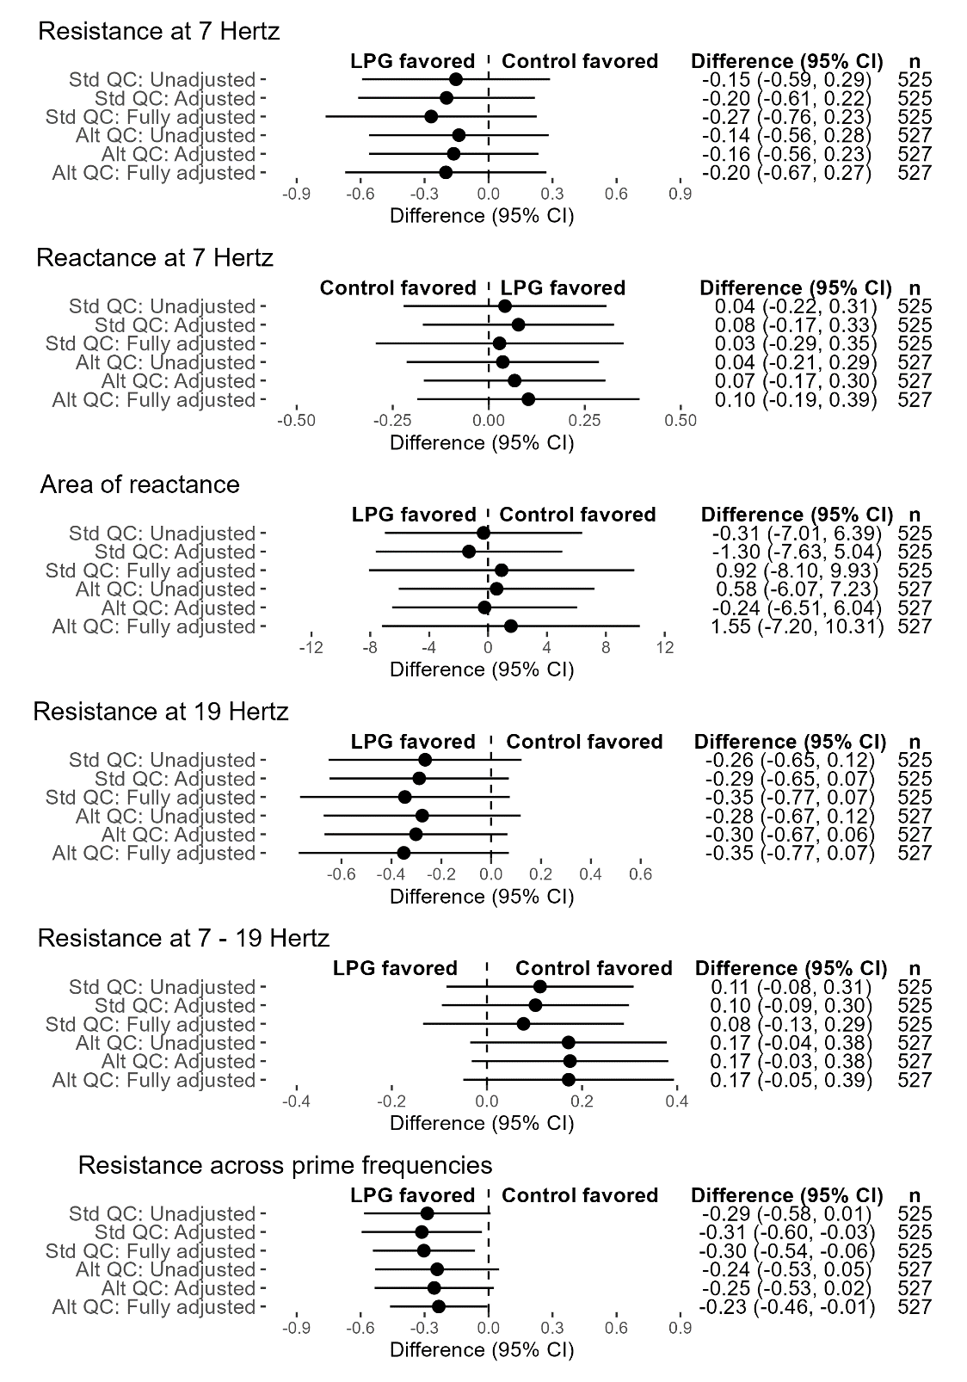
The figure shows the main, unadjusted, and fully adjusted models using the standard measurement quality control (Std QC) method or an alternative quality control (Alt QC) method.

Figure E3: Effect of LPG intervention on lung oscillometry at age 3 or 4 years in cmH₂O*S/L by oscillometry quality control method and alternative covariate adjustment
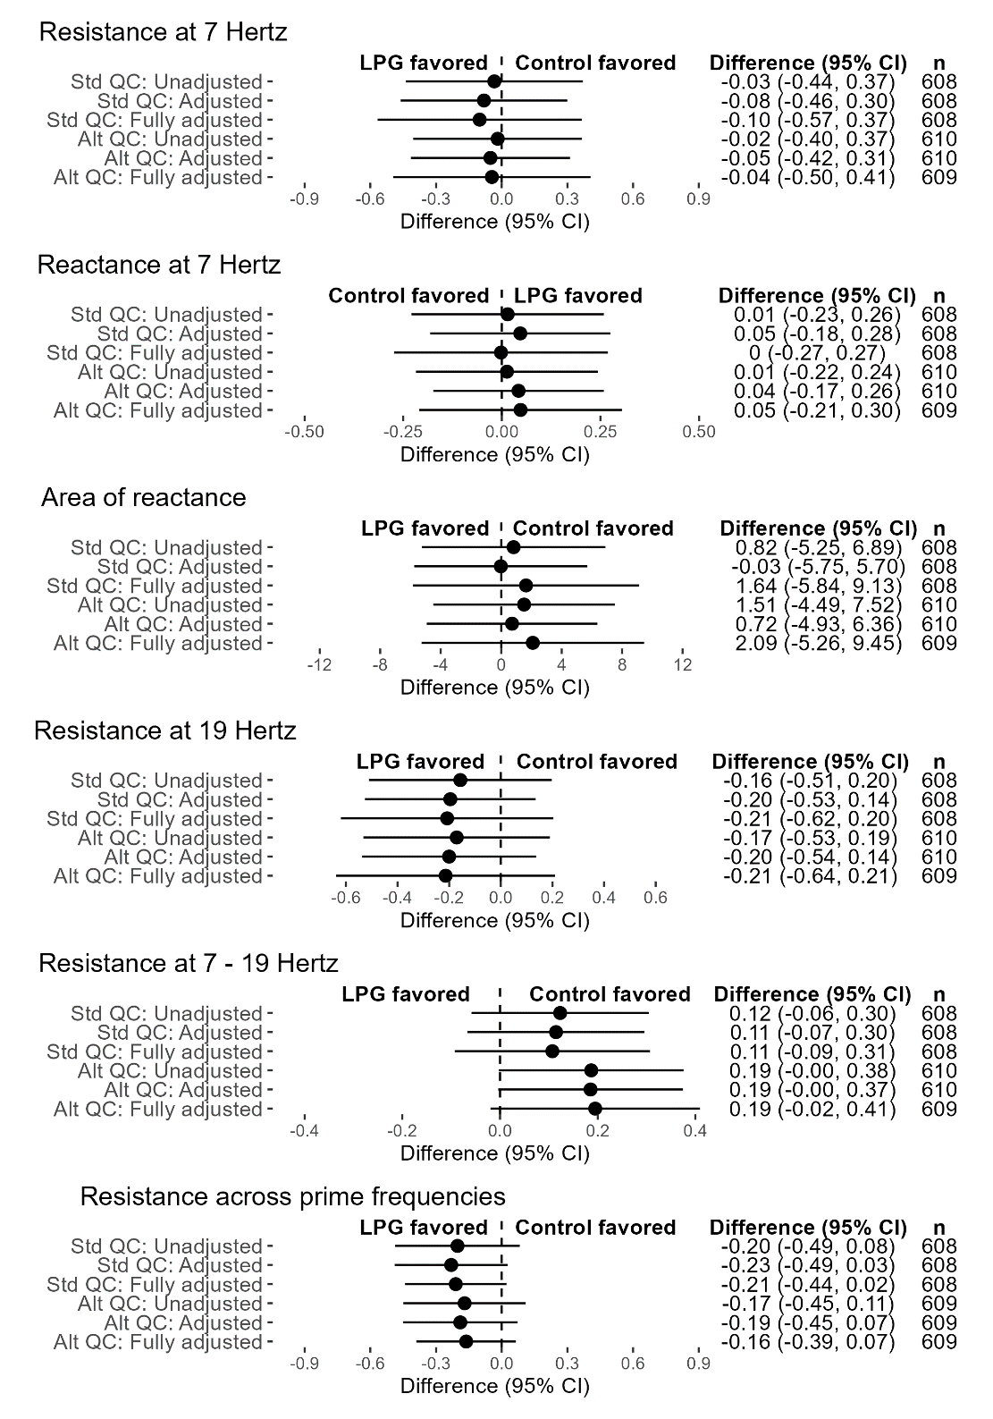
The figure shows the main, unadjusted, and fully adjusted models using the standard measurement quality control (Std QC) method or an alternative quality control (Alt QC) method.

References
1. Beydon N, Davis SD, Lombardi E, Allen JL, Arets HG, Aurora P, Bisgaard H, Davis GM, Ducharme FM, Eigen H, Gappa M, Gaultier C, Gustafsson PM, Hall GL, Hantos Z, Healy MJ, Jones MH, Klug B, Lodrup Carlsen KC, McKenzie SA, Marchal F, Mayer OH, Merkus PJ, Morris MG, Oostveen E, Pillow JJ, Seddon PC, Silverman M, Sly PD, Stocks J, Tepper RS, Vilozni D, Wilson NM, American Thoracic Society/European Respiratory Society Working Group on I, Young Children Pulmonary Function T. An official American Thoracic Society/European Respiratory Society statement: pulmonary function testing in preschool children. Am J Respir Crit Care Med 2007; 175: 1304-1345.
2. King GG, Bates J, Berger KI, Calverley P, de Melo PL, Dellaca RL, Farre R, Hall GL, Ioan I, Irvin CG, Kaczka DW, Kaminsky DA, Kurosawa H, Lombardi E, Maksym GN, Marchal F, Oppenheimer BW, Simpson SJ, Thamrin C, van den Berge M, Oostveen E. Technical standards for respiratory oscillometry. Eur Respir J 2020; 55.
3. Kaminsky DA, Simpson SJ, Berger KI, Calverley P, de Melo PL, Dandurand R, Dellaca RL, Farah CS, Farre R, Hall GL, Ioan I, Irvin CG, Kaczka DW, King GG, Kurosawa H, Lombardi E, Maksym GN, Marchal F, Oostveen E, Oppenheimer BW, Robinson PD, van den Berge M, Thamrin C. Clinical significance and applications of oscillometry. Eur Respir Rev 2022; 31.
4. Mori K, Shirai T, Mikamo M, Shishido Y, Akita T, Morita S, Asada K, Fujii M, Suda T, Chida K. Colored 3-dimensional analyses of respiratory resistance and reactance in COPD and asthma. COPD 2011; 8: 456-463.
5. Ling Y, Si M, Niu Y, Han Y, Xu Y. The predictive value of impulse oscillometry for asthma exacerbations in childhood: A systematic review and meta-analyses. Pediatr Pulmonol 2021; 56: 1850-1856.
6. Deprato A, Ferrara G, Bhutani M, Melenka L, Murgia N, Usmani OS, Lacy P, Moitra S. Reference equations for oscillometry and their differences among populations: a systematic scoping review. Eur Respir Rev 2022; 31.
7. Agyapong PD, Jack D, Kaali S, Colicino E, Mujtaba MN, Chillrud SN, Osei M, Gennings C, Agyei O, Kinney PL, Kwarteng A, Perzanowski M, Dwommoh Prah RK, Tawiah T, Asante KP, Lee AG. Household Air Pollution and Child Lung Function: The Ghana Randomized Air Pollution and Health Study. Am J Respir Crit Care Med 2023.
8. Zeng J, Chen Z, Hu Y, Hu Q, Zhong S, Liao W. Asthma control in preschool children with small airway function as measured by IOS and fractional exhaled nitric oxide. Respir Med 2018; 145: 8-13.

