Appendix A

CREDI data cleaning
Oscar de León and Brigitte Pfluger

Extensive work was performed to clean and manage the raw CREDI data collected in the HAPIN trial. This was done to ensure that the early child development assessments followed the data collection and analysis guidelines from the CREDI development team.

1 CREDI assessment in HAPIN
The CREDI was evaluated in HAPIN using the C35 form, which contained the four groups of questions listed in the table below. Questions in the LMH, B, and PSS groups should all be answered, so any item without a response should be considered as missing.
Table A1: Questions included in the HAPIN form c35

group | questions | items | description
LMH | 9 | LMH 1-9 | CREDI long form child mental health
B | 18 | B 1-12 | Family care indicators
PSS | 10 | PSS 1-10 | Maternal Perceived Stress Scale
LF | 108 | LF 1-108 | CREDI long form questions

The starting point in the LF group is age-specific, so it should be checked whether an item should have been answered or left out based on the child age at the visit. Age specific start points are listed below.
Table A2: Starting point in the CREDI long form for each age group

ages (months) items

0 to < 6 Start with LF 1
6 to < 12 Start with LF 6
12 to < 18 Start with LF 11
18 to < 24 Start with LF 29
24 to < 30 Start with LF 39
30 to < 36 Start with LF 52

The interviewer should have stopped after getting 5 consecutive “No” answers, so any responses recorded after that should not be included in the scoring. Incorrectly stopping before that point results in a censored questionnaire, and those cases should be noted. Starting at a later item than required for the child’s age results in a censored questionnaire, and those cases should be noted. The “Don’t know” answer should not be common, as for scoring it is basically a missing answer, so patterns of this answer are also of interest. Items LF9 and LF102 are reverse coded items (a “Yes” reduces the score and should be counted in the runs of “No” for stopping).

2. Overview of the collected CREDI data

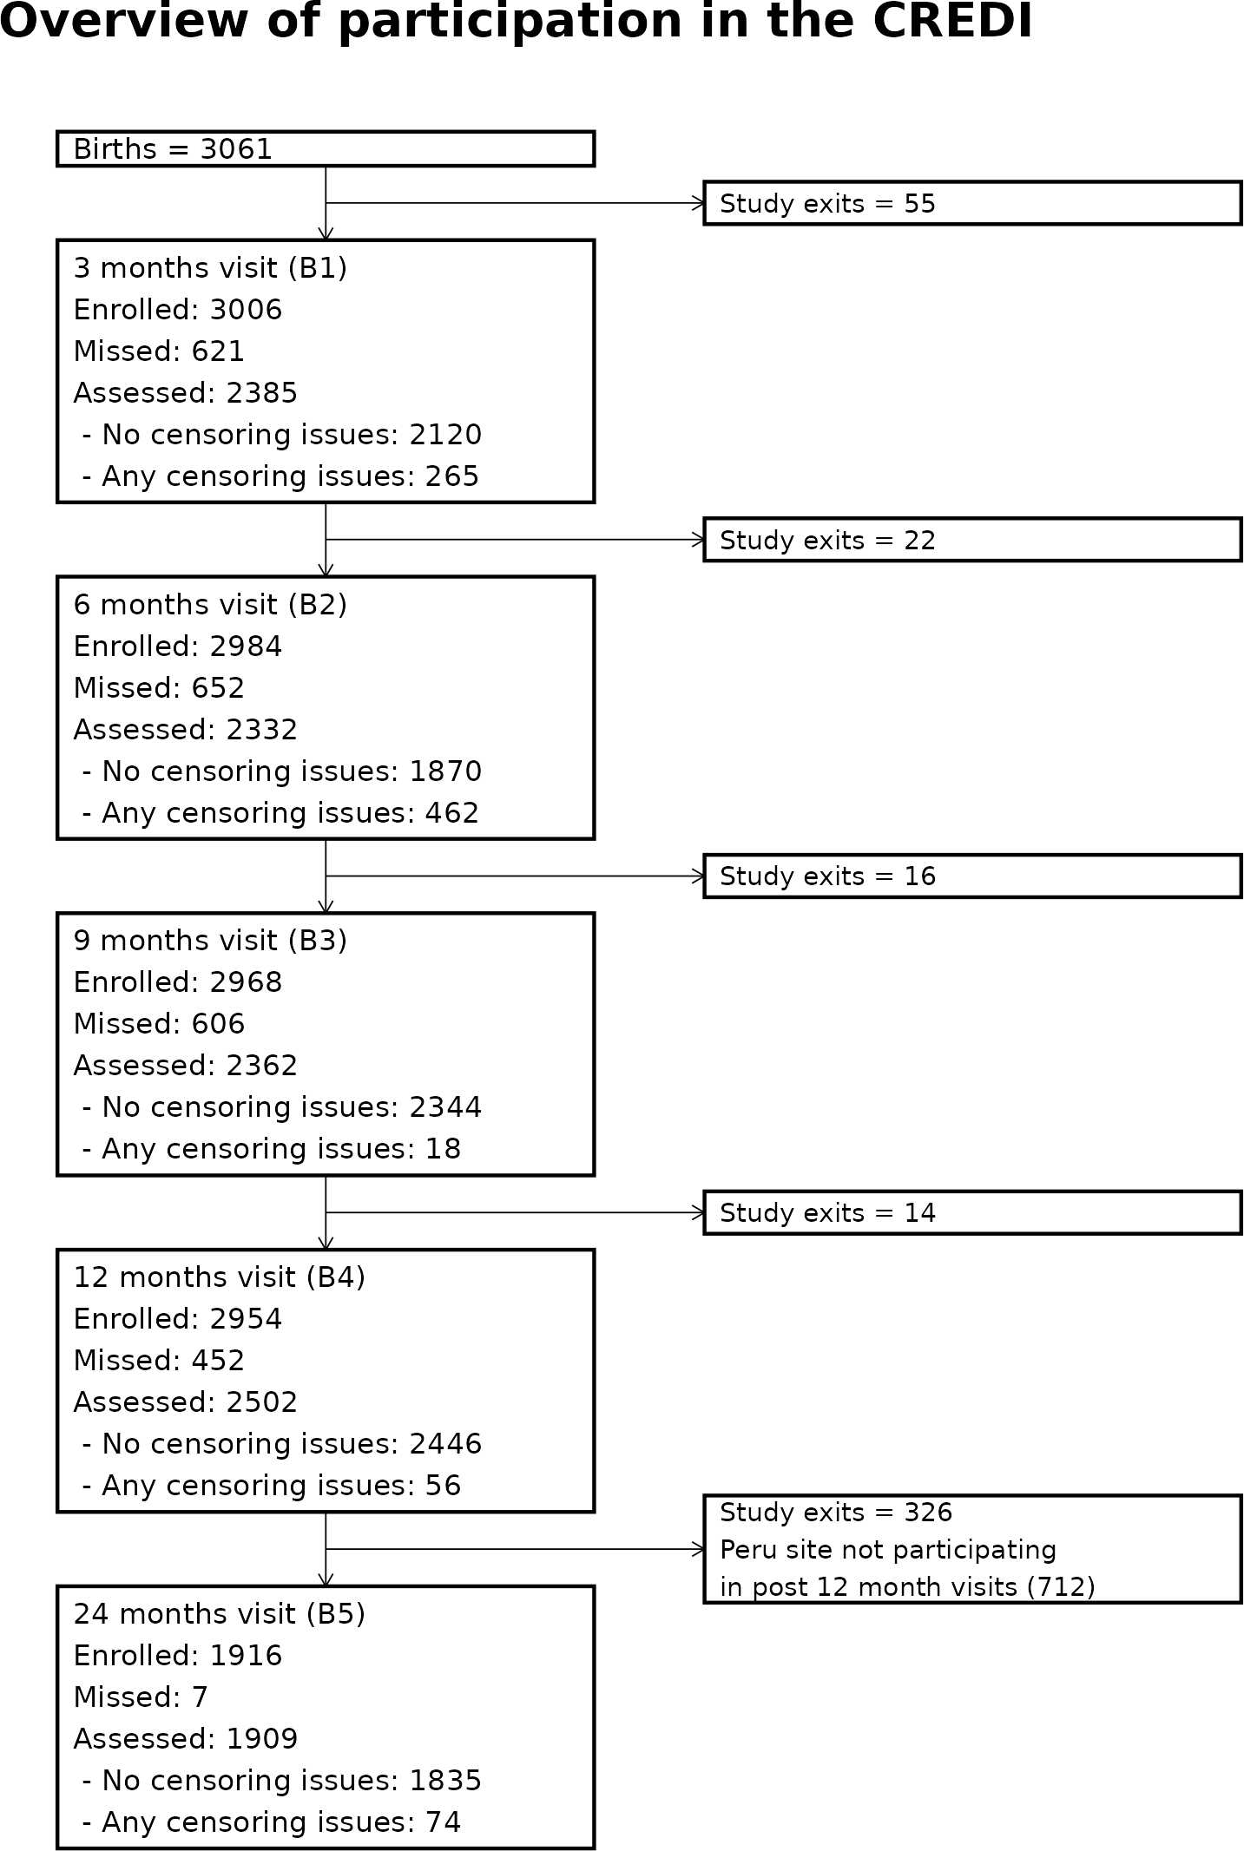
The attrition diagram in the following page shows the overall starting pool of HAPIN children (live births) available for CREDI assessment, with the study exits that happened between each pair of consecutive visits. For each B visit it shows how many children were still enrolled in the study, how many of them were missed or assessed, and how many of the assessments resulted in censored forms. A form is considered censored if it has any issues that result in missing items, which means that the CREDI score we can calculate using the data is only a lower bound of the score we would calculate if responses were available for all the relevant items. Additional details about these issues are presented later in this report.

3. Scheduling
CREDI visits were planned with the same scheduling as the anthropometry visits, which had a +/- 14 day visit windows around ages 3, 6, 9, and 12 months, and a +/- 90 day visit window around age 24 months (with a preferred visit window of +/- 28 days).
Based on the available data, the table below lists the number of visits when any C35 data was recorded. Timing is calculated based on the birth date for each child, and the expected day when it should have happened corresponding to ages 3, 6, 9, 12, and 24 months, plus/minus the visit windows mentioned above.

Months are defined as 365.25 / 12 days, and the expected visit day is defined as the day during which the exact age in months happened. Visits labeled as missed correspond to households for which a visit was expected, but no C35 data is available. If the participant left the study before the beginning of a visit window, the data for that window is not available either.

Table A3: CREDI visit timing for each IRC, n (%). Timeliness calculated based on the exact age in days, and the expected visit windows in days.

timing | Guatemala | India | Peru | Rwanda | Total
on time | 2740 (71.2) | 3265 (84.3) | 1697 (57.1) | 2612 (67.6) | 10314 (70.8)
too early | 11 (0.3) | 104 (2.7) | 1 (0) | 74 (1.9) | 190 (1.3)
too late | 276 (7.2) | 279 (7.2) | 107 (3.6) | 324 (8.4) | 986 (6.8)
exit before visit window started | 141 (3.7) | 179 (4.6) | 99 (3.3) | 315 (8.2) | 734 (5)
missed | 682 (17.7) | 48 (1.2) | 1068 (35.9) | 540 (14) | 2338 (16.1)

Of note, several C35 forms from the Guatemala and Peru IRCs were submitted to REDCap with at least some of the auxiliary data (CREDI date, the required date of birth, age at visit, or data from the LMH, B, and PSS groups) but no data for the CREDI LF, as shown in the table below. This was reportedly done to record the attempt to perform the CREDI assessment.

Table A4: Forms submitted to RedCap without CREDI data

irc B1 B2 B3 B4

Guatemala 131 180 177 114
Peru 243 248 234 174

All of those empty forms were submitted during the initial COVID-19 lockdown in Guatemala (2020-03-25 to 2020-07-02) but the period was more spread out in Peru, as shown in the figure below. The forms from Peru that were submitted without CREDI LF data did have data for the other question groups (LMH, B, and PSS). These forms were considered as missed visits.

Figure A1. Missed CREDI assessments during COVID lockdowns
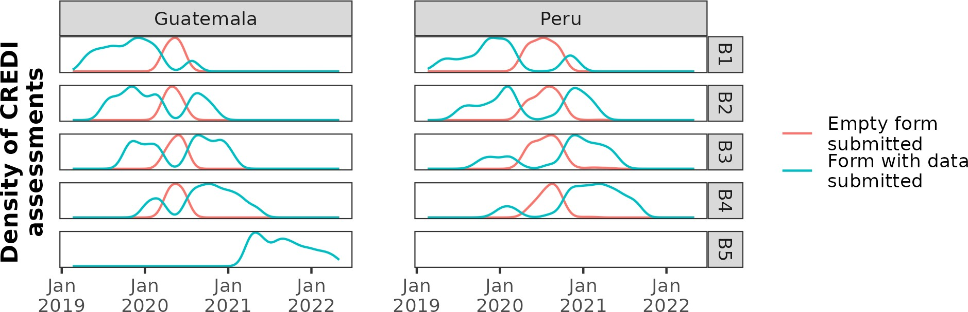

3.1 Missed CREDI assessments
The tables below show the number of CREDI assessments for which no C35 data at all is available in the dataset. Some were missed because the participant left the study before the study visit window started (labeled as exit before visit window started), but others could still have been performed because the participant was still in the study (labeled as missed).

Total assessments
Table A5: Distribution of missed CREDI assessments by IRC and timepoint, n (% of those enrolled at that timepoint)

Type | Visit | Guatemala | India | Peru | Rwanda | Total
missed | B1 | 161 (21.2) | 18 (2.4) | 302 (41.5) | 140 (18.5) | 621 (20.7)
 | B2 | 202 (26.9) | 14 (1.8) | 304 (42.3) | 132 (17.6) | 652 (21.8)
 | B3 | 194 (25.9) | 12 (1.6) | 279 (39) | 121 (16.3) | 606 (20.4)
 | B4 | 121 (16.3) | 4 (0.5) | 183 (25.7) | 144 (19.5) | 452 (15.3)
 | B5 | 4 (0.6) |  |  | 3 (0.5) | 7 (0.6)
 | Total | 682 (18.4) | 48 (1.6) | 1068 | 540 (15.2) | 2338 (17.7)
 |  |  |  | (37.2)
exit before visit
window started | B1 | 12 (1.6) | 11 (1.4) | 16 (2.2) | 16 (2.1) | 55 (1.8)
 | B2 | 19 (2.5) | 13 (1.7) | 24 (3.3) | 21 (2.8) | 77 (2.6)
 | B3 | 22 (2.9) | 14 (1.8) | 28 (3.9) | 29 (3.9) | 93 (3.1)
 | B4 | 26 (3.5) | 15 (2) | 31 (4.4) | 35 (4.7) | 107 (3.6)
B5 62 (8.8) 126 (19.4) 214 (38.3) 402 (21)
Total 141 (3.8) 179 (4.8) 99 (3.4) 315 (8.9) 734 (5.3)

The increased percentage of households with exits before B5 are due to delays in approvals in India and financial issues in Rwanda. Most missing visits correspond to different households, but a few households have more than 1 missing visit (n = 755), as shown in the table below. A total of 84 households missed all 5 (Guatemala, India, Rwanda) or 4 (Peru) c35 visits, so no CREDI data is available for those.

Table A6: Distribution of the number of assessments missed per household by IRC

Number of assessments
missed | Guatemala | India | Peru | Rwanda | households | missed
0 | 171 | 623 | 115 | 176 | 1085 | 0
1 | 458 | 122 | 201 | 440 | 1221 | 1221
2 | 104 | 13 | 341 | 111 | 569 | 1138
3 | 9 | 3 | 60 | 17 | 89 | 267
4 | 10 |  | 26 | 3 | 39 | 156
5 | 18 | 14 |  | 26 | 58 | 290

Total
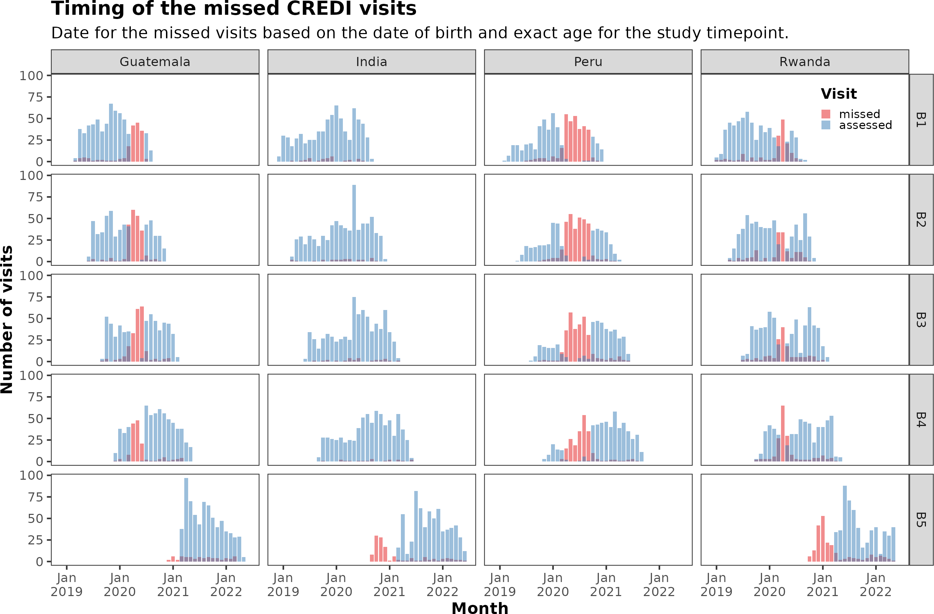

3.2 Visits outside of the window
A total of 1176 (10.2%) visits were conducted outside of the scheduling window. The table below shows the distribution of visits given how much they were outside of the scheduled window. Child ages were calculated using the CREDI visit date and the actual date of birth.
Table A7: Detailed distribution of visits given their timing, n (%)
Timing | Guatemala | India | Peru | Rwanda
Up to 1 month too early | 11 (0.3) | 104 (2.7) | 1 (0) | 74 (1.9)
Within scheduled window | 2740 (71.2) | 3265 (84.3) | 1697 (57.1) | 2612 (67.6)
Up to 1 month too late | 246 (6.4) | 257 (6.6) | 104 (3.5) | 307 (7.9)
Up to 2 months too late | 25 (0.6) | 18 (0.5) | 3 (0.1) | 13 (0.3)
Up to 3 months too late More than 3 months too late | 5 (0.1) | 3 (0.1) |  | 4 (0.1)
No CREDI visit | 823 (21.4) | 227 (5.9) | 1167 (39.3) | 855 (22.1)

1 (0)

The exact divergence from the scheduled visit times can be seen in the figure below. Points are scattered horizontally to reduce the over plotting, but the variability of interest is on the vertical axis. It seems that the pattern is similar for every IRC, except that Guatemala is skewed towards being too early for 24-month visits (as confirmed by the density plot further down).
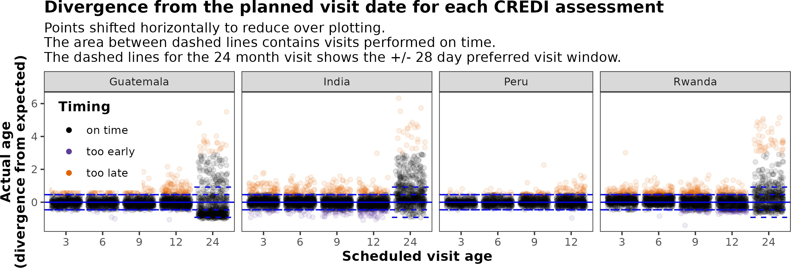

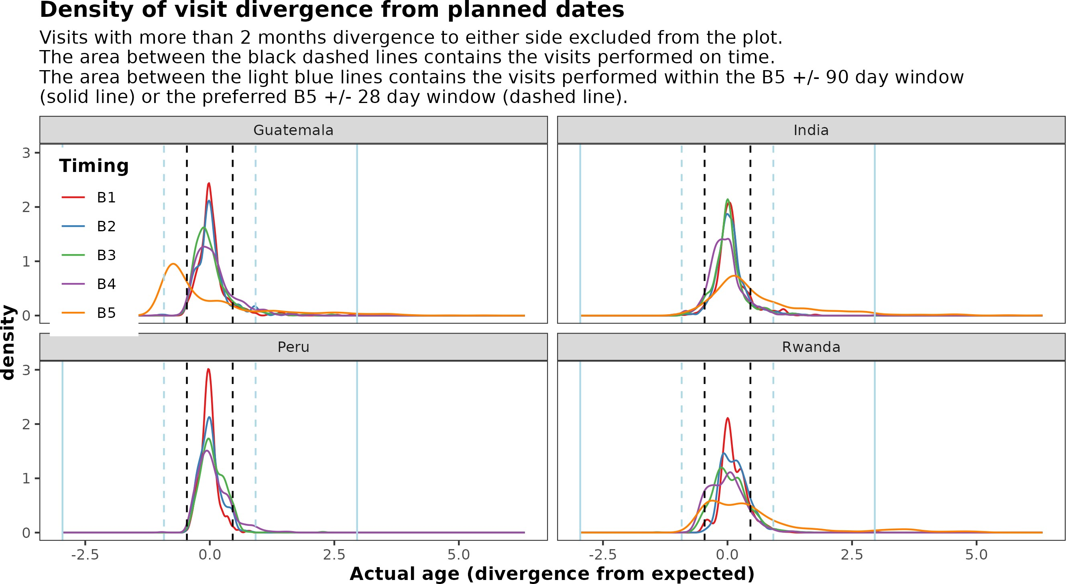

4. Response validity

4.1 Reverse coded items
For items LF9 and LF102, the interviewer had to select in RedCap the literal answer reported by the participant but consider it recoded for checking the stopping pattern (i.e. a literal “Yes” counts as a “No”, and vice versa). This could result in stopping errors, which are discussed in the next section. It is expected that LF9 and LF102 should have more “No” answers, so we should check if the large number of “Yes” for LF102 in India is correct:

Table A8: Frequency of each response for reverse coded items

item variable value Guatemala India Peru Rwanda

LF9 c35_fist | Don’t know | 2 |  | 8 | 1
LF9 c35_fist | No | 1904 | 2963 | 1519 | 2365
LF9 c35_fist | Yes | 155 | 35 | 276 | 84
LF102 c35_impulsive Don’t know 3
LF102 c35_impulsive No |  | 64 | 96 | 1 | 7
LF102 c35_impulsive Yes |  | 44 | 404 |  | 14
\\

The HAPIN trial REDCap implementation of the long form CREDI questionnaire automatically reverse coded items LF9 and LF102 upon data entry, so that a “Yes” answer by the caregiver would be recorded as a 0 (otherwise meaning “No”). This is important to consider for data management when using the raw REDCap data (stored as 0, 1, etc.) where a 0 represents a “Yes” response for the reverse coded items (data is reverse coded), and when using the coded REDCap data (stored as No, Yes, etc.) where a “Yes” represents a “Yes” response (i.e. data is not reverse coded).

4.2 Unexpected and missed items
As stated at the beginning of this document, any items that were not expected should be removed before scoring. Based on the age-dependent starting points and the stopping pattern discussed in section 1, it is sometimes possible to determine for each form which items should have and which items shouldn’t have been responded. There are three main reasons for data missing at the item level:
    - Interviewer failed to record an answer. These items would be missing anywhere on the form, should not be common, and we know exactly which items are missing.
    - Interviewer used the wrong starting point based on age calculation issues or by mistake. This results in groups of answers missing at the beginning of the LF, and we know exactly which items are missing.
    - Interviewer stopped too early. The stopping pattern was not implemented in the HAPIN REDCap as advised by the CREDI documentation, so it was easier for the interviewers to make this mistake. This mistake might be more likely to happen around LF9 or LF102, because of the requirement of thinking about the recoded answer.
Additionally, if the stop pattern is not found before the end of the questionnaire (called hitting the ceiling) the child could have conceivably obtained a higher score if additional, more difficult items were available. Cases where the assessment “hit the ceiling” are noted as well under the issues that result in censoring, since the score in that situation represents a lower bound of the latent characteristic we are trying to measure. The “Don’t know” answers are effectively missing data (as those can’t be used to calculate the score) and also result in potential censoring of the CREDI score. The table below shows the number of forms with each of these issues, by visit. A form might have more than one of the issues.

Table A9: Summary of issues in the CREDI data. Most issues are not mutually exclusive, so the total number of issues can be greater than the number of forms with issues.

Forms with. . . | B1 | B2 | B3 | B4 | B5
Any issue that results in a | 265 (11.1) | 462 (19.8) | 18 (0.8) | 56 (2.2) | 74 (3.9)
censored form
- Missed items at the beginning | 6 (0.3) | 440 (18.9) | 0 (0) | 45 (1.8) | 20 (1)
- Incorrect stop due to LF9 | 245 (10.3) | 5 (0.2) | 1 (0) | 0 (0) | 0 (0)
- Incorrect stop due to LF102 | 0 (0) | 0 (0) | 0 (0) | 0 (0) | 50 (2.6)
- Incorrect stop at another point | 15 (0.6) | 19 (0.8) | 17 (0.7) | 11 (0.4) | 5 (0.3)
- Less than 5 items answered | 0 (0) | 0 (0) | 0 (0) | 0 (0) | 0 (0)
Issues that do not result in | 317 (13.3) | 196 (8.4) | 224 (9.5) | 1080 | 953 (49.9)
censoring  - Hit ceiling 0 (0) |  | 0 (0) | 0 (0) | (43.2)  0 (0) | 425 (22.3)
- Includes “Don’t know” answers 66 (2.8) |  | 71 (3) | 119 (5) | 125 (5) | 106 (5.6)
- Missed items in the middle 33 (1.4) |  | 34 (1.5) | 50 (2.1) | 55 (2.2) | 21 (1.1)
- Unexpected items before starting 0 (0) |  | 10 (0.4) | 6 (0.3) | 948 (37.9) | 356 (18.6)
- Unexpected items after end 231 (9.7) |  | 84 (3.6) | 61 (2.6) | 46 (1.8) | 140 (7.3)

5 Other information
5.1 Structure of the dataset

The dataset has one row per CREDI form, and includes variables not related to the B series timepoints adding information about births [c30_sex (child sex at birth), and c30_dob (date of birth), Table 3], main study exits [e3_ variables, Table 4], and enrollment to follow-up study after the 12 months visit [s4_ variables, Table 5]. Exit reason “Study Completion” in Table 4 applies to all households that were still in the study at the 12 months visit (B4) and does not necessarily imply/preclude participation in the follow-up study.

Table A10: Number of births in each IRC

irc | births
Guatemala | 770
India | 775
Peru | 743
Rwanda | 773

Table A11: Reasons for main study exits (birth to 12 months visit)

Exit reason | Guatemala | India | Peru | Rwanda
Lost to follow-up |  |  |  | 3
Moved away from study area | 2 | 5 5 16
Participant voluntary withdrawal | 4 | 10 3
Withdrawn by study team |  |  | 1 | 2
Deceased | 20 | 12 | 15 | 17
Study Completion | 744 | 758 | 710 | 732
Other |  |  | 2

Table A12: Participation in follow-up study

irc | Consented to follow-up study | Declined participation in follow-up study
Guatemala | 708 | 40
India | 649 | 18
Rwanda | 557 | 22

Besides the IRC, time point, and household ID, the rest of the columns exclusively represent data from the c35 form:
Table A13: Number of variables in the CREDI dataset
c35 hhid irc timepoint 151 1 1 1

Concordance checks
To calculate the child age at each CREDI evaluation, the interviewer recorded the date of birth (DOB) of the child each time. Errors when entering the data in the CREDI form (c35) could result in errors in the calculated age or the questionnaire flow. The DOB entered in form C30 (birth outcome form) is considered the reference DOB for this QC. The source for the DOB is recorded in C30 [c30_verify], but not considered here since data cleaning for the DOB already was part of the main birth outcome papers. The table below shows all the DOB entry errors found in the most recent export of C35 data. It is likely that other errors occurred but were detected and fixed during previous data QC runs. Most current errors affect a single digit in the entered date (resulting in varying deviations from the actual date, depending on the position of the wrong digit), except those from Peru. It is checked in a later section whether these errors resulted in an invalid test flow.

Table A14: Errors in the date of birth (DOB) entered into the C35 form

irc | hhid | timepoint | DOB recorded in c35 | DOB recorded in c30 | Actual birth was
Guatemala | 33578 | B3 | 2020-02-02 | 2020-02-01 | 1 days earlier
Guatemala | 33578 | B4 | 2020-02-02 | 2020-02-01 | 1 days earlier
Guatemala | 33599 | B3 | 2020-03-24 | 2020-03-23 | 1 days earlier
Guatemala | 33599 | B4 | 2020-03-24 | 2020-03-23 | 1 days earlier
Guatemala | 35104 | B4 | 2019-10-20 | 2019-10-19 | 1 days earlier
Guatemala | 33518 | B4 | 2019-12-19 | 2019-12-09 | 10 days earlier
Guatemala | 33623 | B3 | 2020-05-05 | 2020-04-05 | 30 days earlier
Guatemala | 33482 | B4 | 2019-12-12 | 2019-12-14 | 2 days later
Guatemala | 33464 | B4 | 2019-11-16 | 2019-11-26 | 10 days later
Guatemala | 33619 | B4 | 2019-04-04 | 2020-04-04 | 1 years later
Guatemala | 33639 | B4 | 2019-04-08 | 2020-04-08 | 1 years later
Guatemala | 35145 | B4 | 2019-04-16 | 2020-04-16 | 1 years later
Peru | 45059 | B3 | 2020-06-24 | 2020-04-29 | 1.8 months earlier
Peru | 51068 | B4 | 2020-03-03 | 2020-01-09 | 1.8 months earlier

Interviewer checks

Table A15. Variability in CREDI scores due to the assessor¹
Scores | Intraclass correlation coefficient
Overall raw score | 0.18
Overall z-score | 0.11
¹Model adjusted for country

About 11-18% of the variation in the CREDI was due to the assessor, so we ran mixed effects models to account for the assessor clustering to assess this influence on the intervention effect. There was no appreciable effect on the coefficients or the 95% CI compared with Table 4.

Model | Estimate (95% CI)
Overall | 0.04 (-0.019, 0.088)
Cognitive | 0.02 (-0.038, 0.078)
Motor | 0.03 (-0.024, 0.076)
Language | 0.03 (-0.024, 0.076)
Social-emotional | 0.02 (-0.049, 0.081)
¹ Mixed-effects model (REML); fixed effect: intervention; and random intercept: assessor-by-site.
Table A16. Effect of intervention on CREDI z-score¹

Appendix B

Socioeconomic status score

Each household’s data was collected on items such as ownership of durable goods, access to utilities and services, and housing quality indicators. To generate a Socioeconomic Status (SES) score, we conducted an inventory of assets (radio, color TV, phone, personal computer, watch, air conditioning, heating, bookshelf, sofa, dining room table, mattress, microwave, pressure cooker, blender, refrigerator, washing machine, bicycle, motorcycle, car, tractor or other large farming equipment), access to infrastructural services (electricity, cable TV, internet, improved toilets, improved water sources, bank account), and improved house characteristics (roof, floor, and wall materials, windows with blinds). This inventory was based on the Equity Tool106. These variables were then standardized and subjected to Principal Component Analysis (PCA), a statistical technique that reduces the dimensionality of the data while retaining most of the variability. The first principal component, which explains the largest variance in the data, was used to construct the SES score, effectively summarizing the socioeconomic status of each household.
We used descriptive statistics to evaluate the performance of the SES score. Figure SE.1 shows the distribution according to the number of each of the components evaluated in the inventory described above. While the number of improved household characteristics is not particularly well correlated with the SES score, the number of owned appliances and the number of available infrastructural services correlate well with it, suggesting internal consistency.

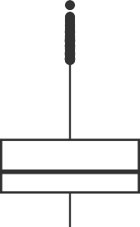
3
Number of improved household characteristics

2

1

0

−1

0 1 2 3 4

3
Number of available infrastructural services
Socioeconomic status score

2

1

0

−1

0 1 2 3 4 5 6


3
Number of owned appliances

2

1

0

−1

0 1 2 3 4 5 6 7 8 9 10 11 12 13 14
Count
Figure B.1: Distribution of SES score based on the components used to generate it.
The panels summarize the number of improved household characteristics, available infrastructural services, and number of appliances owned.

We evaluated the predictive validity of the SES score by describing its distribution across the levels of other variables theoretically related to socioeconomic status, including maternal education, food insecurity, and maternal diet diversity. Figure SE.2 shows that the median SES score decreases for higher levels of household food insecurity, increases for higher levels of maternal minimum dietary diversity, and increases for higher levels of attained maternal education. This matches with the expectations for these variables commonly associated with socioeconomic status, suggesting a good predictive validity for our SES score.

3
Household food insecurity
aternal minimum dietary divers
Highest level of maternal education

2

1
Socioeconomic score

0

−1
None
(0)
Mild (1−3)
Low (0−3)
High (6+)

Level
Missing
Moderate/Severe
(4−8)
Missing
Medium
(4−5)
No formal education
Primary school incomplete
Primary school
complete
Secondary school
incomplete (e.g. high school) Secondary school
complete (e.g. high school)
Vocational
Some college or university
Figure B.2: Distribution of SES score for each level of other variables associated with socioeconomic status.
The panels summarize the SES score for levels of maternal education, household food insecurity, and maternal diet diversity, which are variables we expect to be correlated with socioeconomic status. Maternal minimum dietary diversity adapted from Food and Agriculture Organization of the United Nations Minimum Diet Diversity for Women. The Food and Agriculture Organization Food Insecurity Experience Scale was used to assess food insecurity during the previous 30 days. Boxes for the "Missing" level shown in a lighter shade.

Appendix C

THE HAPIN STUDY
Data Analysis Strategy/Plan

Investigator and Paper Details
Date of plan creation: | 05/30/2023
Proposed paper HAPIN number and title: | HE-14  Effects of a cleaner fuel intervention on child development at 12 months (ITT and exposure response) in the Household Air Pollution Intervention Network trial
Study investigator/first author: | Oscar de León, Lisa Thompson, (co-first)
E-mail: | odeleon@emory.edu, lisa.thompson@emory.edu
Telephone: | (470) 661-2726, (510) 965-7779
Data analyst: | Oscar de León
List of authors (please place a  * by primary contacts for questions): | Oscar de León*, Lisa Thompson* (co-first), Vigneswari Aravindalochanan, Sheela Sinharoy, Miles Kirby, Ajay Pillarisetti, Michael Johnson, Shirin Jabbarzadeh, Anaité Diaz, Kalpana Balakrishnan, William Checkley, Ghislaine Rosa, John McCracken, Kyle Steenland, Dana Barr, Viviane Valdés, Jennifer Peel, Thomas Clasen

Background and Analysis
Paper Research Question(s): | - What is the effect of the intervention on the CREDI scores at 12 months  - What is the association between the exposure to PM2.5, BC, and CO during pregnancy and the first year of life, and the CREDI scores at 12-months
Specific Hypotheses | - Children born to women enrolled in the intervention  arm will have higher CREDI scores at 12 months than children born to women enrolled in the control arm in the HAPIN trial  - The slope of the linear relationship between PM2.5 exposure levels and child development scores is > 0
Endpoints or Outcomes of Interest: | Overall CREDI scores at 12-months, and domain specific CREDI scores for cognitive, motor, language, and social-  emotional aspects of early child development.
Inclusion/Exclusion Criteria for this paper (if focus is a subset of the participants) | This paper will focus on all children enrolled in the study at 12-months, across Guatemala, India, Peru, and Rwanda
Approach to dealing with missing data | Any observation with missing CREDI or exposure data on any variable will be excluded from the main analysis  Postnatal exposure estimates are missing for a large proportion of infants (~40%), using the maternal postnatal exposure to impute the missing infants exposures will be considered in sensitivity analyses (Spearman correlation  >0.85 among valid maternal and infant measures) Imputation of the overall CREDI score based on assessments before 12 months will be considered in sensitivity analyses for infants missing an assessment at 12

 | months.
Variables
 | name | Source  (crf or monitor) | Variable name (see redcap codebook)
Outcome measures | Calculated CREDI score (overall and domain specific) as provided by the CREDI data cleaning team. | Derived variables created by Oscar de León and Brigitte Pluger for the CREDI data cleaning. | C35 variables Variables from the scored CREDI data, including the OVERALL score, and domain specific COG, MOT, LANG, SEM  scores and associated measures of variability.
Exposure Variables (ITT) | Study arm  IRC  randomization strata
Exposure Variables (ER) | PM2.5 CO  Black Carbon | ECM / filters, Lascar CO monitors, derived for EX-0  and EX-1 | PM2.5 CO  Black Carbon
Covariates to check for balance in ITT | Maternal highest completed education level | m10 | m10_educ
 | Family care indicators | C35 | c35_book : c35_draw_who
 | SES (assets) | M11 | derived
Covariates for ITT subgroup analyses | IRC  Gestational age at intervention | Derived | Derived variable, intergrowth
 | Sex of the child | C30 | c30_sex
 | SES (assets) | M11 | derived
Covariates for ER models and subgroup analyses | Maternal age Nulliparity | S1 M13 | s1_self_dob m13_pregnancy1
 | Gestational age at baseline | Derived from M17 | Derived variable, intergrowth
 | Diet diversity | m11 | Derived variable
 | Household food | m11 | Derived variable

 | insecurity score (baseline)
 | Maternal highest completed education level | m10 | m10_educ
 | Gestational age at birth | Derived from C30 and M17 | Derived variable, intergrowth & birth
 | Preterm  Sex of the child, birth weight | Derived from prev.  C30 | Derived variable c30_sex
 | Family care indicators | C35 | c35_book : c35_draw_who
 | Maternal perceived stress | C35 | c35_unexpect : c35_difficulty
 | SES (assets) | M11
 | LAZ at 12 months | C33
Timepoints: We will assess the effect of the intervention (ITT) and the association of exposure to PM2.5, BC, and CO (ER) on the CREDI scores at 12-months (B4). Exposures from the gestational period and the first year of life will be considered.

Descriptive analyses: We will assess missing values in the dataset. Participants missing CREDI scores (overall and domain specific) at 12-months will be excluded. Table 1 below shows the distribution of births, study exits, missed visits, and completed CREDI assessments by IRC and study arm. Participants missing aggregate exposure values for the gestational period or the first year of life will be excluded from the main analysis, and might be included in sensitivity analyses using the maternal exposure. Participants missing values for covariates or variables defining subgroups will be excluded from those specific analyses. Missingness in outcomes, exposures, or covariates will be described given the study arm and randomization strata.

For each study arm we will calculate descriptive statistics for the CREDI scores, and include descriptive statistics for the exposure values corresponding to the participants included in this study. Summary statistics will include mean, standard deviation, median, 25th-75th percentiles, IQR, and minimum-maximum values. Distributions of the CREDI scores and exposure values (log transformed) will be visualized using histograms. For the ITT analysis we will compare the baseline characteristics of included participants between study arm to ensure there are no imbalances that might affect covariates used in the models or sub-group analyses.

Primary and secondary analyses: The primary and secondary analyses are shown in Table 3 and 4 below (using single pollutant models as examples).
Please Outline the Proposed Analytic Strategy

ITT: (table 3)

Model 1 will be a primary ITT analysis using a simple linear regression model, with study arm as the main exposure and IRC strata as covariates. If the model does not fir assumptions for SLR, we will consider transformations as appropriate. If other model assumptions are still not met, a non-parametric approach will be used to evaluate if there is a difference in the distribution of CREDI scores between the study arms (Wilcoxon rank-sum test to compare two independent groups) or the study arms and IRC strata (Kruskal-Wallis rank-sum test to compare more than two groups).

Models described in 2 are secondary analyses corresponding to model 1 but performed for each of the CREDI sub-scales (motor, cognitive, language, and social-emotional).

Models described in 3 correspond to 1 and 2 above but focusing on sub-group analyses.

ER: (table 4)

Model 1 will be a main ER analysis using a simple linear regression model, the exposure to each single pollutant (or multipollutant: PM2.5 and CO, BC and CO), adjusted for maternal education less than highschool, socioeconomic status*, child stimulation at 12 months, infant sex, and breastfeeding

Models 2 and 3 evaluate possible non-linear associations using quartile regression and cubic splines for the exposure.

Model 4 depicts the subgroup analysis for each variable considered for effect modification

Equivalent models will be used for sensitivity analysis using imputed exposure and outcome values

* Socioeconomic status will be a composite index based on an inventory of household characteristics (roof, floor, and wall materials, windows with blinds), appliances and other assets (listed in the supplemental information), access to services (electricity, cable TV, internet, improved toilets, improved water sources, bank account), and crowding

Draft Abstract, Dummy Tables and Graphics:

Draft abstract: (accepted for ISEE, ITT only)
Has 329 words, needs 300 for ISEE. Results and conclusions could focus on overall CREDI scores instead of domain specific, given length of abstract. Draft structured per ISEE guidelines.

Objective: Early Child Development (ECD) encompasses physical, cognitive, social, and emotional changes from birth to early childhood. Exposure to air pollution has been associated with delays across all ECD domains. The Household Air Pollution Intervention Network (HAPIN) trial reduced exposure to air pollution using a liquefied petroleum gas (LPG) intervention, compared to using solid fuels for cooking. Our objective was to evaluate the effect of that intervention on early child development.

Materials and Methods: We used the Caregiver Reported Early Development Instruments (CREDI) to assess ECD at 12 months of age in 2446 children born to trial participants in Guatemala, India, Peru, and Rwanda. We used linear regression to evaluate the effect of the intervention on overall and cognitive, motor, language, or social-emotional domain ECD scores at 12 months under intention to treat, with the study arm as the main covariate. We also evaluated possible effect modification by study site, infant sex, socioeconomic status (SES) or time of intervention.

Results: The intervention did not have a significant effect on the overall ECD score (0.008, 95% CI: -0.06 to 0.07) or on the cognitive, motor, language, or social-emotional sub-domain scores. Subgroup analyses showed lower scores in the cognitive (-0.05, 95% CI: -0.099 to -0.0004) and social-emotional domains (-0.053, 95% CI: -0.105 to - 0.001) among children who received the intervention after 18 weeks gestation, compared to those receiving the intervention earlier. We found a positive association between SES and ECD scores, supporting the construct validity of this assessment tool as observed in other studies.

Conclusion: While the LPG intervention did not have an effect on maternal-reported ECD at 12 months in this trial, our results suggest that earlier interventions could have an increased impact on this critical childhood outcome. (Funded by the NIH and the Bill and Melinda Gates Foundation; ClinicalTrials.gov #NCT02944682)

Table C1. Availability of CREDI scores at 12-months for each study arm and IRC
IRC | Intervention arm |  |  |  | Control arm
IRC | Births | Exits | Missed | Assesed | Births | Exits | Missed | Assesed
Guatemala
India
Peru
Rwanda

Table C2. Descriptive summary of baseline characteristics of pregnant women and birth characteristics of their children included in this study, by study arm
Characteristic | All participants (n= ) | Intervention arm (n= ) | Control arm (n= )
Maternal baseline characteristics
Maternal age
Nulliparity
Diet diversity
Household food insecurity
Highest completed education level
Gestational age at baseline
SES
Maternal perceived stress
Child characteristics
Gestational age at birth
Preterm
Low birth weight
Sex [Female, n (%)]
Family care indicators
LAZ at 12 months

Table C3. Proposed model equations for primary and secondary ITT analyses
Model no. | Analysis | Model equation
Primary model
1 | Simple linear regression | Overall CREDI score = β₀ + β₁Arm + β₁₋₉IRC strata + ε
Secondary models
2 | Equivalent to 1 above, but using each CREDI sub- scale score as dependent variable | CREDI sub-scale score = β₀ + β₁Arm + β₁₋₉IRC strata + ε
Subgroup analyses
3 | Equivalent to 1  and 2 above, stratified by one of IRC, infant sex, gestational age at intervention, and SES level | CREDI score = β₀ + β₁Arm + β₁₋₉IRC strata + βSub-group + ε

Table C4. Proposed model equations for primary and secondary ER analyses
Model no. | Analysis | Model equation
Primary models
1 | Linear model,  e.g. single pollutant | CREDI score = β0 + β1Exposurei + Covariates + εi  Covariates based on minimal confounder + risk factor set
Evaluate non-linear associations
2 | Equivalent to 1 above, using the quartiles of exposure as the predictor variable | CREDI score = β0 + β1ExposureQuartilei + Covariates + εi
3 | Equivalent to 1 above, using cubic splines for the exposure as the predictor variable | CREDI score = β0 + β1CubicSplines(exposurei)+ Covariates + εi
Primary models
4 | Linear model,  e.g. single pollutant | CREDI score = β0 + β1Exposurei + Covariates + εi Covariates based on minimal confounder + risk factor set  Restricted to levels of each variable considered for effect modification

