Supplemental Tables and Figures

Table S1: Characteristics of participants from households with a live birth.

Characteristics
 | Overall  (n=3061) | Guatemala  (n=770) | India  (n=775) | Peru  (n=743) | Rwanda  (n=773)
Maternal factors
Mother’s age [years, median (IQR)] | 24.9 (7.1) | 24.2 (7.1) | 23.5 (5.4) | 25.2 (7.4) | 27.7 (7.1)
Mother’s height [cm, median (IQR)] | 152 (7.9) | 148.3 (7) | 151.2 (7.5) | 152.7 (6.2) | 156.1 (8)
Mother’s body mass index [kg/m2, median (IQR)] | 22.9 (5.1) | 23.3 (4) | 19 (3.7) | 25.6 (4.7) | 22.8 (4)
Mother’s highest level of education completed, n (%)
No formal education or Primary school incomplete | 1001 (32.7) | 367 (47.7) | 275 (35.5) | 32 (4.3) | 327 (42.3)
Primary school complete or Secondary school incomplete | 1052 (34.4) | 300 (39) | 219 (28.3) | 226 (30.4) | 307 (39.7)
Secondary school complete or Vocational or Some college or university | 1008 (32.9) | 103 (13.4) | 281 (36.3) | 485 (65.3) | 139 (18)
Mother’s minimum dietary diversity at baseline, n (%)1
Low | 1724 (56.3) | 527 (68.4) | 601 (77.5) | 74 (10) | 522 (67.5)
Medium | 984 (32.1) | 211 (27.4) | 150 (19.4) | 410 (55.2) | 213 (27.6)
High | 352 (11.5) | 32 (4.2) | 24 (3.1) | 259 (34.9) | 37 (4.8)
Missing | 1 (0) |  |  |  | 1 (0.1)

Pregnancy factors
Nulliparous, n (%)

Yes | 1167 (38.1) | 218 (28.3) | 443 (57.2) | 280 (37.7) | 226 (29.2)
No | 1888 (61.7) | 552 (71.7) | 332 (42.8) | 459 (61.8) | 545 (70.5)
Missing | 6 (0.2) |  |  | 4 (0.5) | 2 (0.3)

Characteristics Overall
 | (n=3061) | (n=770) | (n=775) | (n=743) | (n=773)
Gestational age at baseline [weeks, median (IQR)] | 15.3 (5.1) | 13.9 (4.9) | 16 (4.7) | 15.7 (5.6) | 15.4 (4.4)
Child factors
Gestational age at birth [weeks, median (IQR)] | 39.4 (1.7) | 39.3 (1.7) | 39 (1.7) | 39.4 (1.5) | 40 (1.9)
Preterm, n (%)2
Yes | 173 (5.7) | 50 (6.5) | 51 (6.6) | 36 (4.8) | 36 (4.7)
No | 2888 (94.3) | 720 (93.5) | 724 (93.4) | 707 (95.2) | 737 (95.3)
Infant sex, n (%)
Female | 1474 (48.2) | 373 (48.4) | 358 (46.2) | 373 (50.2) | 370 (47.9)
Male | 1587 (51.8) | 397 (51.6) | 417 (53.8) | 370 (49.8) | 403 (52.1)
Age at CREDI assessment [months, median (IQR)] | 12 (0.4) | 12 (0.4) | 11.9 (0.3) | 12 (0.4) | 12 (0.5)
Household factors
Household food insecurity score (baseline), n (%)3
None | 1724 (56.3) | 424 (55.1) | 629 (81.2) | 386 (52) | 285 (36.9)
Mild | 827 (27) | 246 (31.9) | 109 (14.1) | 254 (34.2) | 218 (28.2)
Moderate/Severe | 467 (15.3) | 91 (11.8) | 33 (4.3) | 92 (12.4) | 251 (32.5)
Missing | 43 (1.4) | 9 (1.2) | 4 (0.5) | 11 (1.5) | 19 (2.5)
Second hand smoking, n (%)
Yes | 320 (10.5) | 41 (5.3) | 244 (31.5) | 7 (0.9) | 28 (3.6)

Guatemala
India
Peru
Rwanda

Characteristics Overall
 | (n=3061) | (n=770) | (n=775) | (n=743) | (n=773)
No | 2738 (89.4) | 729 (94.7) | 531 (68.5) | 735 (98.9) | 743 (96.1)
Missing | 3 (0.1) |  |  | 1 (0.1) | 2 (0.3)
Number of improved structures, max = 4 (baseline) [median (IQR)]4 | 2 (1) | 2 (1) | 2 (2) | 3 (1) | 3 (2)
Number of appliances, max = 20 (baseline) [median (IQR)]5 | 4 (3) | 3 (3) | 5 (3) | 5 (3) | 4 (2)
Number of infrastructural services, max = 6 (baseline) [median (IQR)]6 | 3 (2) | 3 (1) | 4 (2) | 2 (1) | 2 (1)
Number of people who sleep in the house [median (IQR)] | 4 (2) | 5 (4) | 4 (2) | 4 (2) | 3 (2)
Socioeconomic score (baseline) [median (IQR)]7 | 0.07 (1.59) | -0.53 (0.89) | 0.97 (0.99) | 0.51 (0.81) | -1.1 (1.15)

Guatemala
1Adapted from Food and Agriculture Organization of the United Nations Minimum Diet Diversity for Women.
2Gestational Age at Birth <37 weeks.
3The Food and Agriculture Organization Food Insecurity Experience Scale was used to assess food insecurity during the previous 30 days.
4Number of structures build using improved materials. Includes roof, walls, and floor.
5Number of appliances and other assets (listed in the supplemental information).
6Access to infrastructural services (electricity, cable TV, internet, improved toilets, improved water sources, bank account)
7Composite score based on household characteristics, appliances and other assets, and access to services. Calculated using the first component of a principal component analysis.

India
Peru
Rwanda

Missingness and Quality Control

Exposure assessments resulted in average gestational exposure information for at least ~90% of infants with valid CREDI assessment at 12 months, but the data are considerably more sparse during the postnatal period, particularly for the PM2.5 estimates in Peru and Rwanda. This data availability issue limits the number of observations for the statistical analysis; only ~60% of infants with valid CREDI assessment can be included in the models for the association with exposure to PM2.5. Using maternal exposure measures as a proxy for missing infant exposure measures results in 2133 (>87%) observations with average exposure estimates for both periods. Data missingness for the exposure assessments is the result of a variety of issues with participant compliance, instrument error, and field logistics. Scheduling issues also resulted in missed CREDI assessments throughout the trial.

Table S2: Detailed count of observations with outcome and exposure information.

Infants with valid
Valid period-average exposure estimates, n (%)

Country

CREDI assessment at 12 Gestational Postnatal Both periods1 Both periods,

months
using proxy2

Overall | 2,446 | 2210 (90.4) | 1633 (66.8) | 1482 (60.6) | 2133 (87.2)
Guatemala | 575 | 539 (93.7) | 490 (85.2) | 460 (80) | 539 (93.7)
India | 753 | 693 (92) | 619 (82.2) | 575 (76.4) | 688 (91.4)
Peru | 527 | 432 (82) | 264 (50.1) | 208 (39.5) | 381 (72.3)
Rwanda | 591 | 546 (92.4) | 260 (44) | 239 (40.4) | 525 (88.8)
1Value in bold is the number of observations used in the base models.
2Maternal exposure measures used as a proxy when infant measures where missing.

Additional missingness in the data can be largely attributed to lock down periods during the COVID-19 pandemic, when the field teams were restricted in their access to participants homes, as described before. Figure S1 below shows the number of weekly exposure and CREDI assessments throughout the trial, with an apparent increase in missed assessments of both types during the March 2020 through October 2020 periods when restrictions were in place.
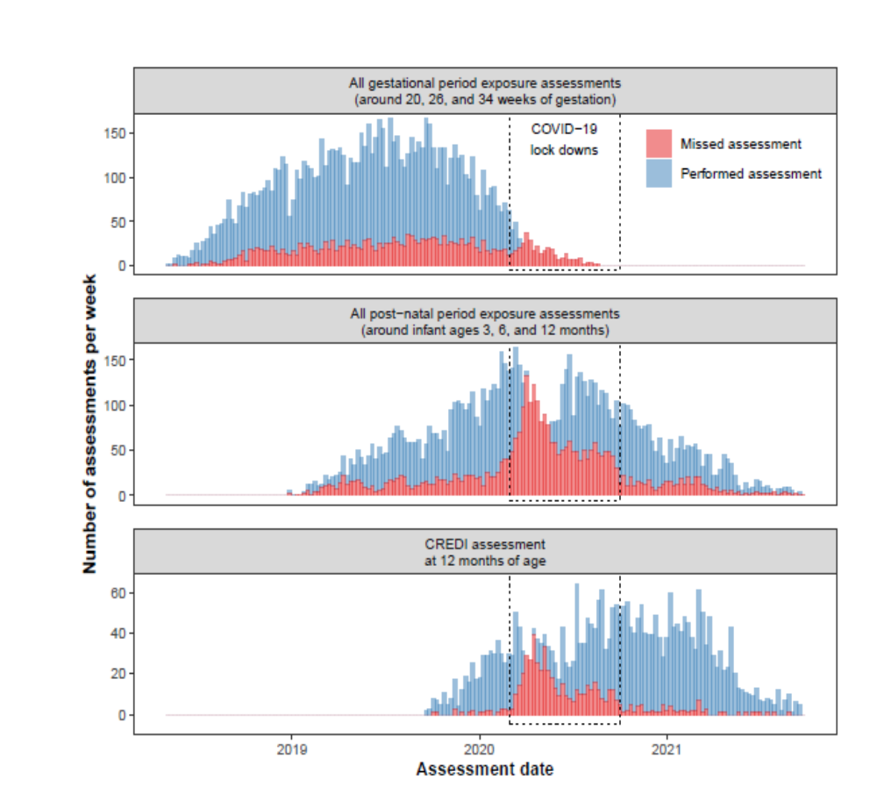

Figure S1: Exposure and outcome assessments performed and missed over time.
This figure shows the number of exposure or CREDI assessments performed per week (blue) and the number of assessments missed per week (red). Bars representing the performed assessments are stacked on top of the bars representing the missed assessments. The period corresponding to lock downs due to the COVID-19 pandemic is highlighted in a dotted rectangle.

Table S3: Summary of quality control for the CREDI assessments at 12 months

Criteria1 | Overall | Guatemala | India | Peru | Rwanda
CREDI assessed at 12 months (n) | 2502 | 623 | 756 | 529 | 594
Didn’t have an issue resulting in censoring of the CREDI assessment, n (% of assessments at 12 months)
No censoring issue2 | 2446 (97.8) | 575 (92.3) | 753 (99.6) | 527 (99.6) | 591 (99.5)
Recorded answers before correct start point3 | 948 (37.9) | 94 (15.1) | 304 (40.2) | 269 (50.9) | 281 (47.3)
Found the stop pattern4 | 2491 (99.6) | 620 (99.5) | 753 (99.6) | 527 (99.6) | 591 (99.5)
Recorded answers after stop pattern | 46 (1.8) | 6 (1) | 29 (3.8) | 8 (1.5) | 3 (0.5)
Answered "Don’t Know" to any item | 125 (5) | 12 (1.9) | 5 (0.7) | 80 (15.1) | 28 (4.7)
Any item missed between start and stop | 55 (2.2) | 21 (3.4) | 5 (0.7) | 5 (0.9) | 24 (4)
Had at least one issue resulting in censoring, n (% of assessments at 12 months)
Some censoring issue | 56 (2.2) | 48 (7.7) | 3 (0.4) | 2 (0.4) | 3 (0.5)
Missed items in the beginning | 45 (1.8) | 45 (7.2) | 0 | 0 | 0
Stopped without stop pattern | 11 (0.4) | 3 (0.5) | 3 (0.4) | 2 (0.4) | 3 (0.5)
1The criteria within each group are not mutually exclusive.
2The CREDI assessments are considered censored if a sequence of items that includes the starting point is missed, or if the assessment is stopped before finding 5 consecutive No answers
3Age specific start points are defined for the CREDI assessments. An infant under 12 months should have been assessed starting with item LF6, and an infant over 12 months should have been assessed starting with item LF11.
4CREDI assessments end when recording 5 consecutive No answers

Table S4. Linear regression full model for overall CREDI scores

Variables | Estimate (95% CI) | t value | p-value
Intercept | -0.875 (-0.984, -0.767) | -15.834 | <0.001
Exposure
Gestational concentration | 0 (0, 0) | -0.424 | 0.671
Postnatal concentration | 0 (0, 0) | 0.700 | 0.484
Sex
Female | Reference
Male | -0.013 (-0.086, 0.060) | -0.342 | 0.732
Mother education
No formal education or Primary education incomplete | Reference
Primary complete | -0.003 (-0.091, 0.086) | -0.057 | 0.954
Secondary complete or some university degree | -0.038 (-0.062, 0.137) | 0.745 | 0.457
Country
Guatemala | Reference
India | 0.543 (0.397, 0.688) | 7.314 | <0.001
Peru | -0.173 (-0.301, -0.044) | -2.641 | <0.01
Rwanda | 0.402 (0.280, 0.523) | 6.500 | 0.008
Socioeconomic status¹ | 0.127 (0.058, 0.196) | 3.600 | <0.001
Overall model fit:
F-statistic: 45.26, <0.001, R²=0.217, Adjusted R²=0.212
1Access to infrastructural services (electricity, cable TV, internet, improved toilets, improved water sources, bank account)
Table S5. Association between fine particulate matter exposure and the age-standardized CREDI z-scores
ECD domain¹ | Exposure | n | Estimate, change (95% CI)²³ |  | R-squared | Akaike's Information Criterion⁴
ECD domain¹ | Exposure | n | Gestational | Postnatal | R-squared | Akaike's Information Criterion⁴
PM 2.5
Overall | linear | 1482 | -0.008 (-0.041, 0.025) | 0.007 (-0.013, 0.026) | 0.22 | 3214
 | log-linear | 1482 | 0.001 (-0.004, 0.006) | 0 (-0.004, 0.004) | 0.22 | 3214.3
Cognitive | linear | 1482 | -0.025 (-0.061, 0.011) | 0.002 (-0.019, 0.023) | 0.05 | 3433
 | log-linear | 1482 | -0.003 (-0.008, 0.003) | -0.002 (-0.006, 0.003) | 0.05 | 3433.1
Motor | linear | 1482 | 0.001 (-0.029, 0.032) | 0.006 (-0.012, 0.024) | 0.33 | 2983.6
 | log-linear | 1482 | 0.003 (-0.002, 0.008) | 0 (-0.004, 0.004) | 0.33 | 2982.5
Language | linear | 1482 | -0.056 (-0.096, -0.016) | 0.01 (-0.014, 0.033) | 0.04 | 3783
 | log-linear | 1482 | -0.007 (-0.013, -0.001) | 0 (-0.005, 0.005) | 0.04 | 3785.1
Socio-emotional | linear | 1482 | -0.02 (-0.06, 0.02) | -0.002 (-0.025, 0.022) | 0.05 | 3810.2
 | log-linear | 1482 | -0.002 (-0.008, 0.005) | -0.003 (-0.008, 0.002) | 0.05 | 3809
¹ECD z-scores obtained using the Caregiver Reported Early Development Instruments.
²Fully adjusted model, with covariates: country, infant sex, maternal education, secondhand smoking and socioeconomic status.
³For linear exposure, the change in age-standardized score for an IQR change in the exposure; for log-linear exposures, the percent change in age-standardized score for a 10% increase in the exposure.
⁴Akaike's Information Criterion (AIC) is a statistical measure used to compare models, balancing goodness of fit and model complexity, with lower AIC values indicating models that fit better the data.

