Effects of an LPG stove intervention on COVID-19 antibodies and infection in adult women and infants: results from the Household Air Pollution Intervention Network Trial
Supplemental Tables & Figures 2
Table S1. Results of ITT analyses testing for the difference in COVID-19 seroprevalence and antibody levels between intervention and control arms, by study site and participant type (GEE). HAPIN, 2020-2021, Guatemala, Peru, India. 2
Table S2. Results of exposure-response analyses for the association between COVID-19 infection and exposure (PM_{2.5} and CO), by study site. HAPIN, 2020-2021, Guatemala, Peru, India. 3
Table S3. Results of exposure-response analyses for the association between COVID-19 antibody levels and exposure (PM_{2.5} and CO), by study site. (GEE). Household Air Pollution Intervention Network, 2020-2021, Guatemala, Peru, India. 4
Figure S1. Correlation between serum and DBS COVID seropositivity response 5
Table S4. Total number and proportion of dried blood samples (DBS) used for COVID-19 infection determination collected before vs. after vaccine eligibility by country and participant type. 5
Figure S2. Timeline of dried blood spot (DBS) sample collection relative to COVID-19 vaccine eligibility by country. Density plots depict the distribution of DBS collection dates for participants in Guatemala, India, and Peru. Vertical dashed lines indicate the earliest vaccine eligibility dates for each age group within each country. 6
MODEL FIT 6

TABLES

Table S1. Total number and proportion of dried blood samples (DBS) used for COVID-19 infection determination collected before vs. after vaccine eligibility by country and participant type.

Country | Participant Type | n (%) before or after vaccine eligibility
 |  | AFTER | BEFORE
Guatemala | Mother | 56 (14%) | 344 (86%)
Guatemala | OAW | 5 (8%) | 54 (92%)
Guatemala | Child | 0 (0%) | 866 (100%)
Guatemala | Total | 61 (5%) | 1264 (95%)
India | Mother | 26 (8%) | 308 (92%)
India | OAW | 11 (22%) | 40 (78%)
India | Child | 0 (0%) | 334 (100%)
India | Total | 37 (5%) | 682 (95%)
Peru | Mother | 4 (16%) | 21 (84%)
Peru | OAW | 2 (2%) | 79 (98%)
Peru | Child | 0 (0%) | 709 (100%)
Peru | Total | 6 (1%) | 809 (99%)
Overall | Total | 104 (4%) | 2755 (96%)
* Counts and percentages reflect the DBS sample used to determine COVID-19 infection status for each participant, categorized by whether it was collected before or after their age- and country-specific vaccine eligibility date. These data do not reflect whether participants had been vaccinated or which vaccine type they may have received, as this information was not collected. Children were not eligible for vaccination during sampling. Age- and country-specific vaccine eligibility dates were defined based on national COVID-19 vaccine rollout timelines (India: ≥60 + 45–59 years with comorbidities from 1-Mar-21, ≥45 years from 1-Apr-21, ≥18 years from 1-May-21; Peru: ≥80 years from 26-Apr-21, ≥18 years from 12-Jul-21; Guatemala: ≥18 years from 11-Mar-21)

Table S2. Results of ITT analyses testing for the difference in COVID-19 seroprevalence and antibody levels between intervention and control arms, by study site and participant type (GEE). HAPIN, 2020-2021, Guatemala, Peru, India.

Outcome | Site/Type | Estimate | 95% CI (Lower, Upper) | P-Value
COVID Infection (Odds Ratio) | Overall | 1.10 | (0.78, 1.54) | 0.59
 | Guatemala | 1.59 | (0.89, 2.84) | 0.12
 | India* | 0.64 | (0.35, 1.17) | 0.15
 | Peru | 1.40 | (0.55, 3.57) | 0.48
 | Mothers | 1.11 | (0.57, 2.15) | 0.77
 | OAW | 1.09 | (0.45, 2.63) | 0.84
 | Children | 1.17 | (0.77, 1.76) | 0.47
Antibody Level (Relative Mean) | Overall | 1.03 | (0.92, 1.15) | 0.58
 | Guatemala | 1.08 | (0.93, 1.25) | 0.31
 | India | 0.92 | (0.76, 1.11) | 0.39
 | Peru | 0.91 | (0.73, 1.13) | 0.39
 | Mothers | 1.10 | (0.93, 1.32) | 0.27
 | OAW | 1.08 | (0.75, 1.56) | 0.69
 | Children | 0.95 | (0.82, 1.10) | 0.49

Table S3. Results of exposure-response analyses for the association between SARS-CoV-2 infection and exposure (PM_{2.5} and CO), by study site. HAPIN, 2020-2021, Guatemala, Peru, India.
 | PM_{2.5} |  |  | CO
Outcome | Estimate | 95% CI | p-value | Estimate | 95% CI | p-value
Infection (0/1)
OVERALL (all sites)
Log linear | -0.15 | (-0.40, 0.09) | 0.21 | -0.04 | (0.15, 0.07) | 0.44
Quartile (ref. quartile 1)
Quartile 2 | -0.08 | (-0.65, 0.48) | 0.77 | -0.24 | (0.81, 0.34) | 0.42
Quartile 3 | -0.43 | (-1.04, 0.17) | 0.16 | -0.19 | (-0.68, 0.30) | 0.45
Quartile 4 | -0.41 | (-0.95, 0.12) | 0.13 | -0.29 | (-0.87, 0.31) | 0.31
GUATEMALA
Log linear | -0.22 | (-0.56, 0.12) | 0.20 | -0.08 | (-0.27, 0.10) | 0.65
Quartile (ref. quartile 1)
Quartile 2 | -0.02 | (-0.88, 0.84) | 0.96 | -0.290 | (-1.17, 0.59) | 0.518
Quartile 3 | -0.17 | (-1.06, 0.71) | 0.70 | -0.615 | (-1.47, 0.28) | 0.179
Quartile 4 | -0.49 | (-1.34, 0.36) | 0.26 | -0.325 | (-1.67, 0.56) | 0.470
INDIA*
Log linear | 0.75 | (0.06, 1.44) | 0.03 | 0.33 | (-0.02, 0.67) | 0.06
PERU*
Log linear | 0.06 | (-0.42, 0.53) | 0.82 | -0.02 | (-0.21, 0.17) | 0.86
* Quartile-based infection models were evaluated but not presented for India and Peru due to sparse cell counts resulting in unstable and non-interpretable estimates; India model adults-only due to infants having zero prevalence.

Table S4. Results of exposure-response analyses for the association between SARS-CoV-2 antibody levels and exposure (PM_{2.5} and CO), by study site. (GEE). Household Air Pollution Intervention Network, 2020-2021, Guatemala, Peru, India.
 | PM_{2.5} |  |  | CO
Outcome | Estimate | 95% CI | p-value | Estimate | 95% CI | p-value
Antibody level (u/ml)
OVERALL (all sites)
Log linear | -0.06 | (-0.13, 0.01) | 0.11 | -0.01 | (-0.05, 0.03) | 0.60
Quartile (ref. quartile 1)
Quartile 2 | -0.03 | (-0.23, 0.18) | 0.78 | -0.04 | (-0.22, 0.13) | 0.59
Quartile 3 | -0.10 | (-0.30, 0.10) | 0.33 | -0.07 | (-0.23, 0.10) | 0.43
Quartile 4 | -0.17 | (-0.35, -0.001) | 0.049 | -0.04 | (-0.21, 0.15) | 0.75
GUATEMALA
Log linear | -0.06 | (-0.14, 0.03) | 0.19 | 0.97 | (0.92, 1.03) | 0.36
Quartile (ref. quartile 1)
Quartile 2 | -0.07 | (-0.31, 0.17) | 0.56 | -0.09 | (-0.35, 0.16) | 0.91
Quartile 3 | -0.08 | (-0.32, 0.16) | 0.53 | -0.11 | (-0.33, 0.11) | 0.19
Quartile 4 | -0.17 | (-0.38, 0.04) | 0.11 | -0.08 | (-0.30, 0.14) | 0.99
INDIA
Log linear | 0.075 | (0.06, 1.44) | 0.03 | 0.33 | (0.18, 0.67) | 0.06
Quartile (ref. quartile 1)
Quartile 2 | -0.23 | (-0.52, 0.07) | 0.13 | 0.20 | (-0.14, 0.53) | 0.25
Quartile 3 | -0.17 | (-0.45, 0.11) | 0.22 | 0.16 | (-0.16, 0.47) | 0.33
Quartile 4 | 0.08 | (-0.14, 0.29) | 0.49 | 0.27 | (-0.05, 0.59) | 0.10
PERU
Log linear |  |  |  | 0.04 | (-0.02, 0.10) | 0.15

FIGURES

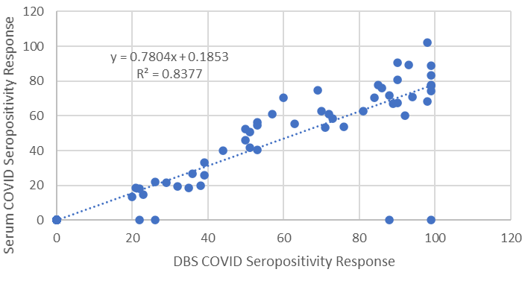

Figure S1. Correlation between serum and DBS COVID seropositivity response in a pre-study validation assessment.

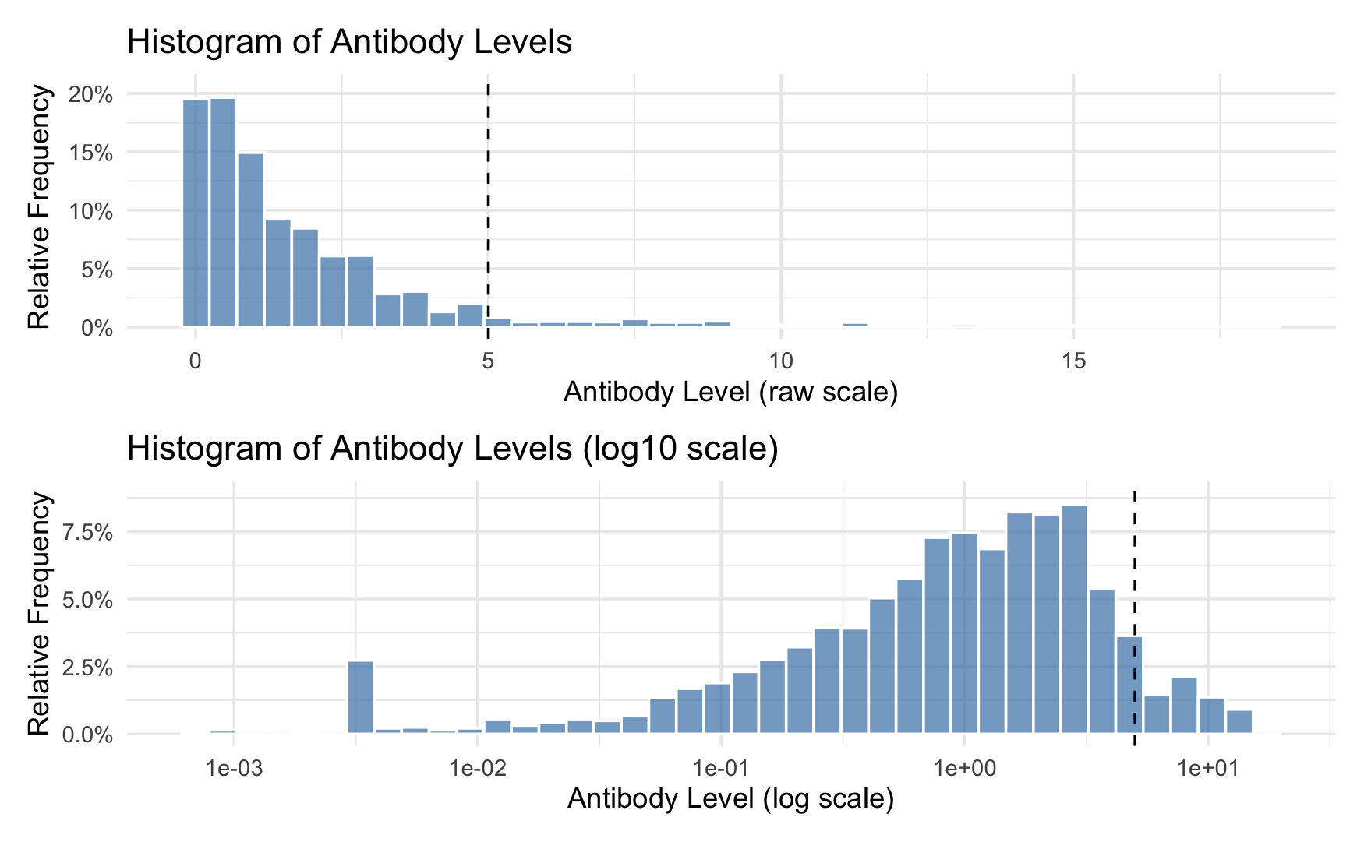

Figure S2. Distribution of SARS-CoV-2 IgG antibody concentrations. Histograms display antibody concentrations on the raw and log₁₀ scales; the dashed vertical line denotes the assay limit of detection (5 IU/mL) used to define seropositivity.

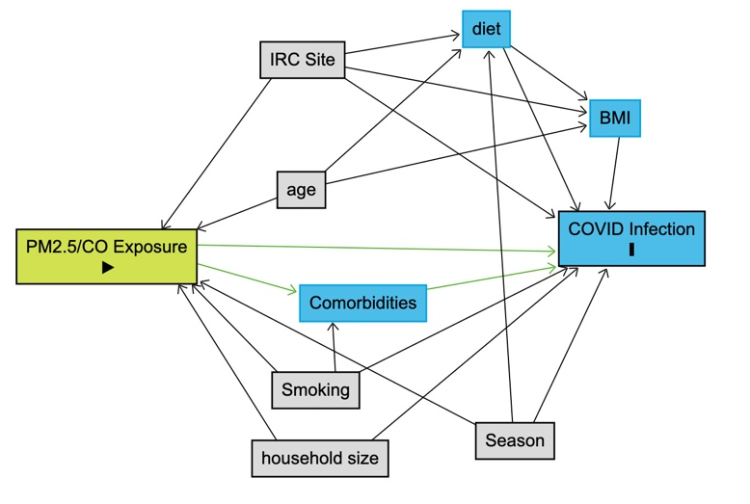

Figure S3. Direct Acyclic Graph of the relationship between personal PM2.5 and CO exposure and covid-19 infection. Lime green block represents the primary exposure of interest, blue square with outline represents the primary outcome, gray variables represent a minimally sufficient set of adjusted variables.

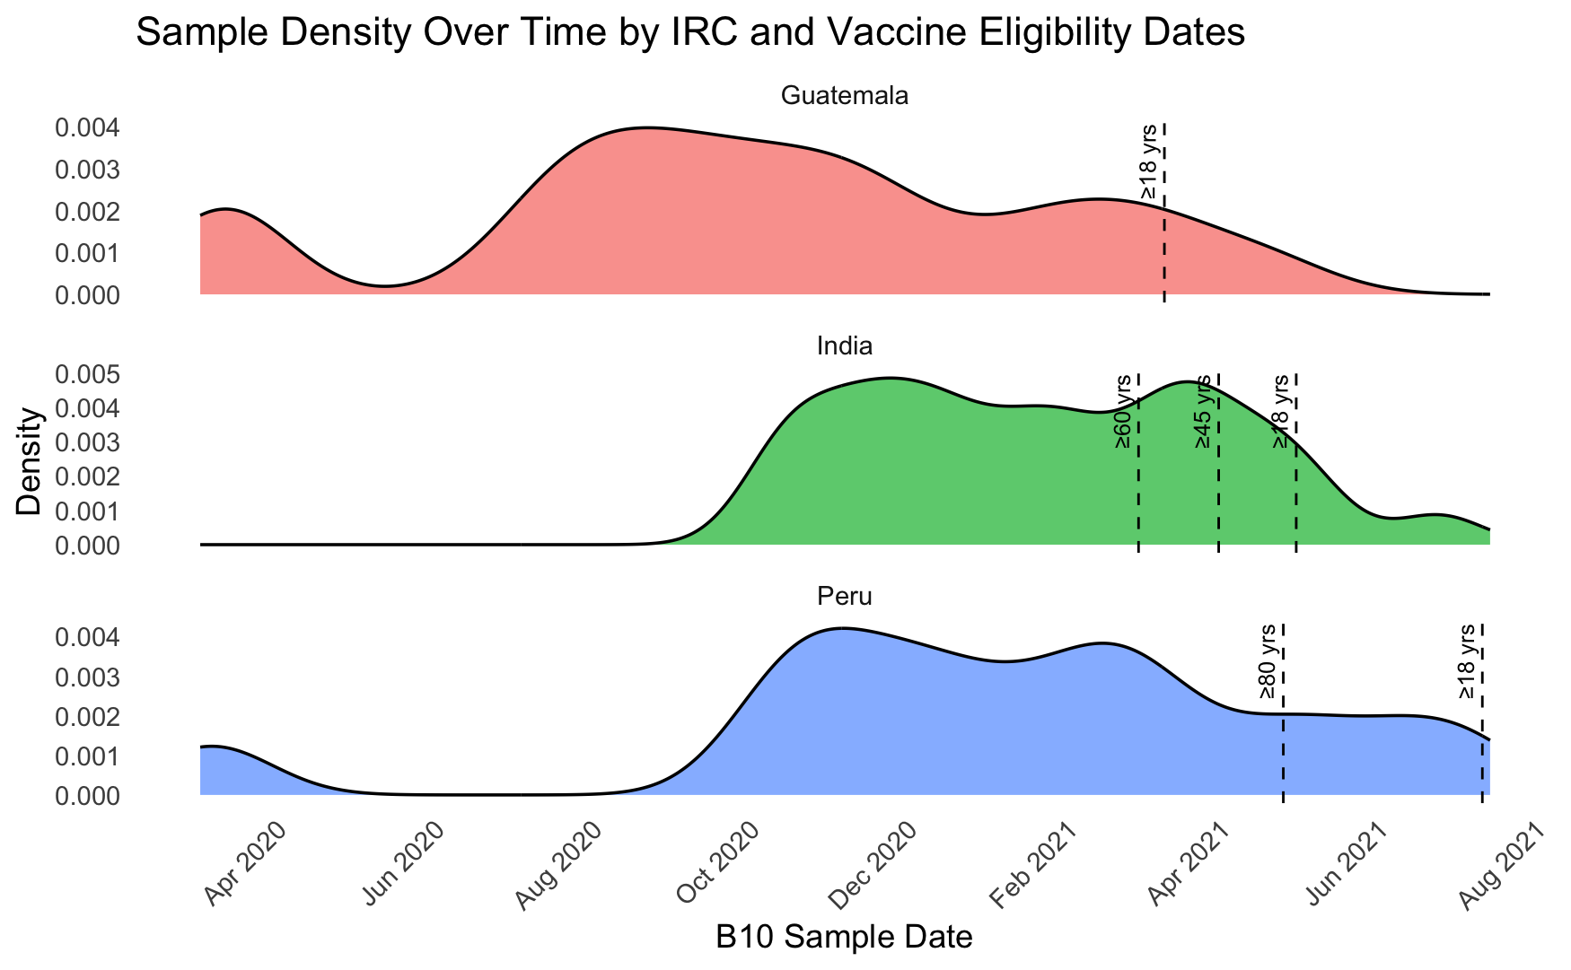

Figure S4. Timeline of dried blood spot (DBS) sample collection relative to COVID-19 vaccine eligibility by country. Density plots depict the distribution of DBS collection dates for participants in Guatemala, India, and Peru. Vertical dashed lines indicate the earliest vaccine eligibility dates for each age group within each country.

