Supplementary Material
Real-world emission factors and inhalation health risks of PM-bound metals from workboats using ultra-low sulfur marine fuel

Po-Yen Chien ª, Chia-Hsiang Lai ^{b}, Chia C. Wang ^{c, f}, Dhruv Vishal Patel ^{d},
Ajay Pillarisetti ^{d}, Wu-Xing Chen ª, Chia-Hung Chen ª, Yi-Ching Lin ª,
Tsai-Jung Yen ª, Hsiang-Ying Wu ª, Dong-Ni Wu ª, I-Hsuan Wu ª,
Kun-Tu Lu ^{e}, Yen-Ping Peng ^{a, f,} *

ª Institute of Environmental Engineering, National Sun Yat-sen University, Kaohsiung, Taiwan
^{b} Department of Biotechnology, National Formosa University, Yunlin, Taiwan
^{c} Department of Chemistry, National Sun Yat-sen University, Kaohsiung, Taiwan
^{d} Division of Environmental Health Sciences, School of Public Health, University of California, Berkeley, CA 94720, United States
^{e} Asian Marine Salvage Limited, Kaohsiung, Taiwan
^{f} Aerosol Science Research Center, National Sun Yat-sen University, Kaohsiung, Taiwan

To whom correspondence should be addressed:
* Yen-Ping Peng
TEL:+886-7-5252000#4422
Institute of Environmental Engineering, National Sun Yat-sen University, No. 70, Lien-hai Road, Kaohsiung 80424, Taiwan (R.O.C.)
*Corresponding author email: yppeng@mail.nsysu.edu.tw

S2.1. Test vessels and operating mode
The research vessel (Vessel A) has a gross tonnage of 811 t, with a length and breadth of 45.0 m and 11.2 m, respectively. It is equipped with four AE, each rated at 600 kW; during berthing, typically one AE operates at 23% load. The tugboats (Vessels B and C) have gross tonnages of 1,864 and 1,741 t, respectively, and share similar technical specifications except for their year of construction. Each tugboat is equipped with two AEs rated at 210 kW, of which one AE typically operates during berthing at an average load of approximately 35%. The reported auxiliary engine fuel consumption during berthing was 0.850 t/d for vessel A, 0.514 t/d for vessel B, and 0.510 t/d for vessel C. All tested vessels used MGO supplied by the Chinese Petroleum Company Corporation (Taiwan) as fuel for both main engines and auxiliary engines.
S2.2. Fuel parameters of test vessels
MGO and lubricating oil samples collected from the tested vessels were analyzed for 33 metals (Zn, Na, Ca, Fe, Al, Cr, Cu, Mg, K, V, Ni, Sr, Mn, Pb, Ba, Ti, Co, Ag, Ga, Cd, In, As, Pt, Hg, Mo, Rb, Pd, Sn, Li, Rh, Be, Se, and Sb). The samples were analyzed by the Super Micro Mass Research and Technology Center at Cheng Shiu University in Taiwan, an analytical laboratory certified and accredited by the Taiwan Ministry of Environment. Metal concentrations were determined following the NIEA M105.01B method issued by the Ministry of Environment in Taiwan. The method involves microwave-assisted acid digestion prior to analysis using ICP-MS.
S2.3. Online measurement instruments and sample analysis
Engine exhaust emissions measured in this study included conventional gaseous compounds (NO, NO₂, SO₂, CO, CO₂, and O₂) and particulate matter (PM₁, PM_{2.5}, PM₄, and PM₁₀). Gaseous compounds were continuously monitored using a Belltone BE-500 S/Pro analyzer (Taiwan), while particulate matter was measured in real time using a Palas Fidas Frog analyzer (Germany) coupled to a Palas VKL 100 diluter (Germany). Exhaust opacity was continuously monitored using a Belltone OPA-550 analyzer (Taiwan). The maximum light absorption coefficient (k) measured during each test was used as the representative indicator of exhaust opacity.
The gaseous compounds, particulate matter, and exhaust opacity were continuously monitored for 1.5 h under stable operating conditions. Instrument calibration was rigorously conducted before and after each measurement campaign. Gaseous compounds (NO, NO_{X}, SO₂, CO, CO₂, and O₂) were measured using a Belltone BE-500 S/Pro analyzer, which conforms to high analytical standards with repeatability, linearity, and accuracy all within < ±2% of the full scale (FS). PM was characterized using a Palas Fidas Frog analyzer operating at a constant volumetric flow rate of 1.4 L/min. The expanded measurement uncertainty for both PM_{2.5} and PM₁₀ mass concentrations was approximately 12%, ensuring the reliability of the aerosol data. Additionally, the gaseous analyzer was zero-calibrated in the field before each test. For PM, background concentrations were measured under ambient conditions, and all reported concentrations were corrected by subtracting the corresponding average background values to minimize interference from ambient pollution.
Two particulate samplers were used to collect PM_{2.5} and TSP for the analysis of 19 metal elements, with PM_{2.5} and TSP sampled separately. TSP samples were collected at a constant flow rate of 3 L/min, whereas PM_{2.5} samples were collected with a five-stage size-selective dust sampler operating at a constant flow rate of 9 L/min. All particulate samples were collected on Teflon filters with a pore size of 0.22 μm.
Sample filters were digested using 70% mercury-free nitric acid (HNO₃) in a microwave digestion system at 170 ± 5°C for 30 min. After cooling, the digestates were filtered and diluted to a final volume of 25 mL with 3% HNO₃. A total of 19 metals were quantified using Inductively Coupled Plasma Mass Spectrometry (ICP-MS), including common crustal metals (e.g., Zn, Na, Ca, Fe, Al, Cu, and Mn), shipping-related markers (V and Ni), and toxic metals (e.g., Cr, Pb, Cd, and Co). Field blanks were processed alongside the samples to correct for background concentrations (Table S4).
S2.4.1. Fuel-based emission factor
A carbon balance method was applied, assuming that the total carbon content in the fuel was completely converted into carbonaceous gases and particulate matter during combustion. Based on this assumption, the EF for CO₂ was calculated as:
${EF}_{{CO}_{2}}=\frac{C_{F}}{{c(C}_{CO}){+ c(C}_{{CO}_{2}}) +{ c(C}_{PM})}×c^{*}{(CO}_{2})×M_{{CO}_{2}}$ (1)
where ${EF}_{{CO}_{2}}$ represents the emission factors for CO₂ (g/kg-fuel); C_{F} is the mass of carbon in 1 kg fuel (g C/kg-fuel); c(C_{CO}), c($C_{{CO}_{2}}$), and c(C_{PM}) represent the mass concentrations of carbon as CO, CO₂, and PM (g C/m³), respectively, in the flue gas; c*(CO₂) is the molar concentration of CO₂ (mol/m³); and $M_{{CO}_{2}}$ represents the molecular weight of CO₂.
In addition to CO₂, the EFs of other species were calculated using the following formula:
${EF}_{X}=\frac{∆X}{{∆CO}_{2}}×\frac{M_{X}}{M_{{CO}_{2}}}×{EF}_{{CO}_{2}}$ (2)
where EF_{X} is the emission factor of species X (g/kg-fuel), ΔX and ΔCO₂ are background-corrected concentrations of X and CO₂ (mol/m³), respectively, and M_{X} is the molecular weight of species X (g/mol).
The emission factor of SO₂ was calculated based on fuel sulfur content as:
${EF}_{{SO}_{2}}=P×20$ (3)
where P is the sulfur content of the fuel (% by mass), and coefficient 20 denotes the mass of SO₂ (g) formed per unit percentage of sulfur per kilogram of fuel (g/kg-fuel).

S2.4.2. Gaussian plume model
Since the risk assessment focused on human exposure in port areas, pollutant concentrations were evaluated at ground level (z = 0 m), where most port-related activities occur. Concentrations were assessed at a downwind distance (x) of 35 m, corresponding to the location of maximum ground-level concentrations predicted by the Gaussian Plume Model. The lateral distance (y) was set to 0 m to represent the plume centerline. The following assumptions were adopted: (i) pollutant transport occurs only in the downwind (x) direction; (ii) ambient wind speed in the y and z directions is negligible; (iii) pollutant emission rates are constant during berthing; and (iv) the ground surface acts as a perfect reflector, with no deposition or chemical transformation. These assumptions are appropriate for vessels in a stationary berthing state, where plume dispersion is dominated by local meteorological conditions rather than vessel movement. Parameters of ambient wind speed, solar radiation, and atmospheric stability class were considered, incorporated, and summarized in Table S6. Given the high solar radiation, minimal cloud cover, and relatively low wind speeds observed in Kaohsiung Harbor during the sampling period, atmospheric stability classes were determined to be primarily A, and at most, B. Thus, dispersion simulations were conducted at atmospheric stabilities A, B, and C to capture potential variability. Model results indicated that ground-level concentrations for Vessels A, B, and C reached a maximum at approximately 35 m downwind (Figures S1–S5); therefore, concentrations at this distance were used to calculate the average daily dose in the subsequent health risk assessment.

List of tables and figures in the supporting information:
Table S1. Fuel characteristics used by the tested vessel.
Table S2. Average background concentrations of gaseous compounds (NO, NO_{X}, SO₂, CO, CO₂, and O₂) and PM.
Table S3. Measurement ranges of the Belltone BE-500 S/Pro and Palas Fidas Frog analyzer.
Table S4. Quality control parameters for metal analysis.
Table S5. PM_{2.5} heavy metal emission rates (Cr, Ni, Pb, Co, and Cd) measured from vessels A, B, and C (μg/s).
Table S6. Parameters for Gaussian plume model simulation.
Table S7. The values of RfD and SFI for individual heavy metals.
Table S8. Metal concentrations in MGO from tested vessels (µg/kg).
Table S9. Metal concentrations in lubricating oil from tested vessels (µg/kg).
Table S10. PM_{2.5} metal lifetime average daily dose for vessels A, B, and C at atmospheric stability classes A, B, and C (calculated using concentration at downwind distance of 35m) (mg/kg-day).

Figure S1. Cr ground-level Gaussian Plume Model concentrations.
Figure S2. Ni ground-level Gaussian Plume Model concentrations.
Figure S3. Pb ground-level Gaussian Plume Model concentrations.
Figure S4. Co ground-level Gaussian Plume Model concentrations.
Figure S5. Cd ground-level Gaussian Plume Model concentrations.
Figure S6. Fuel-based EFs in this study and previous studies (g/kg-fuel).

Table S1. Fuel characteristics used by the tested vessel.
Item | Vessel A | Vessel B | Vessel C
Fuel type | MGO | MGO | MGO
Density (at 15 ºC, kg/L) | 0.830 | 0.842 | 0.849
Viscosity (at 40 ºC, mm²/s) | 2.67 | 3.54 | 4.44
Flash point (ºC) | 75.00 | 80.00 | 101.00
Sulfur content (wt.%) | 0.010 | 0.093 | 0.060
Moisture content (vol.%) | 0.010 | 0.010 | 0.010
Note: viscosity at 50 °C was not measured.

Table S2. Average background concentrations of gaseous compounds (NO, NO_{X}, SO₂, CO, CO₂, and O₂) and PM.
Vessel ID | Vessel A | Vessel B | Vessel C
NO (ppm) | 0.0 | 0.0 | 0.0
NO_{X} (ppm) | 0.0 | 0.0 | 0.0
SO₂ (ppm) | 0.0 | 0.0 | 0.0
CO (ppm) | 0.0 | 0.0 | 0.0
CO₂ (Vol%) | 0.0 | 0.0 | 0.0
O₂ (Vol%) | 20.53 | 21.05 | 21.17
PM_{0.18-1.0} (µg/m³) | 16.28 | 20.79 | 21.78
PM_{1.0-2.5} (µg/m³) | 20.60 | 26.37 | 24.17
PM_{2.5-4.0} (µg/m³) | 27.64 | 35.20 | 27.97
PM_{4.0-10} (µg/m³) | 33.09 | 45.07 | 28.21
Note: the gaseous analyzer was zero-calibrated prior to each test; therefore, the background concentrations of NO, NO_{X}, SO₂, CO, and CO₂ were recorded as zero.

Table S3. Measurement ranges of the Belltone BE-500 S/Pro and Palas Fidas Frog analyzer.
Belltone BE-500 S/Pro
Species | Measurement range
NO | 0−5,000 ppm
NO_{X} | 0−5,000 ppm
SO₂ | 0−1,000 ppm
CO | 0−100,000 ppm
CO₂ | 0−20 %
O₂ | 0−25%
Repeatability | < ±2% full scale
Palas Fidas Frog
Species | Measurement range
PM_{0.18-1.0} | 0−100 mg/m³
PM_{1.0-2.5} | 0−100 mg/m³
PM_{2.5-4.0} | 0−100 mg/m³
PM_{4.0-10} | 0−100 mg/m³
Measurement uncertainty | Approximately 12%

Table S4. Quality control parameters for metal analysis.
Item | R² | R | RPD  (%) | Spike recovery (%) | Control sample recovery (%) | Drift  (%) | QDL  (µg/L) | PM_{2.5} field blank  (µg/L) | TSP field blank  (µg/L)
Na | 0.9993 | 0.9996 | 0.7 | 106.8 | 112.2 | 4.2 | 25.0 | ND | ND
Ca | 0.9990 | 0.9995 | 2.9 | 84.9 | 99.5 | 2.2 | 25.0 | ND | ND
Al | 0.9995 | 0.9997 | 2.5 | 95.7 | 114.4 | 7.0 | 25.0 | ND | ND
V | 0.9999 | 1.0000 | 5.0 | 107.6 | 100.8 | 6.0 | 0.5 | ND | ND
Cr | 0.9994 | 0.9997 | 1.1 | 97.6 | 97.3 | 0.3 | 0.5 | ND | ND
Mn | 0.9998 | 0.9999 | 1.6 | 96.7 | 100.3 | 5.1 | 25.0 | ND | ND
Fe | 0.9989 | 0.9994 | 0.2 | 101.5 | 108.5 | 4.0 | 25.0 | ND | ND
Co | 0.9998 | 0.9999 | 0.7 | 100.6 | 101.5 | 8.2 | 0.5 | ND | ND
Ni | 0.9999 | 0.9999 | 0.1 | 99.6 | 102.9 | 9.2 | 0.5 | ND | ND
Cu | 0.9999 | 1.0000 | 2.1 | 99.1 | 96.9 | 9.0 | 0.5 | ND | ND
Zn | 0.9996 | 0.9998 | 1.0 | 99.1 | 105.9 | 7.8 | 2.0 | ND | ND
Ga | 0.9994 | 0.9997 | 0.2 | 92.3 | 94.2 | 9.6 | 0.5 | ND | ND
Sr | 0.9996 | 0.9998 | 1.4 | 102.3 | 105.2 | 3.3 | 0.5 | ND | ND
Ag | 1.0000 | 1.0000 | 1.2 | 103.8 | 107.3 | 6.1 | 0.5 | ND | ND
Cd | 0.9990 | 0.9995 | 3.8 | 103.7 | 104.0 | 6.8 | 0.5 | ND | ND
In | 1.0000 | 1.0000 | 1.3 | 96.6 | 93.3 | 5.2 | 0.5 | ND | ND
Ba | 1.0000 | 1.0000 | 0.0 | 100.4 | 102.5 | 3.6 | 0.5 | ND | ND
Ti | 0.9999 | 0.9999 | 3.4 | 89.3 | 101.1 | 1.4 | 2.0 | ND | ND
Pb | 1.0000 | 1.0000 | 0.0 | 103.0 | 103.7 | 8.9 | 0.5 | ND | ND
ND: not detected.

Table S5. PM_{2.5} heavy metal emission rates (Cr, Ni, Pb, Co, and Cd) measured from vessels A, B, and C (μg/s).
 | Vessel A | Vessel B | Vessel C
Metal | Emission rate | Emission rate | Emission rate
Cr | 2.363 | 2.035 | 1.837
Ni | 0.906 | 0.477 | 0.400
Pb | 0.807 | 0.287 | 0.236
Co | 0.025 | 0.087 | 0.054
Cd | 0.023 | 0.007 | 0.005
Table S6. Parameters for Gaussian plume model simulation.
 | Vessel A | Vessel B | Vessel C
Atmospheric wind speed (m/s) | 2.00−3.00 | 2.00−3.00 | 2.00−3.00
Solar radiation | High | High | High
Cloudy | No | No | No
Atmospheric stability class | A−B | A−B | A−B
Stack effective height (m) | 8.10 | 10.00 | 10.00
Exhaust emission velocity (m/s) | 12.5−15.00 | >15.00 | >15.00
Table S7. The values of RfD and SFI for individual heavy metals.
Metal | Inhalation Slope factor (SFI)  (mg/kg-day) | Reference Dose (RfD)  (mg/kg-day)
Cr(VI) | 42.0 ^{b} | 3.0×10⁻⁵ ª
Ni | 8.4×10^{-1 b} | 2.0×10⁻² ª
Pb | 8.5×10^{-3 c} | 3.5×10⁻³ ^{c}
Co | 9.8 ^{b} | 6.0×10⁻⁶ ª
Cd | 6.3 ^{b} | 1.8×10⁻³ ª
a: USEPA/IRIS database, https://iris.epa.gov
b: Wen et al. (2018) (Wen et al., 2018)
c: Zhang and Aikawa (2023) (Zhang and Aikawa, 2023)

Table S8. Metal concentrations in MGO from the tested vessels (mg/kg).
Item | Vessel A |  | Vessel B |  | Vessel C
Item | Concentration | Percentage | Concentration | Percentage | Concentration | Percentage
Major Metals
Zn | 25.94 | 30.3% | 21.46 | 18.7% | 32.50 | 25.8%
Na | 24.93 | 29.1% | 47.86 | 41.7% | 11.20 ª | 8.9%
Ca | 9.80 | 11.5% | 17.72 | 15.4% | 68.07 | 54.05%
Fe | 9.66 | 11.3% | 3.86 | 3.4% | 2.10 | 1.7%
Al | 1.51 | 1.8% | 2.77 | 2.4% | 0.38 ^{b} | 0.3%
Cu | 1.07 | 1.3% | 4.55 | 4.0% | 0.26 ^{c} | 0.2%
Cr | 0.86 | 1.0% | 0.89 | 0.8% | 0.08 ^{c} | 0.1%
K | 4.73 | 5.5% | 6.45 | 5.6% | 3.08 ª | 2.4%
Mg | 7.02 | 8.2% | 9.21 | 8.0% | 8.46 ª | 6.7%
Sub-total | 85.52 | 100.0% | 114.78 | 100.0% | 126.13 | 100.0%
Sub-major Metals
Sr | 0.28 | 12.2% | 0.40 | 18.6% | 0.40 | 53.8%
Mn | 0.27 | 11.8% | 0.18 ^{c} | 8.6% | 0.11 ^{c} | 14.5%
Mo | 0.22 ^{c} | 9.5% | 0.21 ^{c} | 10.0% | 0.10 ^{c} | 13.5%
Pt | 0.99 | 42.9% | 0.77 | 36.4% | 0.06 ^{c} | 7.8%
Ni | 0.31 | 13.6% | 0.13 ^{c} | 6.2% | 0.03 ^{c} | 4.0%
Pb | 0.14 ^{c} | 6.2% | 0.32 | 15.1% | 0.01 ^{c} | 1.8%
Ba | 0.08 ^{c} | 3.7% | 0.11 ^{c} | 5.0% | 0.03 ^{c} | 4.5%
Sub-total | 2.30 | 100.0% | 2.12 | 100.0% | 0.75 | 100.0%
Minor Metals
Rb | 0.04 ^{c} | 25.0% | 0.08 ^{c} | 26.3% | <0.01 ^{c} | 2.1%
Ti | 0.04 ^{c} | 29.4% | 0.07 ^{c} | 22.9% | 0.01 ^{c} | 12.5%
Co | 0.03 ^{c} | 21.8% | 0.02 ^{c} | 6.1% | 0.01 ^{c} | 6.2%
Pd | 0.02 ^{c} | 11.5% | 0.02 ^{c} | 8.2% | <0.01 ^{c} | 0.9%
As | 0.01 ^{c} | 5.3% | 0.03 ^{c} | 10.3% | <0.01 ^{c} | 2.3%
Sn | 0.01 ^{c} | 4.1% | <0.01 ^{c} | 1.6% | 0.04 ^{c} | 44.8%
Ag | <0.01 ^{c} | 1.7% | 0.01 ^{c} | 3.9% | 0.01 ^{c} | 8.1%
Rh | <0.01 ^{c} | 1.1% | <0.01 ^{c} | 0.3% | <0.01 ^{c} | 0.6%
Ga | ND | <0.1% | 0.02 ^{c} | 5.1% | <0.01 ^{c} | 0.4%
Cd | ND | <0.1% | ND | <0.1% | <0.01 ^{c} | 1.0%
In | ND | <0.1% | ND | <0.1% | <0.01 ^{c} | 0.2%
V | ND | <0.1% | ND | <0.1% | <0.01 ^{c} | 4.4%
Se | ND | <0.1% | 0.02 ^{c} | 6.7% | 0.01 ^{c} | 5.9%
Li | ND | <0.1% | 0.02 ^{c} | 8.1% | 0.01 ^{c} | 9.1%
Be | ND | <0.1% | <0.01 ^{c} | 0.3% | <0.01 ^{c} | 1.4%
Hg | ND | <0.1% | ND | <0.1% | ND | <0.1%
Sb | ND | <0.1% | ND | <0.1% | ND | <0.1%
Sub-total | 0.15 | 100% | 0.29 | 100.0% | 0.10 | 100.0%
Total | 87.97 |  | 117.20 |  | 126.98
ND: not detected.
a: concentration below the limit of quantification (LOQ = 12.50 mg/kg).
b: concentration below the limit of quantification (LOQ = 1.00 mg/kg).
c: concentration below the limit of quantification (LOQ = 0.25 mg/kg).
Table S9. Metal concentrations in lubricating oil from tested vessels (mg/kg).
Item | Vessel A |  | Vessel B |  | Vessel C
Item | Concentration | Percentage | Concentration | Percentage | Concentration | Percentage
Zn | 1299.55 | 73.3% | 466.35 | 46.9% | 91.50 | 33.4%
Na | 41.03 | 2.3% | 16.70 | 1.7% | 3.23 ª | 1.2%
Ca | 344.41 | 19.4% | 455.83 | 45.9% | 44.37 | 16.2%
Fe | 7.27 | 0.4% | 9.86 | 1.0% | 4.51 | 1.6%
Al | 2.38 | 0.1% | 1.49 | 0.2% | 6.26 | 2.3%
Cu | 0.69 | <0.1% | 0.84 | 0.1% | 1.15 | 0.4%
Cr | 0.53 | <0.1% | 0.71 | 0.1% | 0.12 ^{c} | <0.1%
K | 25.47 | 1.4% | 1.00 ª | 0.1% | 31.88 | 11.6%
Mg | 46.54 | 2.6% | 35.16 | 3.5% | 86.60 | 31.6%
Sr | 1.37 | 0.1% | 1.61 | 0.2% | 2.20 | 0.8%
Mn | 0.50 | <0.1% | 0.55 | 0.1% | 0.18 ^{c} | 0.1%
Mo | 1.97 | 0.1% | 1.12 | 0.1% | 0.20 ^{c} | 0.1%
Pt | 0.81 | <0.1% | 0.96 | 0.1% | 0.08 ^{c} | <0.1%
Ni | 0.37 | <0.1% | 0.09 ^{c} | <0.1% | 0.26 ^{c} | 0.1%
Pb | 0.21 ^{c} | <0.1% | 0.5 | 0.1% | 0.62 | 0.2%
Ba | 0.11 ^{c} | <0.1% | 0.13 ^{c} | <0.1% | 0.35 | 0.1%
Rb | 0.05 ^{c} | <0.1% | 0.05 ^{c} | <0.1% | 0.02 ^{c} | <0.1%
Ti | 0.09 ^{c} | <0.1% | 0.08 ^{c} | <0.1% | 0.15 ^{c} | 0.1%
Co | 0.01 ^{c} | <0.1% | 0.03 ^{c} | <0.1% | 0.01 ^{c} | <0.1%
Pd | 0.02 ^{c} | <0.1% | 0.02 ^{c} | <0.1% | 0.01 ^{c} | <0.1%
As | 0.03 ^{c} | <0.1% | 0.04 ^{c} | <0.1% | <0.01 ^{c} | <0.1%
Sn | 0.04 ^{c} | <0.1% | 0.36 | <0.1% | 0.04 ^{c} | <0.1%
Ag | 0.01 ^{c} | <0.1% | 0.01 ^{c} | <0.1% | <0.01 ^{c} | <0.1%
Rh | <0.01 ^{c} | <0.1% | <0.01 ^{c} | <0.1% | <0.01 ^{c} | <0.1%
Ga | ND | <0.1% | ND | <0.1% | <0.01 ^{c} | <0.1%
Cd | 0.01 ^{c} | <0.1% | <0.01 ^{c} | <0.1% | <0.01^{c} | <0.1%
In | <0.01 ^{c} | <0.1% | <0.01 ^{c} | <0.1% | ND | <0.1%
V | ND | <0.1% | ND | <0.1% | ND | <0.1%
Se | ND | <0.1% | 0.02 ^{c} | <0.1% | 0.03 ^{c} | <0.1%
Li | ND | <0.1% | ND | <0.1% | 0.09 ^{c} | <0.1%
Be | <0.01 ^{c} | <0.1% | <0.01 ^{c} | <0.1% | <0.01 ^{c} | <0.1%
Hg | ND | <0.1% | ND | <0.1% | ND | <0.1%
Sb | ND | <0.1% | ND | <0.1% | ND | <0.1%
Total | 1773.49 | 100.0% | 993.51 | 100.0% | 273.88 | 100.0%
ND: not detected.
a: concentration below the limit of quantification (LOQ = 12.50 mg/kg).
c: concentration below the limit of quantification (LOQ = 0.25 mg/kg).

Table S10. PM_{2.5} metal lifetime average daily dose for vessels A, B, and C at atmospheric stability classes A, B, and C (calculated using concentration at downwind distance of 35m) (mg/kg-day).
 | Vessel A |  |  | Vessel B |  |  | Vessel C
Metal | Stability class A | Stability class B | Stability class C | Stability class A | Stability class B | Stability class C | Stability class A | Stability class B | Stability class C
Cr | 8.05×10⁻⁰⁷ | 5.59×10⁻⁰⁷ | 1.22×10⁻⁰⁷ | 7.62×10⁻⁰⁷ | 2.85×10⁻⁰⁷ | 1.72×10⁻⁰⁸ | 4.96×10⁻⁰⁷ | 1.85×10⁻⁰⁷ | 1.12×10⁻⁰⁸
Ni | 3.08×10⁻⁰⁷ | 2.14×10⁻⁰⁷ | 4.69×10⁻⁰⁸ | 1.79×10⁻⁰⁷ | 6.67×10⁻⁰⁸ | 4.04×10⁻⁰⁹ | 1.08×10⁻⁰⁷ | 4.03×10⁻⁰⁸ | 2.44×10⁻⁰⁹
Pb | 2.75×10⁻⁰⁷ | 1.91×10⁻⁰⁷ | 4.18×10⁻⁰⁸ | 1.07×10⁻⁰⁷ | 4.01×10⁻⁰⁸ | 2.43×10⁻⁰⁹ | 6.38×10⁻⁰⁸ | 2.38×10⁻⁰⁸ | 1.44×10⁻⁰⁹
Co | 8.59×10⁻⁰⁹ | 5.97×10⁻⁰⁹ | 1.31×10⁻⁰⁹ | 3.26×10⁻⁰⁸ | 1.22×10⁻⁰⁸ | 7.38×10⁻¹⁰ | 1.47×10⁻⁰⁸ | 5.48×10⁻⁰⁹ | 3.32×10⁻¹⁰
Cd | 7.88×10⁻⁰⁹ | 5.44×10⁻⁰⁹ | 1.19×10⁻⁰⁹ | 2.58×10⁻⁰⁹ | 9.62×10⁻¹⁰ | 5.83×10⁻¹¹ | 1.43×10⁻⁰⁹ | 5.35×10⁻¹⁰ | 3.24×10⁻¹¹
Total | 1.40×10⁻⁶ | 9.78×10⁻⁷ | 2.04×10⁻⁷ | 1.08×10⁻⁶ | 4.05×10⁻⁷ | 2.54×10⁻⁸ | 6.84×10⁻⁷ | 2.55×10⁻⁷ | 1.54×10⁻⁸

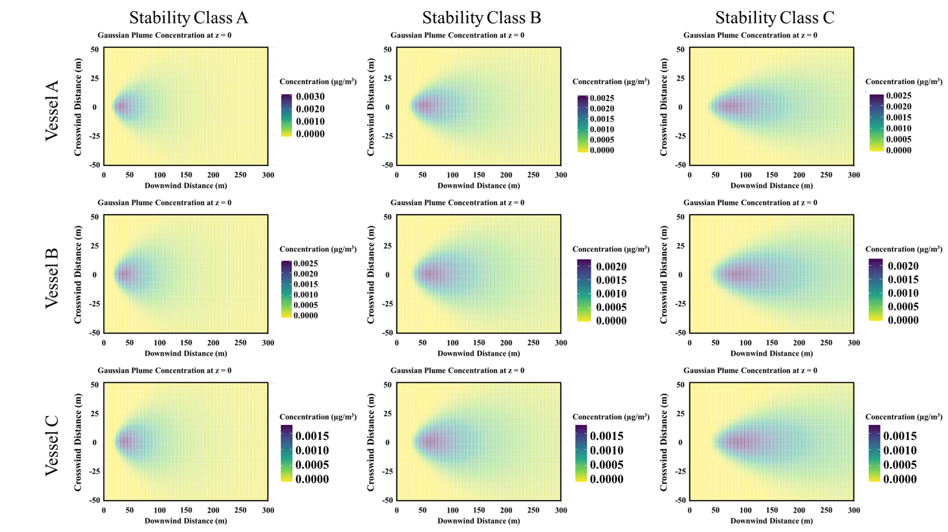
Figure S1. Cr ground-level Gaussian Plume Model concentrations.
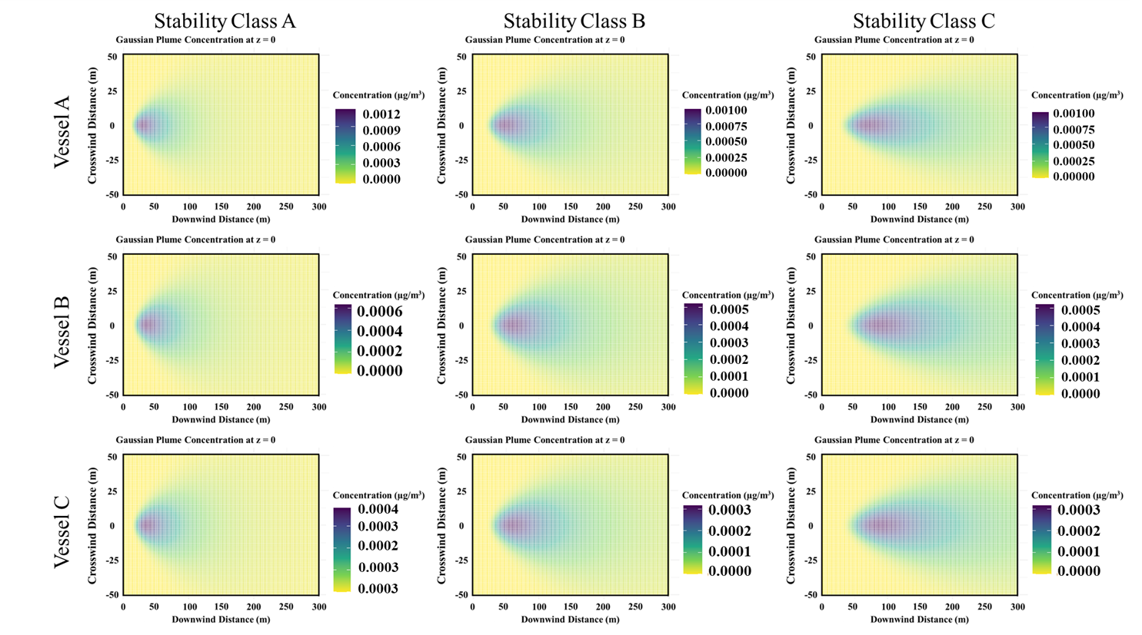
Figure S2. Ni ground-level Gaussian Plume Model concentrations.
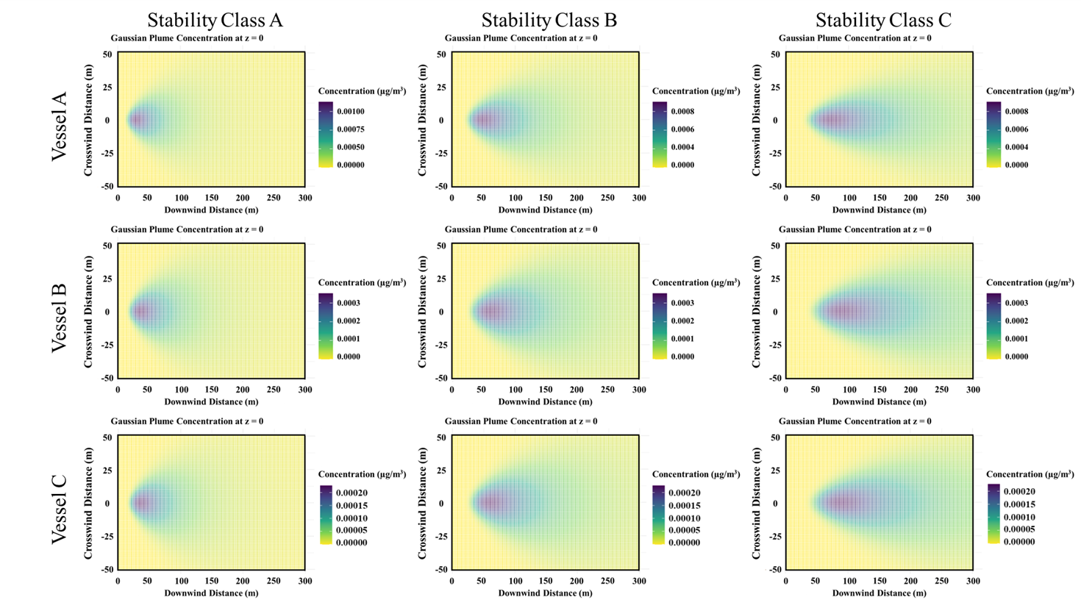
Figure S3. Pb ground-level Gaussian Plume Model concentrations.
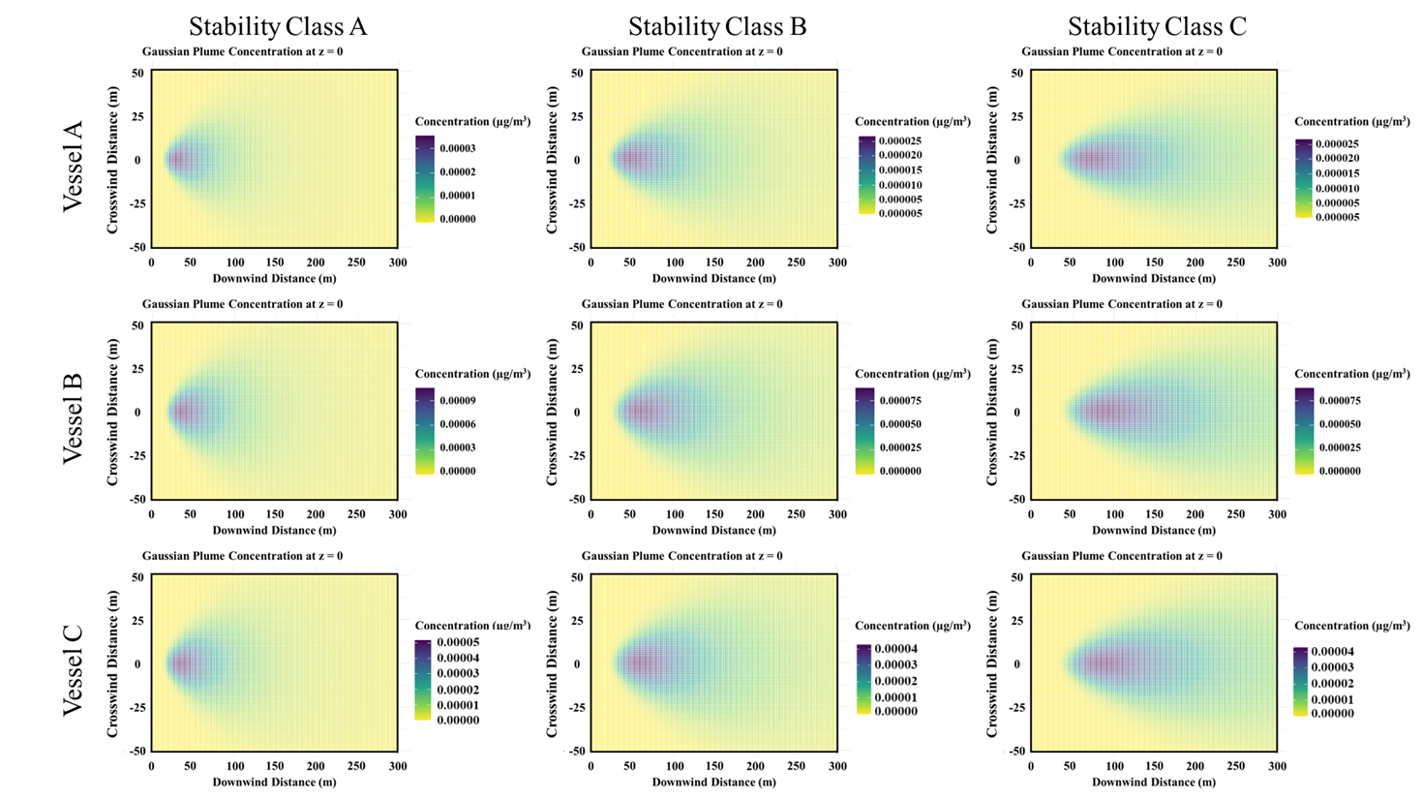
Figure S4. Co ground-level Gaussian Plume Model concentrations.
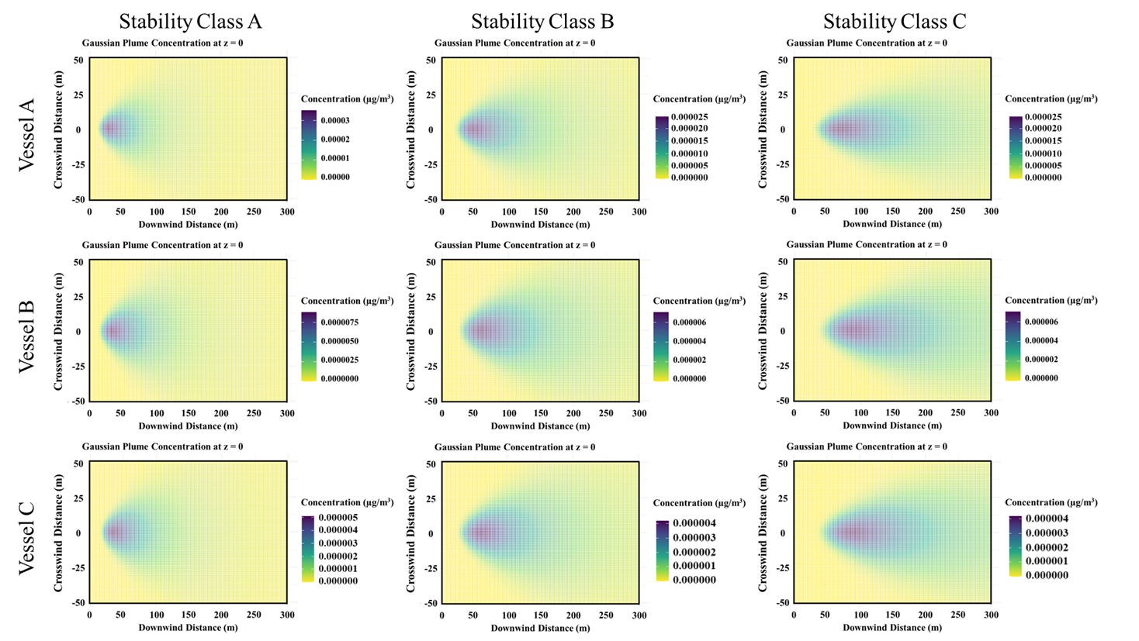
Figure S5. Cd ground-level Gaussian Plume Model concentrations.

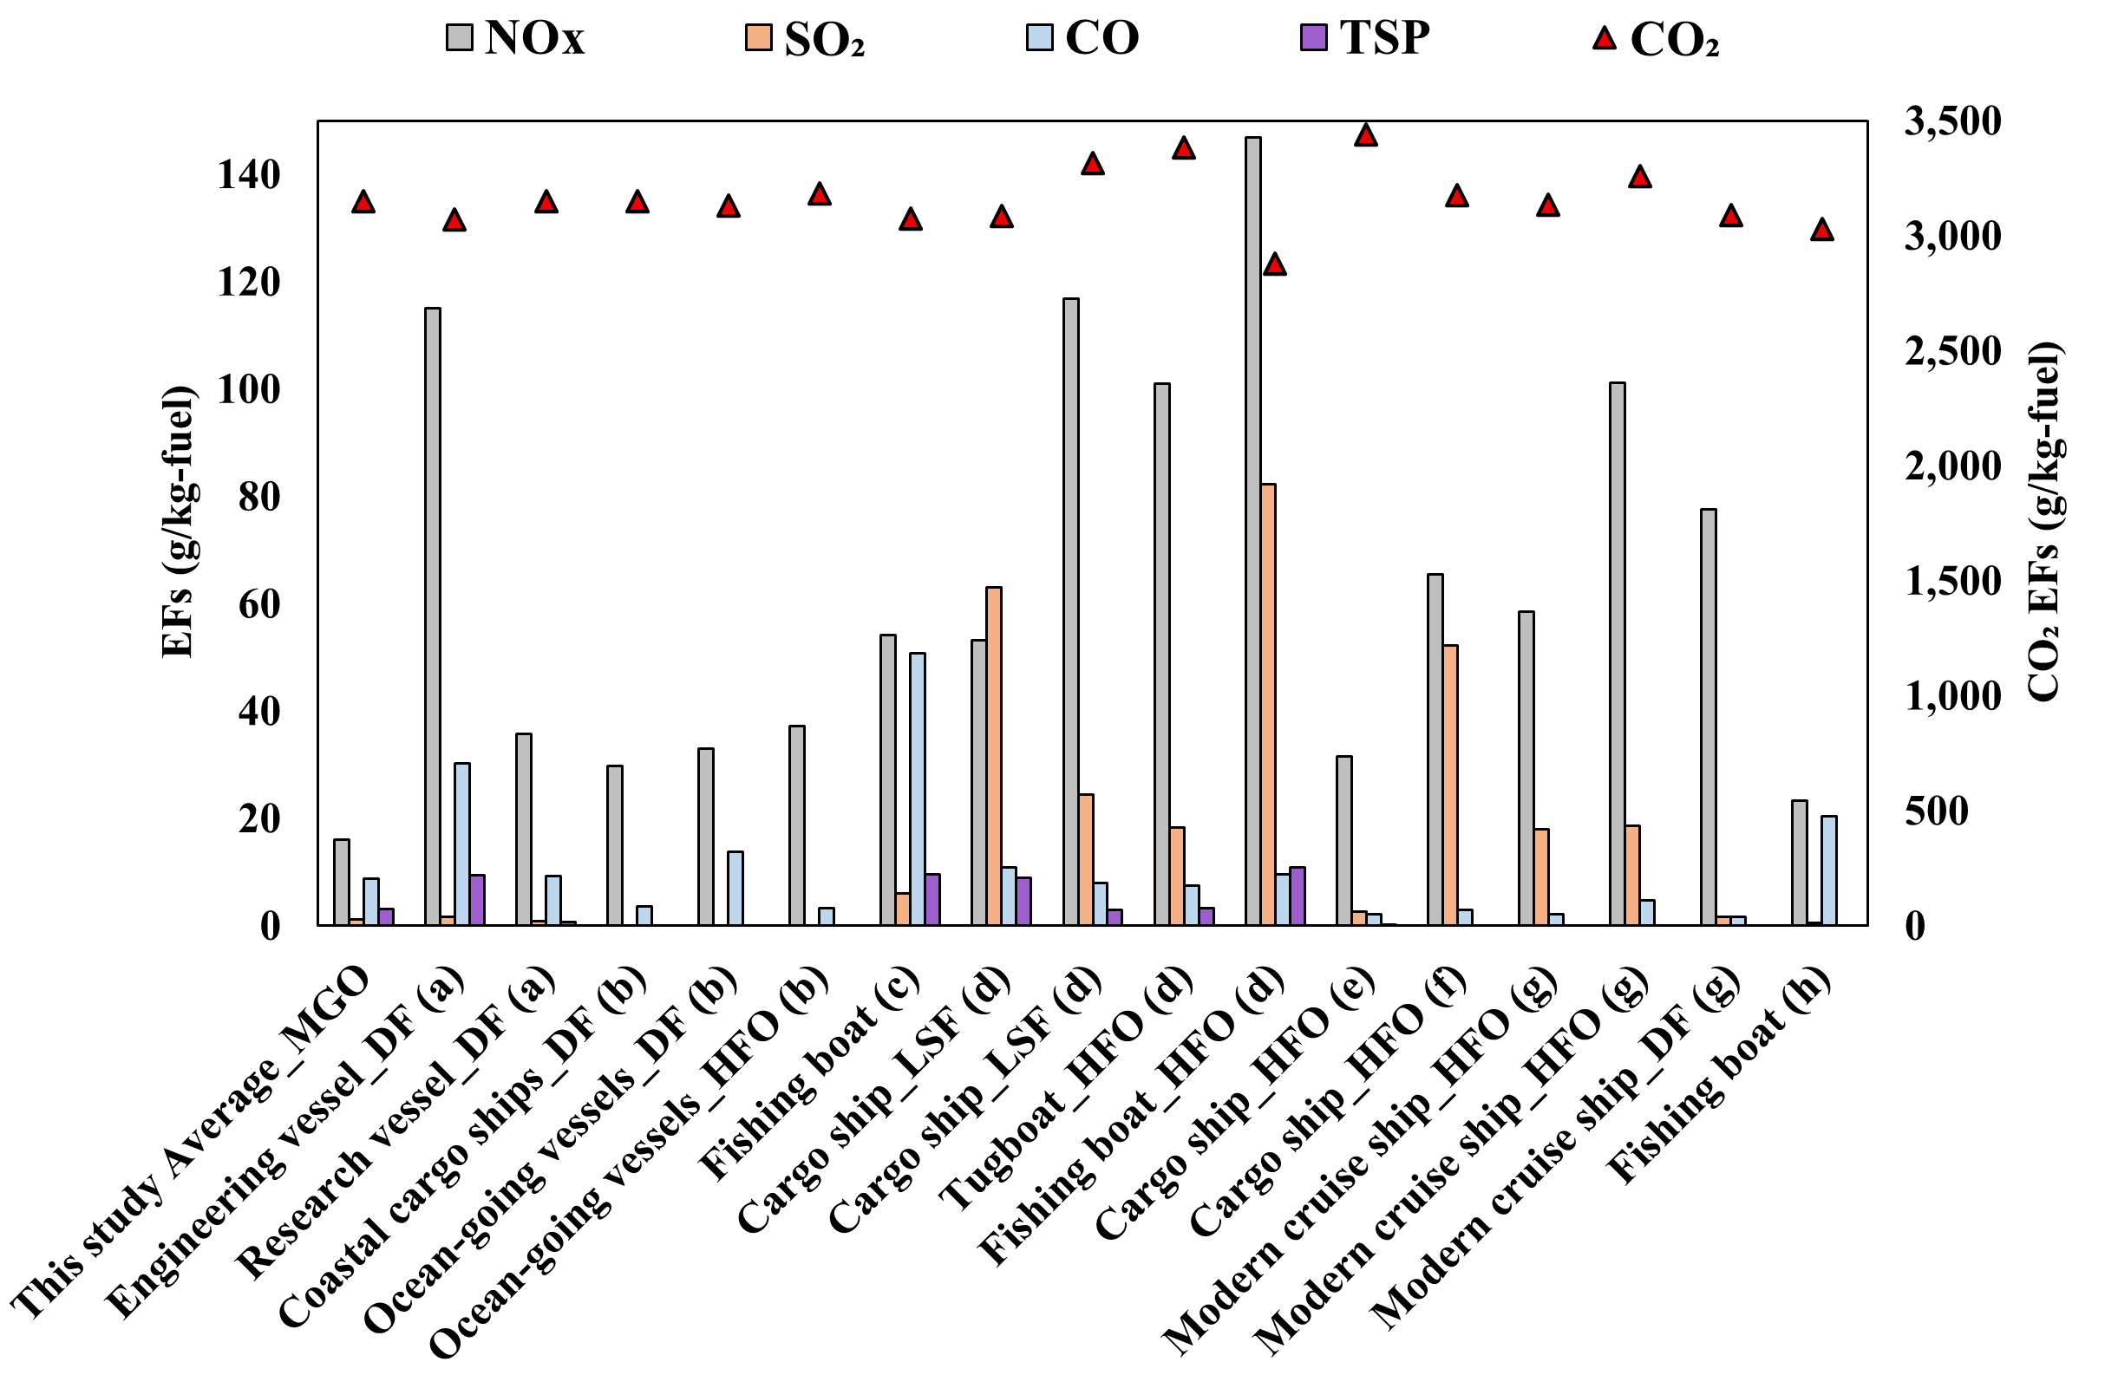
*MGO, marine gas oil; HFO, heavy fuel oil; LSF, low sulfur fuel; DF, diesel fuel.
*References: (a). (Zhang et al., 2016); (b). (Zhang et al., 2024); (c). (Zhang et al., 2018); (d). (Yang et al., 2023); (e). (Moldanová et al., 2009); (f). (Sinha et al., 2003); (g). (Kuittinen et al., 2024); (h). (Chien et al., 2025).
Figure S6. Fuel-based EFs in this study and previous studies (g/kg-fuel).

References
Chien, P. Y., et al., 2025. Real-world emissions and total output from fishing vessels in Taiwan. Transportation Research Part D: Transport and Environment. 148, 104981.
Kuittinen, N., et al., 2024. In-depth characterization of exhaust particles performed on-board a modern cruise ship applying a scrubber. Science of The Total Environment. 946, 174052.
Moldanová, J., et al., 2009. Characterisation of particulate matter and gaseous emissions from a large ship diesel engine. Atmospheric Environment. 43, 2632-2641.
Sinha, P., et al., 2003. Emissions of trace gases and particles from two ships in the southern Atlantic Ocean. Atmospheric Environment. 37, 2139-2148.
Wen, J., et al., 2018. PM2.5 source profiles and relative heavy metal risk of ship emissions: Source samples from diverse ships, engines, and navigation processes. Atmospheric Environment. 191, 55-63.
Yang, L., et al., 2023. Real world emission characteristics of Chinese fleet and the current situation of underestimated ship emissions. Journal of Cleaner Production. 418, 138107.
Zhang, F., et al., 2018. Real-World Emission Factors of Gaseous and Particulate Pollutants from Marine Fishing Boats and Their Total Emissions in China. Environmental Science & Technology. 52, 4910-4919.
Zhang, F., et al., 2016. Emission factors for gaseous and particulate pollutants from offshore diesel engine vessels in China. Atmospheric Chemistry and Physics. 16, 6319-6334.
Zhang, F., et al., 2024. Real-world emission characteristics of VOCs from typical cargo ships and their potential contributions to secondary organic aerosol and O 3 under low-sulfur fuel policies. Atmospheric Chemistry and Physics. 24, 8999-9017.
Zhang, X., Aikawa, M., 2023. The variation of PM2.5 from ship emission under low-sulfur regulation: A case study in the coastal suburbs of Kitakyushu, Japan. Science of The Total Environment. 858, 159968.

