Supplementary Material

Table of Contents
Table S1 | Number of measurements and data completeness for the 48-hour personal CO exposure measurements by study group during the RESPIRE and CRECER study stages
Table S2 | Cumulative CO exposure calculation based on RESPIRE and CRECER 48-hour personal CO tube measurements
Figure S3 | Directed acyclic graph representing the causal relationship between household air pollution exposure and child somatic growth in the CRECER study population in rural Guatemala
Table S4 | CO exposure levels during RESPIRE and CRECER study stages, and cumulative CO exposure at 4.6 years old by study group
Figure S5 | Density distribution of average CO exposure (ppm) before each valid anthropometry assessment, stratified by sex.
Figure S6 | Average height for age z-score (HAZ), weight for age z-score (WAZ), weight for length z-score (WHZ), and body mass index (BMI) z-score by age in months among study children, stratified by sex.
Table S7 | Sensitivity analysis of anthropometry outcomes and cumulative CO exposure with alternative cumulative CO calculations
Table S8 | Point estimates and 95% confidence intervals (CIs) of anthropometry outcomes associated with cumulative CO exposure (ppm-year), among groups 1 and 2 only
Table S9 | Point estimates and 95% confidence intervals (CIs) of anthropometry outcomes associated with average CO exposure (ppm), among groups 1 and 2 only
Table S10 | Point estimates and 95% confidence intervals (CIs) of the associations between repeated measurements of anthropometric z-scores and average CO exposure quartiles.

Table S1: Number of measurements and data completeness for the 48-hour personal CO exposure measurements by study group during the RESPIRE and CRECER study stages.
Study stage | Round | Date range | Median date | Data Completeness
 |  |  |  | Group 1 (n=192) | Group 2 (n=192) | Group 3 (n=157) | Group 3 proxy (n=157)
RESPIRE | 1 | 2003-01-23 to 2004-02-17 | 2003-03-13 | 161 (84%) | 152 (79%) | - | -
RESPIRE | 2 | 2003-05-28 to 2004-01-14 | 2003-07-02 | 174 (91%) | 174 (91%) | - | -
RESPIRE | 3 | 2003-09-24 to 2004-05-18 | 2003-11-19 | 185 (96%) | 177 (92%) | - | -
RESPIRE | 4 | 2004-01-19 to 2004-08-30 | 2004-06-14 | 161 (84%) | 160 (83%) | - | -
RESPIRE | 5 | 2004-05-10 to 2004-12-06 | 2004-10-18 | 102 (53%) | 113 (59%) | - | -
RESPIRE | 6 | 2004-08-24 to 2005-02-15 | 2004-09-07 | 9 (5%) | 27 (14%) | - | -
CRECER | 1 | 2006-03-22 to 2006-04-05 | 2006-03-29 | 0 | 0 | 155 (99%) | 146 (93%)
CRECER | 2 | 2006-07-10 to 2006-09-26 | 2006-08-15 | 188 (98%) | 192 (100%) | 157 (100%) | 153 (97%)
CRECER | 3 | 2006-10-02 to 2006-12-26 | 2006-11-07 | 0 | 0 | 153 (97%) | 147 (94%)
CRECER | 4 | 2007-01-08 to 2007-03-26 | 2007-02-12 | 170 (89%) | 176 (92%) | 145 (92%) | 136 (87%)
CRECER | 5 | 2007-04-09 to 2007-06-27 | 2007-05-15 | 0 | 0 | 154 (98%) | 88 (56%)
CRECER | 6 | 2007-06-18 to 2007-09-24 | 2007-07-31 | 178 (93%) | 184 (96%) | 155 (99%) | 27 (17%)
CRECER | 7 | 2007-10-01 to 2007-12-04 | 2007-11-04 | 0 | 0 | 150 (96%) | 2 (1%)
Average number of CO measurements during RESPIRE |  |  |  | 3.77 | 3.86 | - | -
Average number of CO measurements during CRECER |  |  |  | 2.79 | 2.88 | 6.81 | 4.45

Table S2: Cumulative CO exposure calculation based on RESPIRE and CRECER 48-hour personal CO tube measurements.
Time | Values | Main analysis | Alternative 1 | Alternative 2 | Alternative 3
Birth |  | X1 | X1 | X1 | (X1+X2+X3)/3
- |  | X1 | X1 | X1 | (X1+X2+X3)/3
RESPIRE CO tube 1 | X1 | X1 | X1 | X1 | (X1+X2+X3)/3
- |  | X2 | X2 | X2 | (X1+X2+X3)/3
RESPIRE CO tube 2 | X2 | X2 | X2 | X2 | (X1+X2+X3)/3
- |  | X3 | X3 | X3 | (X1+X2+X3)/3
Last RESPIRE CO tube | X3 | X3 | X3 | X3 | (X1+X2+X3)/3
- |  | X3 | (X3+X4)/2 | X4 | (X1+X2+X3)/3
~18 months old (600 days) |  | X3 | (X3+X4)/2 | X4 | (X4+X5+X6+X7)/3
- |  | X4 | (X3+X4)/2 | X4 | (X4+X5+X6+X7)/3
- |  | X4 | (X3+X4)/2 | X4 | (X4+X5+X6+X7)/3
- |  | X4 | (X3+X4)/2 | X4 | (X4+X5+X6+X7)/3
CRECER CO tube 1 | X4 | X4 | X4 | X4 | (X4+X5+X6+X7)/3
- |  | X5 | X5 | X5 | (X4+X5+X6+X7)/3
CRECER CO tube 2 | X5 | X5 | X5 | X5 | (X4+X5+X6+X7)/3
- |  | X6 | X6 | X6 | (X4+X5+X6+X7)/3
Last CRECER CO tube before 4.6 years old | X6 | X6 | X6 | X6 | (X4+X5+X6+X7)/3
- |  | X6 | X6 | X6 | (X4+X5+X6+X7)/3
4.6 years old  (1675 days old) |  | X6 | X6 | X6 | (X4+X5+X6+X7)/3
- |  | 0 | 0 | 0 | 0
CRECER CO tube after 4.6 years old | X7 | 0 | 0 | 0 | 0
* This table is simplified to include 3 RESPIRE measurements and 3 CRECER measurements before 4.6 years old. The number of CO tube measurements during each study period can be different among study children.

Figure S3: Directed acyclic graph representing the causal relationship between household air pollution exposure and child somatic growth in the CRECER study population in rural Guatemala
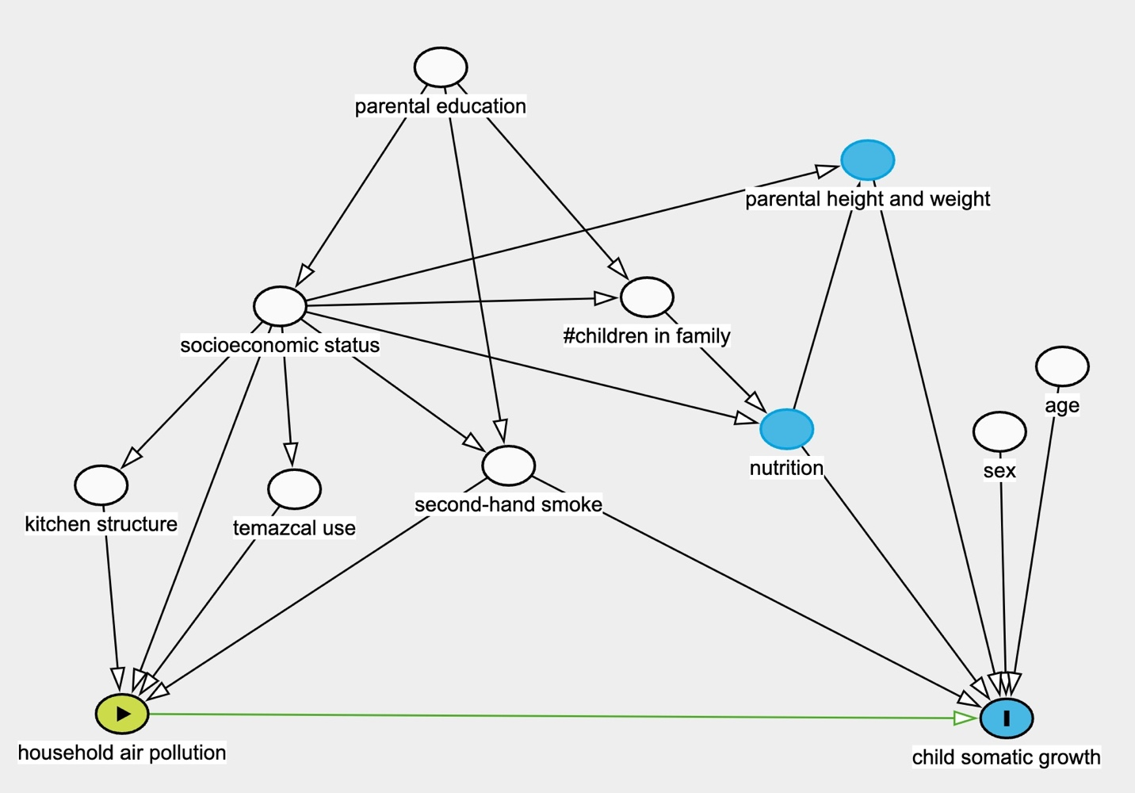
Note: Green node represent exposure variable; blue nodes represent outcome variable or variables associated with the outcome that are not fully adjusted; white nodes represent adjusted covariates.
Table S4: CO exposure levels during RESPIRE and CRECER study stages, and cumulative CO exposure at 4.6 years old by study group.

 | Group 1 | Group 2 | Group 3 | One-way ANOVA p-value
Plancha Installation Age | (<6 months) | (~18 months) | (~57 months) | One-way ANOVA p-value
 | mean (SD) | mean (SD) | mean (SD) | One-way ANOVA p-value
 | median [Min, Max] | median [Min, Max] | median [Min, Max] | One-way ANOVA p-value
Baseline CO exposure before plancha installation (ppm) | 3.13 (2.65) | 3.63 (3.29) | 1.39 (1.65) | Not comparable
Baseline CO exposure before plancha installation (ppm) | 2.43 [0.47, 18.73] | 2.29 [0.41, 20.07] | 0.95 [0.43, 15.34] | Not comparable
Average CO exposure during RESPIRE (ppm) | 1.47* (0.93) | 2.87 (1.72) | 1.67^ (0.88) | <0.001
Average CO exposure during RESPIRE (ppm) | 1.19* [0.31, 5.39] | 2.47 [0.39, 13.8] | 1.48^ [0.53, 7.54] | <0.001
Average CO exposure during CRECER (ppm) | 0.89* (0.72) | 0.89* (0.55) | 1.30 (0.55) | <0.001
Average CO exposure during CRECER (ppm) | 0.67* [0.31, 5.69] | 0.73* [0.30, 4.32] | 1.22 [0.55, 4.13] | <0.001
Cumulative CO exposure at 4.6 years old (ppm-year) | 4.98 (2.91) | 7.16 (3.51) | 6.64 (3.30) | <0.001
Cumulative CO exposure at 4.6 years old (ppm-year) | 4.04 [1.86, 26.5] | 6.31 [2.21, 26.7] | 6.02 [2.43, 22.8] | <0.001
* Mean and median CO values labeled with * indicate measurements after chimney stove installation.
^ Group 3 study children’s CO exposure during the RESPIRE study period was estimated based on their proxy infant siblings’ CO exposure during CRECER.
Note: baseline CO exposures between groups 3 and groups 1 and 2 are not comparable because baseline CO were measured at older ages for group 3 due to their later recruitment.

Figure S5: Density distribution of average CO exposure (ppm) before each valid anthropometry assessment, stratified by sex.
Note: red vertical dashed lines indicate quartile cutpoints of 1.09 ppm, 1.62 ppm, and 2.29 ppm, respectively.

Figure S6: Average height for age z-score (HAZ), weight for age z-score (WAZ), weight for length z-score (WHZ), and body mass index (BMI) z-score by age in months among study children, stratified by sex.
Note: grey shadowed areas indicate the range of z-scores for each age-sex group.
Table S7: Sensitivity analysis of anthropometry outcomes and cumulative CO exposure (ppm-year) with alternative cumulative CO calculations
 | Alternative 1 | Alternative 2 | Alternative 3
Z-score growth indicators: coefficient (95% CI)
Height for age z-score (HAZ) | -0.004 (-0.02, 0.01) | -0.02 (-0.04, 0.003) | -0.02 (-0.04, 0.002)
Weight for age z-score (WAZ) | -0.004, -0.02, 0.01) | -0.002 (-0.02, 0.02) | -0.01 (-0.03, 0.008)
Weight for height z-score (WHZ) | -0.001 (-0.02, 0.01) | 0.02 (-0.003, 0.03) | 0.004 (-0.02, 0.02)
BMI z-score | -0.002 (-0.02, 0.01) | 0.02 (0.00, 0.04) | 0.01 (-0.01, 0.03)
Binary growth indicators: OR (95% CI)
Moderate stunting (HAZ <-2) | 1.01 (0.93, 1.11) | 1.003 (0.92, 1.12) | 1.05 0.94, 1.19)
Severe stunting (HAZ <-3) | 0.99 (0.94, 1.04) | 1.01 (0.95, 1.07) | 1.03 (0.98, 1.10)
Moderate underweight (WAZ <-2) | 1.03 (0.98, 1.08) | 1.04 (0.98, 1.10) | 1.05 (0.99, 1.11)
Severe underweight (WAZ <-3) | 1.01 (0.90, 1.12) | 1.02 (0.90, 1.13) | 1.06 (0.93, 1.18)
Models adjusted for sex, second-hand smoke, number of children in the family, average weekly temazcal (sauna bath) use time of the child, kitchen location and type, maternal height, maternal and paternal education, SES (land-owning, house-owning, and number of major assets). Number of children included in the analyses is 522 for all models.

Table S8: Point estimates and 95% confidence intervals (CIs) of anthropometry outcomes associated with cumulative CO exposure (ppm-year), among groups 1 and 2 only
 | Bivariate model,  all children | Multivariable model,  all children | Multivariable model,  male only | Multivariable model,  female only
Z-score growth indicators: coefficient (95% CI)
Height for age z-score | -0.02 (-0.04, 0.009) | -0.01 (-0.03, 0.02) | -0.02 (-0.06, 0.02) | 0.003 (-0.03, 0.04)
Weight for age z-score | -0.01 (-0.03, 0.01) | -0.004 (-0.03, 0.02) | -0.006 (-0.04, 0.03) | 0.002 (-0.03, 0.03)
Weight for height z-score | 0.01 (-0.02, 0.03) | 0.002 (-0.02, 0.02) | 0.007 (-0.03, 0.04) | -0.001 (-0.03, 0.03)
BMI z-score | 0.01 (-0.02, 0.03) | 0.003 (-0.02, 0.02) | 0.007 (-0.03, 0.04) | 0.00 (-0.03, 0.03)
Binary growth indicators: OR (95% CI)
Moderate stunting | 1.05 (0.95, 1.19) | 0.99 (0.88, 1.13) | 1.33 (1.03, 1.82) | 0.80 (0.66 0.96)
Severe stunting | 1.02 (0.96, 1.08) | 1.00 (0.93, 1.06) | 0.99 (0.89, 1.10) | 0.98 (0.90, 1.08)
Moderate underweight | 1.04 (0.98, 1.11) | 1.04 (0.97, 1.11) | 1.09 (0.98, 1.22) | 0.98 (0.89, 1.08)
Severe underweight | 1.01 (0.86, 1.14) | 1.09 (0.91, 1.24) | 1.06 (0.80, 1.30) | 1.16 (0.81, 1.60)
number of children (n) | 380 | 376 | 179 | 197
Multivariable adjusted for sex, second-hand smoke, number of children in the family, average weekly temascal use time of the child, kitchen location and type, maternal height, maternal and paternal education, SES (land-owning, house-owning and number of major assets). Sex-stratified models adjusted for the same covariates as the multivariable model, except for sex.

Table S9: Point estimates and 95% confidence intervals (CIs) of anthropometry outcomes associated with average CO exposure (ppm), among groups 1 and 2 only
 | Bivariate model,  all children | Multivariable model,  all children | Multivariable model,  male only | Multivariable model,  female only
Z-score growth indicators: coefficient (95% CI)
Height for age z-score | -0.19 (-0.23, -0.15) | -0.20 (-0.24, -0.15) | -0.26 (-0.33, -0.18) | -0.16 (-0.20, -0.09)
Weight for age z-score | -0.13 (-0.17, -0.09) | -0.13 (-0.17, -0.09) | -0.13 (-0.19, -0.07) | -0.13 (-0.18, -0.08)
Weight for height z-score | -0.06 (-0.10, -0.02) | -0.07 (-0.11, -0.02) | -0.06 (-0.12, -0.00) | -0.08 (-0.13, -0.02)
BMI z-score | 0.004 (-0.04, 0.04) | 0.002 (-0.04, 0.04) | -0.004 (-0.06, 0.05) | 0.01 (-0.05, 0.06)
number of children | 384 | 334 | 161 | 203
number of observation | 1346 | 1188 | 574 | 704
All models included random intercepts for childid. Multivariable adjusted for sex, second-hand smoke, number of children in the family, average weekly temascal use time of the child, kitchen location and type, maternal and paternal education, SES (land-owning, house-owning and number of major assets). Sex-stratified models adjusted for the same covariates as the multivariable model, except for sex. Models of HAZ adjust for maternal height.

Table S10: Point estimates and 95% confidence intervals (CIs) of the associations between repeated measurements of anthropometric z-scores and average CO exposure quartiles.
 | 1st quartile:  0.30 - 1.09 ppm | 2nd quartile:  1.09 - 1.62 ppm | 3rd quartile:  1.62 - 2.29 ppm | 4th quartile:  2.29 - 13.84 ppm
All children: coefficient (95% CI)
Height for age z-score (HAZ) | 0.00  (Referent) | -0.07  (-0.05, 0.01) | -0.24  (-0.34, -0.14) | -0.44  (-0.54, -0.32)
Weight for age z-score (WAZ) | 0.00  (Referent) | -0.05  (-0.12, 0.03) | -0.14  (-0.23, -0.05) | -0.29  (-0.40, -0.18)
Weight for height z-score (WHZ) | 0.00  (Referent) | 0.01  (-0.08, 0.11) | -0.02  (-0.12, 0.09) | -0.12  (-0.24, 0.01)
BMI z-score | 0.00  (Referent) | 0.03  (-0.06, 0.12) | 0.06  (-0.04, 0.17) | 0.06  (-0.06, 0.18)
number of observation | 463 | 461 | 471 | 465
Male: coefficient (95% CI)
Height for age z-score (HAZ) | 0.00  (Referent) | -0.10  (-0.22, 0.02) | -0.32  (-0.47, -0.17) | -0.62  (-0.79, -0.44)
Weight for age z-score (WAZ) | 0.00  (Referent) | -0.01  (-0.13, 0.10) | -0.16  (-0.29, -0.02) | -0.27  (-0.42, -0.11)
Weight for height z-score (WHZ) | 0.00  (Referent) | 0.09  (-0.27, 0.47) | 0.01  (-0.05, 0.24) | -0.02  (-0.15, 0.17)
BMI z-score | 0.00  (Referent) | 0.11  (-0.02, 0.26) | 0.09  (-0.06, 0.25) | 0.18  (0.00, 0.36)
number of observation | 227 | 226 | 244 | 181
Female: coefficient (95% CI)
Height for age z-score (HAZ) | 0.00  (Referent) | -0.04  (-0.15, 0.07) | -0.15  (-0.28, -0.01) | -0.26  (-0.42, -0.11)
Weight for age z-score (WAZ) | 0.00  (Referent) | -0.08  (-0.18, 0.02) | -0.13  (-0.25, -0.00) | -0.31  (-0.44, -0.16)
Weight for height z-score (WHZ) | 0.00  (Referent) | -0.06  (-0.18, 0.06) | -0.04  (-0.18, 0.10) | -0.21  (-0.37, -0.05)
BMI z-score | 0.00  (Referent) | -0.04  (-0.16, 0.08) | 0.04  (-0.10, 0.18) | -0.05  (-0.20, 0.11)
number of observation | 236 | 235 | 227 | 284
All models included random intercepts for child ID, adjusted for second-hand smoke, number of children in the family, average weekly temascal use time of the child, kitchen location and type, maternal and paternal education, SES (land-owning, house-owning and number of major assets). Sex-stratified models adjusted for the same covariates as the multivariable model, except for sex. Models of HAZ adjusted for maternal height.

