Supporting Information:
“Comparing Performance and Reliability of Collocated Enhanced Children’s MicroPEM (ECM) on Gravimetric and Nephelometric PM_{2.5} Personal Exposure Samples in Field Measurements in Rural Guatemala”

Table S1: Demographic and maternal characteristics of the study population at enrollment. (Intervention and Control groups represent the actual group the participants were allocated as part of the HAPIN trial)
Characteristics at enrollment | Total | Intervention | Control
Characteristics at enrollment | N= 112 | N= 50 (44.6%) | N= 62 (55.4%)
Participant’s age (years)
Mean ± SD | 24.7 ± 4.61 | 24.7 ± 4.62 | 24.8 ± 4.65
18-23 | 57 (50.9%) | 25 (50%) | 32 (51.6%)
24-29 | 36 (32.1%) | 16 (32%) | 20 (32.3%)
30-35 | 19 (17%) | 9 (18%) | 10 (16.1%)
Gestational age (weeks)
Mean ± SD | 13.8 ± 2.76 | 13.9 ± 2.43 | 13.7 ± 3.0
9-12 | 56 (50%) | 25 (50%) | 31 (50%)
13-16 | 39 (34.8%) | 19 (38%) | 20 (32.3%)
17-20 | 17 (15.2%) | 6 (12%) | 11 (17.7%)
Number of biomass stoves
One | 39 (34.8%) | 21 (42%) | 18 (29%)
Two | 68 (60.7%) | 27 (54%) | 41 (66.2%)
Three or more | 5 (4.5%) | 2 (4%) | 3 (4.8%)
Main stove type
Open fire | 87 (77.7%) | 39 (78%) | 48 (77.4%)
Chimney | 25 (22.3%) | 11 (22%) | 14 (22.6%)
Trash disposal
Burn it | 21 (18.8%) | 8 (16%) | 13 (21%)
Other* | 91 (81.2%) | 42 (84%) | 49 (79%)
Lighting source
Electricity | 97 (86.6%) | 43 (86%) | 54 (87.1%)
Fire source** | 11 (9.8%) | 5 (10%) | 6 (9.7%)
Other^{ǂ} | 4 (3.6%) | 2 (4%) | 2 (3.2%)
Tobacco smoking in home
Yes | 7 (6.2%) | 4 (8%) | 3 (4.8%)
No | 105 (93.8%) | 46 (92%) | 59 (95.2%)
Education level
None | 7 (6.3%) | 3 (6%) | 4 (6.5%)
Primary | 77 (68.7%) | 34 (68%) | 43 (69.4%)
Secondary | 23 (20.5%) | 11 (22%) | 12 (19.3%)
Vocational | 4 (3.6%) | 1 (2%) | 3 (4.8%)
College or University | 1 (0.9%) | 1 (2%) | ---
Occupation
Household work | 103 (92%) | 44 (88%) | 59 (95.2%)
Other# | 9 (8%) | 6 (12%) | 3 (4.8%)
Family size
Mean ± SD | 4.8 ± 2.28 | 4.9 ± 2.08 | 4.8 ± 2.44
2 – 4 | 60 (53.6%) | 26 (52%) | 34 (54.8%)
5 – 7 | 37 (33%) | 18 (36%) | 19 (30.7%)
8 – 11 | 15 (13.4%) | 6 (12%) | 9 (14.5%)
Primary cook
Pregnant participant | 96 (85.7%) | 44 (88%) | 52 (83.9%)
Mother/Mother-in-law | 15 (13.4%) | 6 (12%) | 9 (14.5%)
Sister/Sister-in-law | 1 (0.9%) | --- | 1 (1.6%)
*Trash buried, thrown away, collected by the government, compost and fed to animals
**Candles, traditional stove and oil lamps
^{ǂ}Solar light, battery torches and solar panel
#Housemaid, teaching, agriculture, commercial or industry job

Table S2: Total visits categorized by time-point specified exposure pregnancy visit. (BL= Baseline or <20 weeks of gestation; BL-P1: Assessment intermediate between BL and P1; P1: Assessment between 24-28 weeks of gestation; P1-P2: Intermediate between P1 and P2; P2: 32-36 weeks of gestation, P2-B1: One month after P2 or approximately one week before birth)

Visit | Number | Percentage
BL | 31 | 14%
BLP1 | 35 | 15%
P1 | 52 | 23%
P1P2 | 31 | 14%
P2 | 51 | 22%
P2B1 | 28 | 12%
Total | 228 | 100%

Table S3: Number of participants categorized by total number of visits.

Number of visits | Number of Participants | Percentage
1 | 35 | 31%
2 | 40 | 36%
3 | 36 | 32%
5 | 1 | 1%
Total | 112 | 100%

Table S4: Statistical summary of the individual gravimetric PM_{2.5} concentrations.
Statistic | Baseline |  | Baseline-P1 |  | P1 |  | P1-P2 |  | P2 |  | P2-B1
Statistic | Control | Intervention | Control | Intervention | Control | Intervention | Control | Intervention | Control | Intervention | Control | Intervention
N Samples | 40 | 20 | 34 | 34 | 56 | 42 | 32 | 26 | 62 | 40 | 28 | 24
Mean  (SD) | 163.9  (128.9) | 140.6  (86.2) | 121.0  (75.3) | 31.9  (27.3) | 96.3  (61.4) | 26.1  (12.9) | 143.0  (96.3) | 25.0  (13.8) | 119.8  (89.3) | 23.8  (14.0) | 137.9  (120.2) | 20.3  (8.5)
Range | 40.0 – 601.4 | 30.5 – 320.0 | 11.8 – 336.3 | 11.4 – 109.5 | 17.4 – 259.5 | 9.7 – 53.4 | 21.4 – 349.3 | 11.6 – 55.5 | 26.7 – 431.8 | 10.5 – 82.3 | 11.8 – 486.1 | 11.5 – 39.8
Median  (IQR) | 130.8  (85.9 – 170.1) | 124.0  (78.6 – 174.4) | 112.8  (59.0 – 175.1) | 19.9  (11.8 – 36.1) | 81.9  (50.3 – 118.1) | 23.9  (16.3 – 35.4) | 141.8  (53.5 – 208.7) | 22.4  (11.9 – 33.9) | 85.9  (54.8 – 160.3) | 21.5  (14.9 – 29.0) | 114.3  (47.7 – 166.7) | 19.3  (11.9 – 26.7)

Table S5: Statistical summary of the individual nephelometric PM_{2.5} concentrations.
Statistic | Baseline |  | Baseline-P1 |  | P1 |  | P1-P2 |  | P2 |  | P2-B1
Statistic | Control | Intervention | Control | Intervention | Control | Intervention | Control | Intervention | Control | Intervention | Control | Intervention
N Samples | 40 | 20 | 36 | 34 | 56 | 44 | 32 | 28 | 58 | 40 | 32 | 22
Mean  (SD) | 168.6  (156.0) | 182.1  (185.0) | 112.0  (91.7) | 29.0  (16.9) | 93.8  (70.0) | 30.0  (14.1) | 137.7  (101.9) | 24.4  (10.1) | 119.1  (103.2) | 24.7  (12.9) | 148.9  (141.4) | 21.5  (9.9)
Range | 26.8 – 725.5 | 27.2 – 600.3 | 21.5 – 325.8 | 12.6 – 71.4 | 19.8 – 305.6 | 13.3 – 71.1 | 20.2 – 350.6 | 15.1 – 46.9 | 27.9 – 471.3 | 12.5 – 93.3 | 16.0 – 582.5 | 12.6 – 51.1
Median  (IQR) | 129.1  (70.4 – 182.9) | 104.2  (68.4 – 185.2) | 77.4  (42.8 – 175.6) | 23.8  (16.6 – 34.5) | 79.7  (47.9 – 104.5) | 24.9  (20.6 – 36.7) | 103.4  (49.1 – 227.7) | 20.7  (16.3 – 29.4) | 71.8  (47.0 – 140.7) | 21.6  (18.2 – 25.9) | 113.0  (48.7 – 174.3) | 18.8  (16.3 – 22.6)

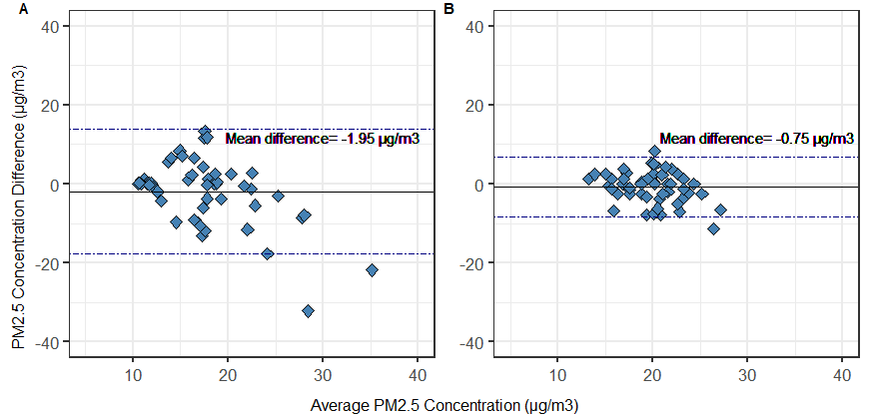
Figure S1: Bland-Altman agreement plots for the ECM (A) gravimetric and (B) nephelometric comparisons at concentrations below the 25th percentile.

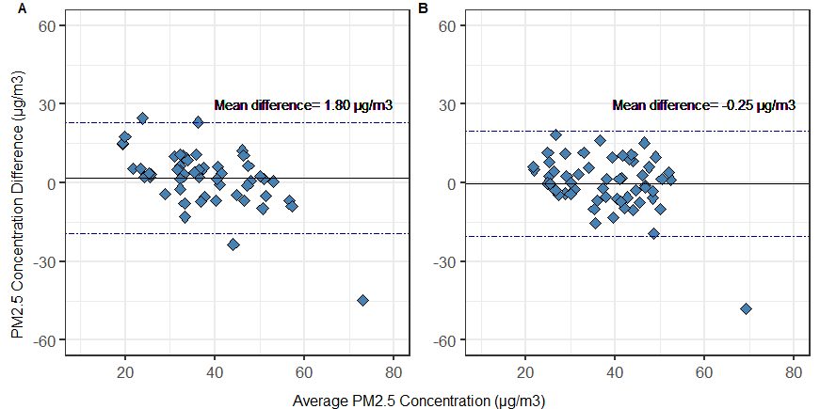
Figure S2: Bland-Altman agreement plots for the ECM (A) gravimetric and (B) nephelometric comparisons at concentrations between the 25th and 50th percentile.

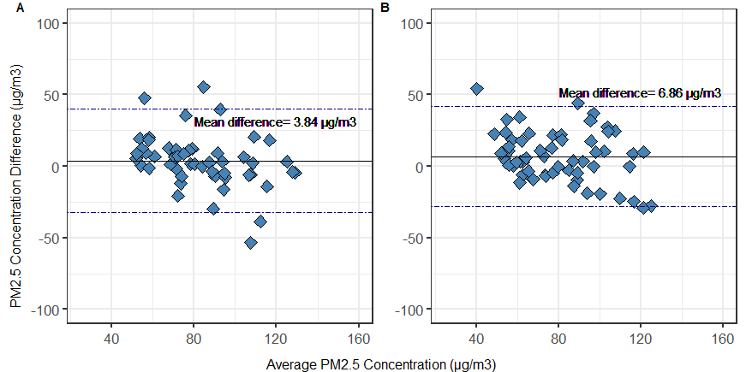
Figure S3: Bland-Altman agreement plots for the ECM (A) gravimetric and (B) nephelometric comparisons at concentrations between the 50th and 75th percentile.

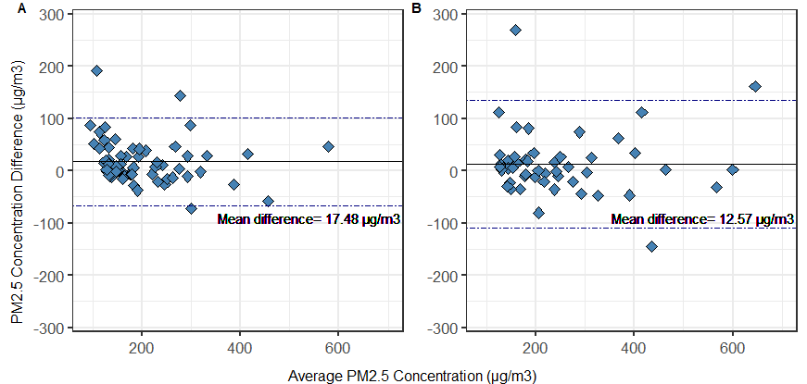
Figure S4: Bland-Altman agreement plots for the ECM (A) gravimetric and (B) nephelometric comparisons at concentrations above the 75th percentile.

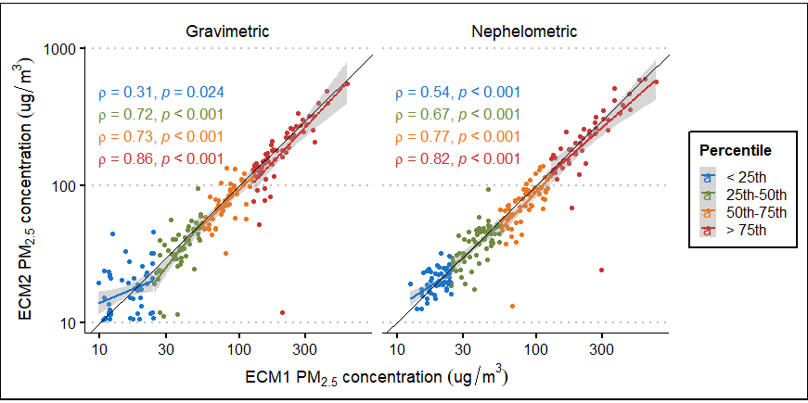
Figure S5: Correlation plots for the ECM gravimetric and nephelometric comparisons by data percentiles

